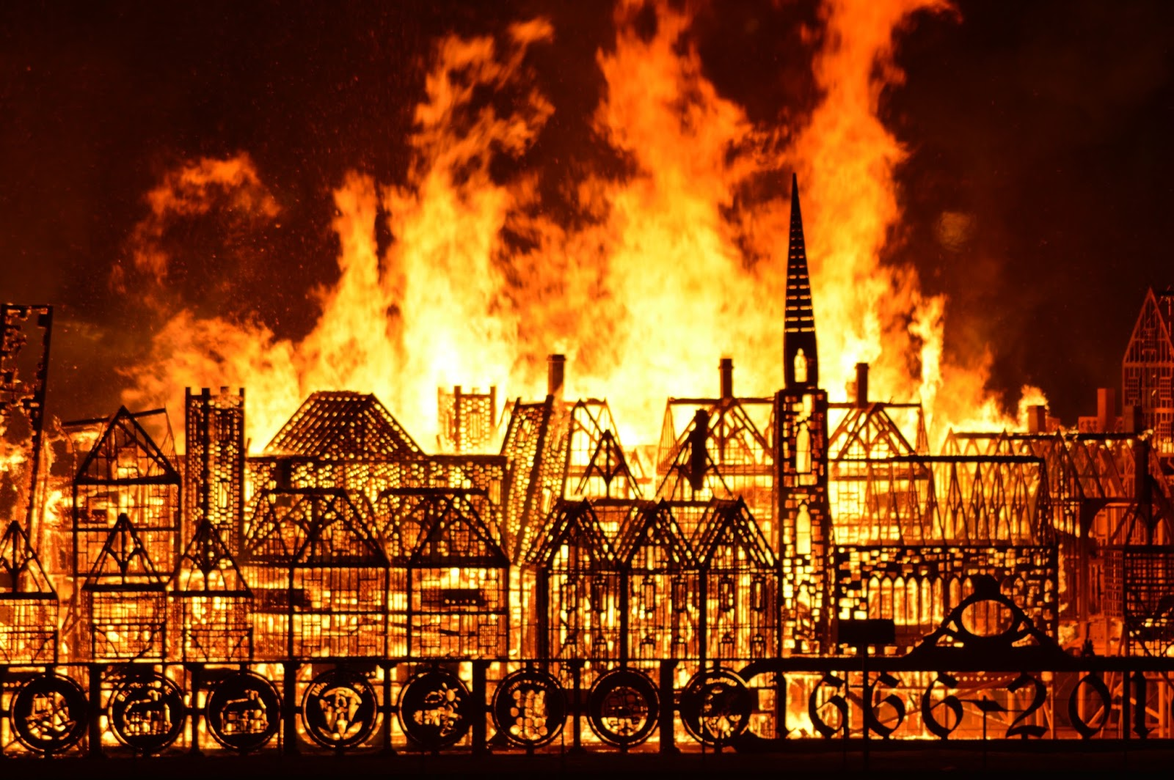
Term 5
The Great Fire of London
Tregeagle Class

Hi everyone,

This is going to be a strange way of learning for us all. Please do not panic or get upset, just try your best that is all I ever ask of you.

This term we will be covering, as best as we can, what would have been our new topic.

To start with we need to research all about ‘The Great Fire of London’. I have devised a grid with some research questions on. It is up to you how you answer them. You do not have to do them in order, but you must try to answer all of them. You can do this by researching the questions on the internet or read the e-book I have attached to find out some of the answers. Or you could ask and adult to help you with some of the questions.

You could just write down the question and answer in your home school book or you could design a poster to display the answers (in your home school book) it is up to you.

Please think about your presentation, spelling and punctuation. Remember the non-negotiables!!!

Art,

In your books, using a double page spread, find a picture of the Great Fire of London and try to re-draw it in your books. Look at the colours and try and mix your paints, pens, pencils to find the nearest colour to the picture. Also, look at the perspective of the building, near and far, how big and small they are compared to what is next to them.

This is a long-term project and it can take you several weeks to complete, so please do not rush it. A little at a time and you will create a master piece. All of you are brilliant artists if you take your time. (Remember your dragon eyes – Amazing!)

Maths

Please continue with your times tables. Also, you could practice your adding, subtracting, dividing and multiplying by rolling a dice to generate a number to calculate. If you are unsure of a method, please email me and I will do my best to show you how to complete it.

I have attached a link for you to complete with White Rose Maths. Click on the link and it will take you to the page, click on your year group and lesson 1. There will be a power point showing and explaining what to do. Please complete the work in your home school books.
https://whiterosemaths.com/homelearning/

Please remember to write down the date for each piece of work you do.

Have a lovely week and keep looking at the blog as I may post some extra work for you to complete.

I miss you all,

Mrs Visick

