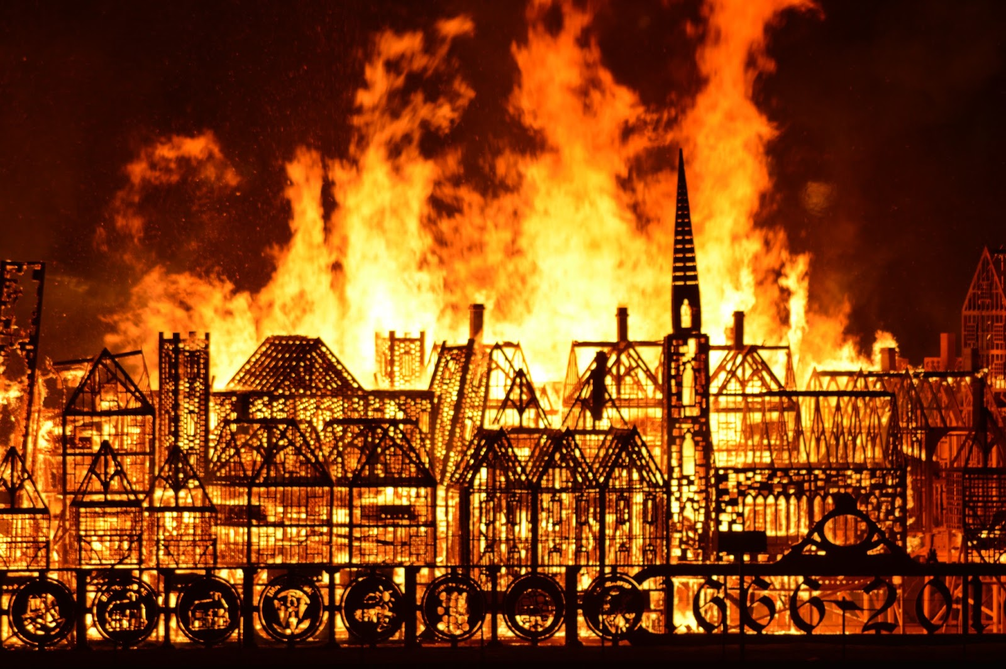
Term 5 Week2
The Great Fire of London
Tregeagle Class

Hi everyone,

I hope that you all are well?

English:

This week we will use the research that you completed last week to make an information text. We have done these before in class and you are familiar with the layout.

This time I would like you to use a two-page spread in your book. I have put in a couple of pictures of what it could look like below, these ones are of the rainforest. You can use the designs to help you make your own information text about The Fire of London. Remember to write up your information in more detail in your own words. Use the internet or the e-book to help you write up more facts. I have also included a fact sheet to help you too.

How to do this:

- Use a double page spread
- Write up your answers from your research with more detail
- Write up your fact/information before you draw any boxes
- Make it colourful
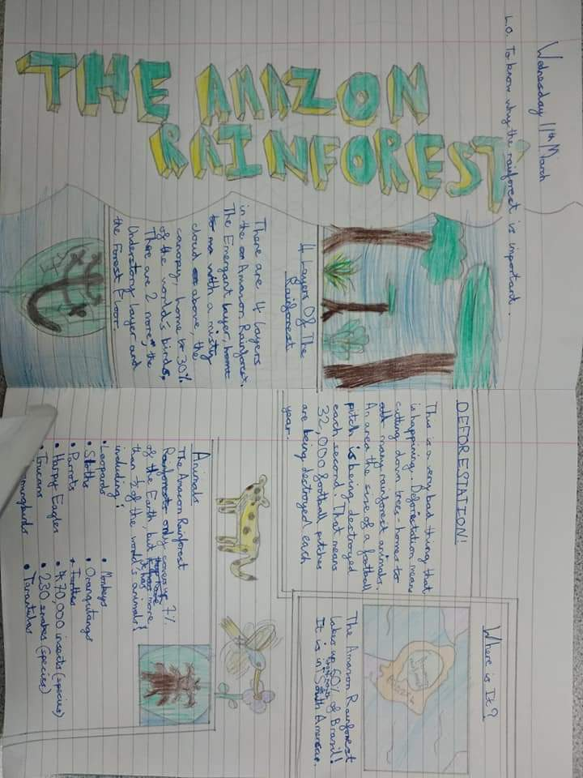
- Edit and improve your work. Check your sentences make sense, spellings are correct, and you have used capital letters, full stops and punctuation.

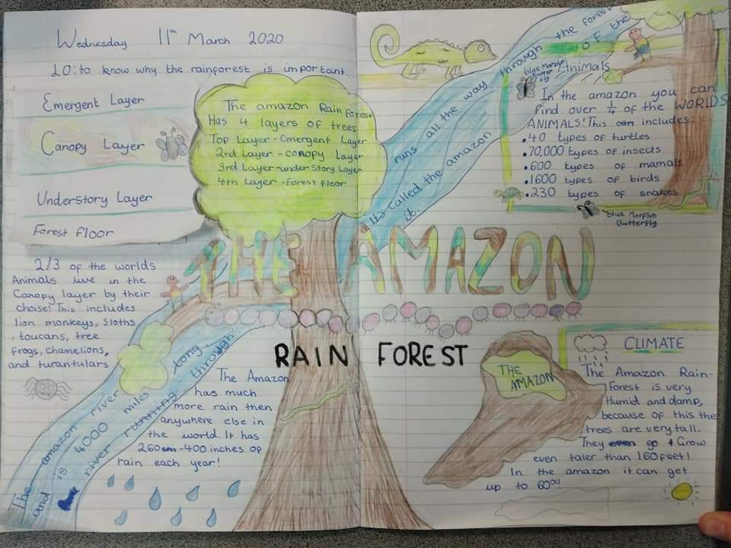

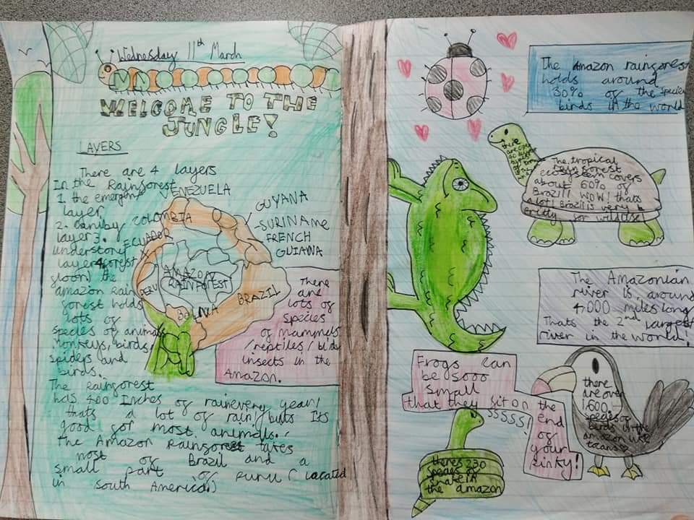

Please remember to write down the date for each piece of work you do.

Mrs Visick

