April 20, 2020
Lisa Barnett (Polruan Primary Academy)

Sensational Safari
Canute class

For your English this week we will begin to study our new class text ‘Mama Panya’s Pancakes’ a lovely village story from Kenya about Mama Panya and her son Adika. Below there are five English tasks (one for each day) which are based around the text.

Task 1:
Read the story Mama Panya’s pancakes (adults will need to read to the children) or use youtube to listen to the story https://www.youtube.com/watch?v=0hWv4PfcBPQ . Then discuss and answer the following questions.
Reception: discuss the story with an adult. Who are the characters? Where is the story set? Do you like the story? What do you like about the story? Which is your favourite part?
Year 1: discuss the questions below and your answers with an adult.
Year 2: discuss the questions below with an adult and write your answers in full sentences.

Page 1: Find the word dousing. What do you think it means?
- putting out
- burning
- lighting
Page 2: What sort of sentence is this:
‘Where are you?’
Page 3: How many coins did Mama have in her cloth?
Page 3: Why do you think Mama says: ‘A little bit and a little bit more.’
Page 4: Where was Mzee Odolo and what was he doing?
Page 5: Why did the children tap the cattle with long reeds?
Page 5: It says: Mama Panya frowned, thinking about the coins in her wrap. Why do you think Mama frowned?
Page 7: What was being traded at the market? Give three.
Page 7: Find and copy one adverb from page 7:
Page 7: Adika waved his hand in the air. What does this show the reader about how Adika is feeling?
Page 8: Find and copy one question from page 8:
Page 8: Why do you think Bwana Zawenna gave Mama an extra cup of flour?
Page 9: Find the word plumpest. What does this mean?
Page 9: Why do you think Mama sighed?
Page 10: How do you think Adika is feeling at this point in the story?
Page 11: Mama piled small twigs and sticks into the firepit.
Why was Mama doing this?

Page 12: Who arrived first for pancakes?
What did they bring?
Page 12: What did Mzee Odolo bring with him?
Page 12: Why did Gamilla bring plantain?
Page 13: Bibi and Bwana brought a package filled with flour.
What did they tell Adika to do with it?
Page 14: Was Mzee a good singer or not? Explain your answer.
Page 14: How did Mama feel at the end of the story? Explain how you know.

The whole story – making links
1. Have you ever invited people round to eat? Give some details.
2. What would you have taken if Adika invited you for pancakes?
3. What do you think the message in the story is?

Task 2:
Today we will be looking at one of the main characters from the story: Adika. In your books draw and colour a portrait of Adika – use the pictures in the book as a guide and try to think back to when we drew portraits of Queen Elizabeth II last half term, use the whole page. Label your portrait using adjectives to describe Adika. They can describe his appearance and character.
Here’s a few adjectives to get you started:
- friendly
- kind
- cheeky
- curly, black hair
Reception: draw your portrait and then discuss Adika with an adult. Use your sound mat to sound out four adjectives to describe him.
Year 1: 5 – 6+ adjectives.
Year 2: 8 – 10+ adjectives.

Task 3:
Today we will be thinking about the setting of the story or where the story takes place. Look at this picture closely:
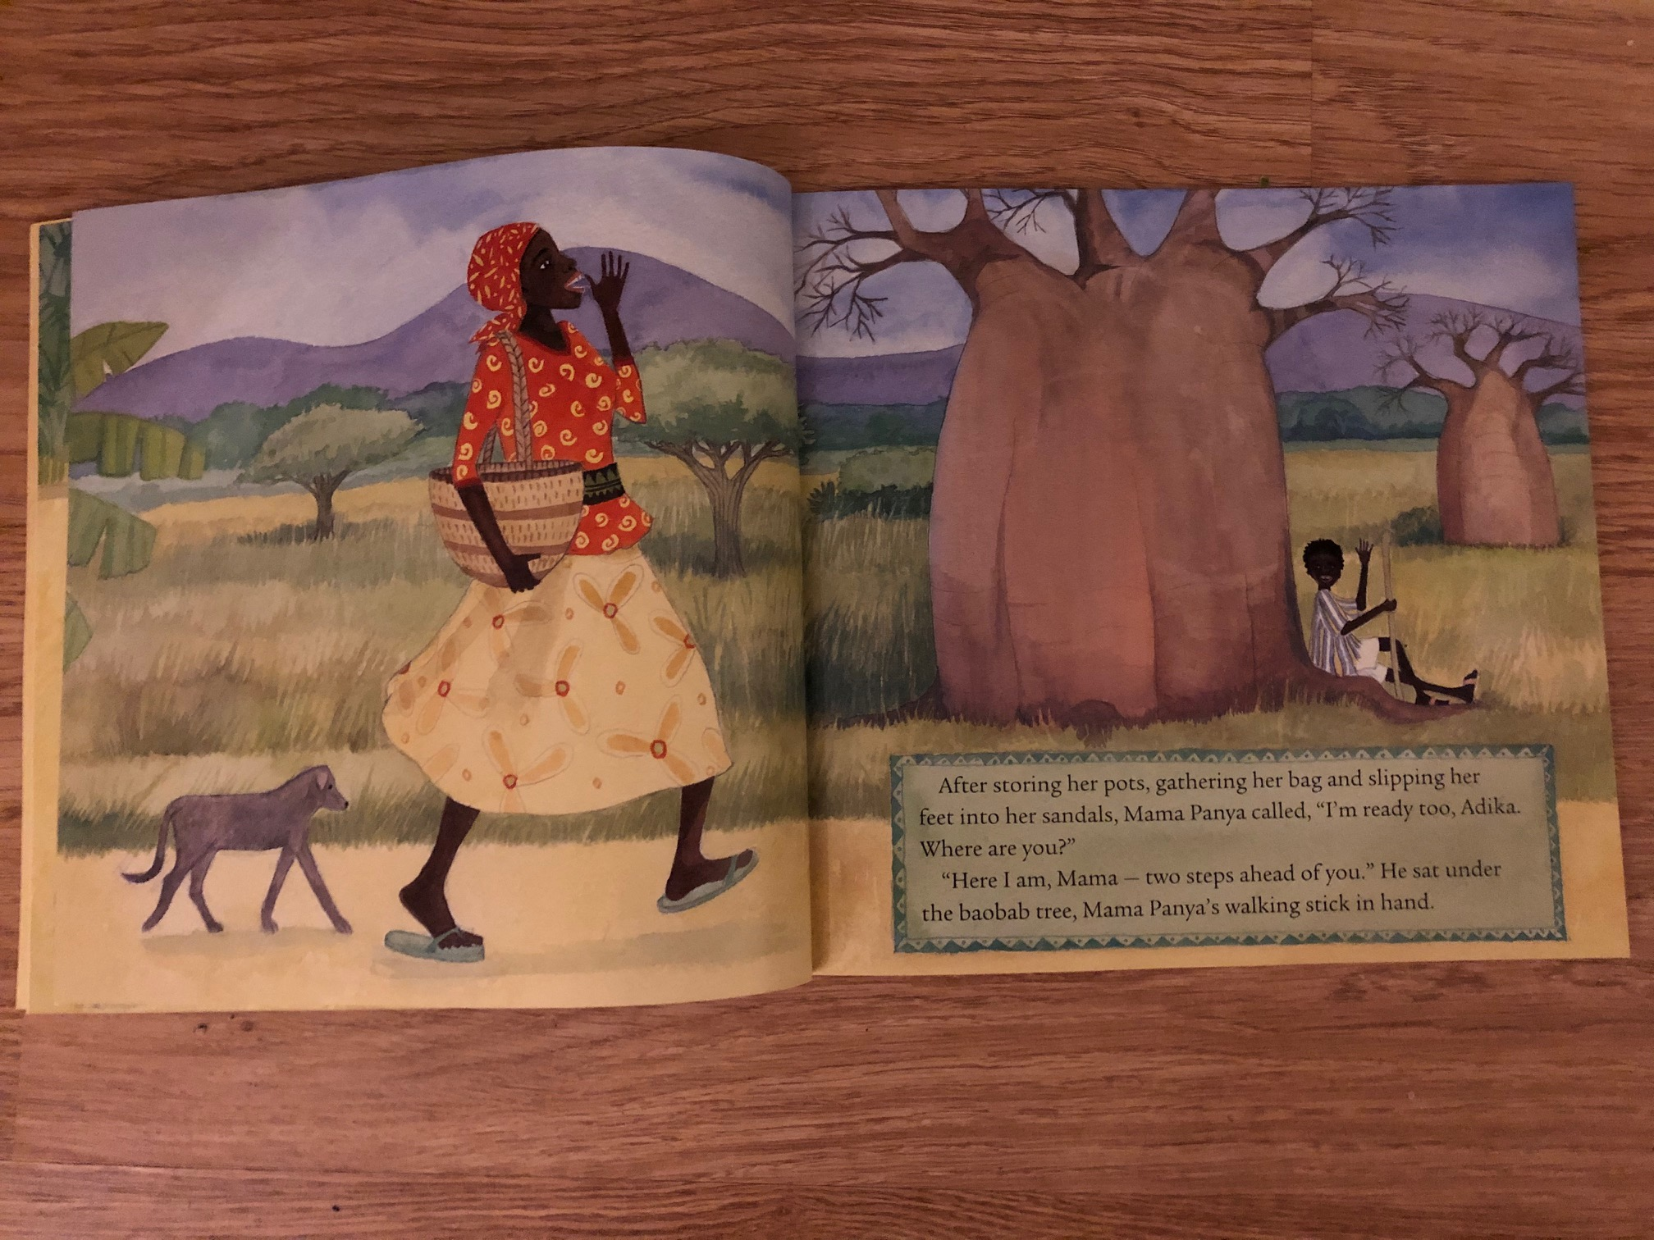

Using bullet points make a list of all the adjectives that you can think of to describe the setting Use your sound mats to sound out your chosen adjectives.
Reception: 4 adjectives
Year 1: 5 – 6 adjectives.
Year 2: 8 – 10+ adjectives.

Here’s a few to start you off:
- Sunny
- Hot
- Tranquil
Y2 challenge (and Y1 if you would like to have a go!): Choose one of your adjectives. Can you use a thesaurus to find synonyms of that word?

Task 4:

Today we will be writing a setting description for the story Mama Panya’s pancakes. Look back at your list of adjectives from yesterday.
Reception: Use your sound mat to write a sentence to describe the setting of the story. Say your sentence aloud before writing it and remember your finger spaces!

Year 1: Use your list of adjectives to write 2 – 3 sentences to describe the setting of the story. Make sure that you say your sentence aloud before trying to write it and use your sound mats to help you sound out words. Remember capital letters, finger spaces, full stops and try really hard to use your best handwriting.

Year 2: Use your list of adjectives to write a paragraph describing the setting of the story. Make sure that you say your sentence aloud before trying to write it and use your sound mats to help you sound out words (if needed). Remember capital letters, finger spaces, full stops, try to use pairs of adjectives, commas in a list and try really hard to use your best handwriting!

Example:

Adika’s village is a quiet and tranquil place full of tall, colourful trees and fruits. The roads are made of golden, soft and dusty sand. Baobab trees stand strong and tall alongside the yellow, dusty road. Adika’s village is hot and sunny. The sky is blue and bright but peaceful too. In the distance there are huge, purple mountains that reach up into the sparkling sky.

Task 5:

Today we will be using your setting descriptions. Read your setting descriptions aloud to an adult. You may need an adults support. Turn your page landscape and ensure you use the whole page. Using your setting description (not the picture from the book!) draw and colour a picture of Adika’s village.

When you have finished discuss your picture with an adult. How close to the picture in the book was your description? Did you need to add any extra descriptions?

