Geography

This week in Geography we will be focusing on Kenya, one of the countries that make up the continent Africa and the setting for our story Mama Panya’s pancakes.

Look at the map below can you locate the continent Africa on a map of the world?

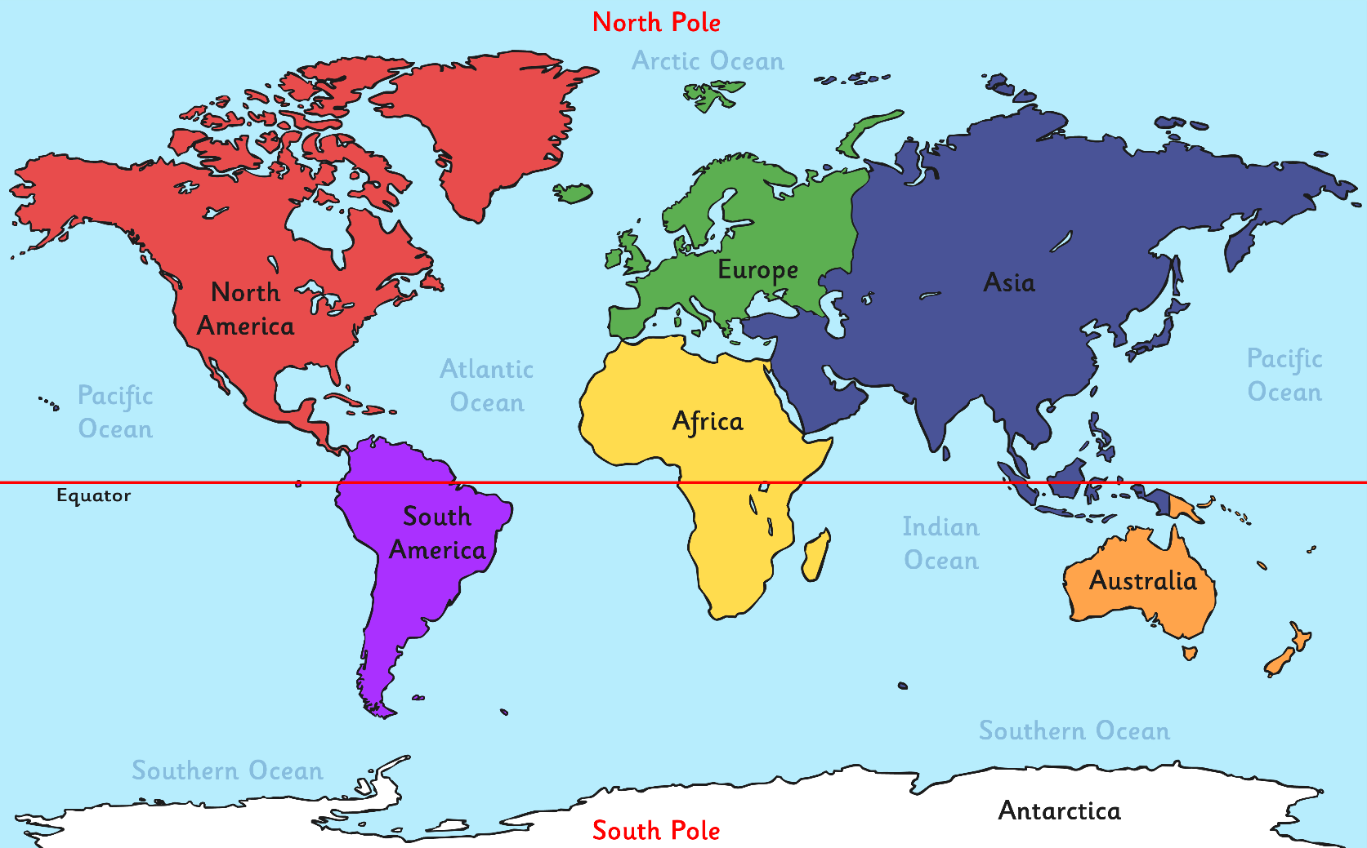

Below you will find a map of Africa, can you locate Kenya?

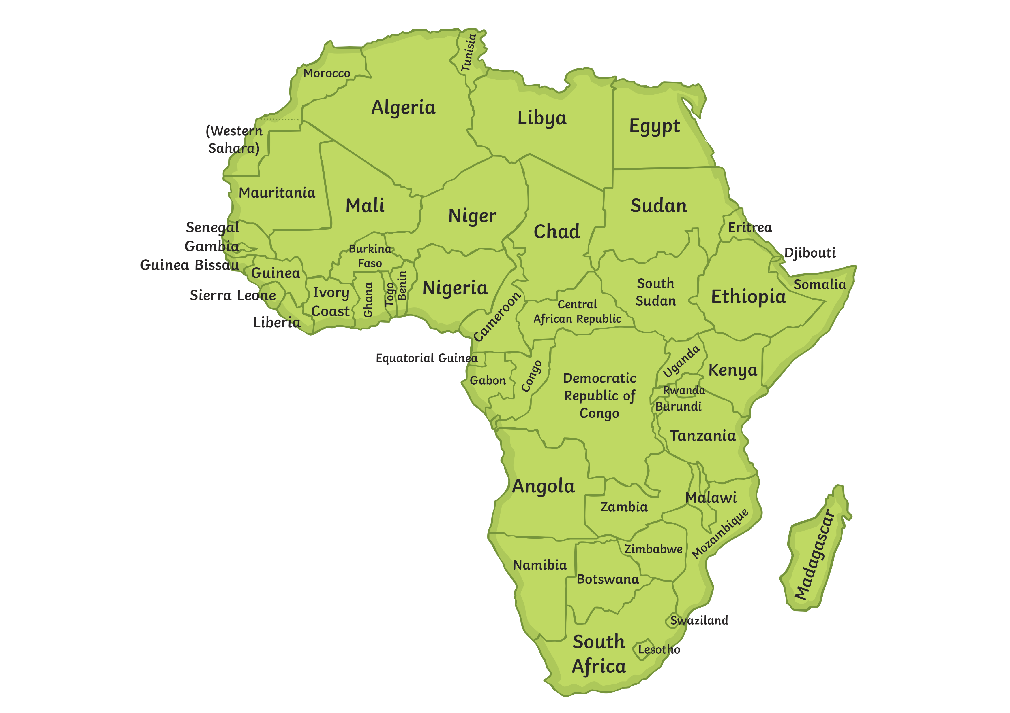

Kenya is located in East Africa. It is known as the Republic
of Kenya.
Kenya’s population is around
44 million! Kenya is one small country compared to the vast size of the continent, Africa.

Nairobi is the capital city and Mombasa is the largest city in Kenya.

Task:

Turn your book landscape, research the flag of Kenya and draw it into your book. Colour your flag carefully to match the colours of the flag.

