Music/ DT

This week we will be studying African music focusing upon rhythms played on Djembe drums. There are a couple of tasks that you can do over the week – spread them out or do them all at once whatever is best for you and your child.

Task 1:

Listen to this video on youtube: https://www.youtube.com/watch?v=q5U8md4rZS8 to find out about the Djembe drum.

In your book – design your own Djembe drum remembering the four parts; the top or skin, rings, rope or string, the base (normally made of wood). Label your design (using a ruler!) to show the parts and the materials you could find around your house to make your Djembe drum.

Example:
Hole punch holes to make rings.
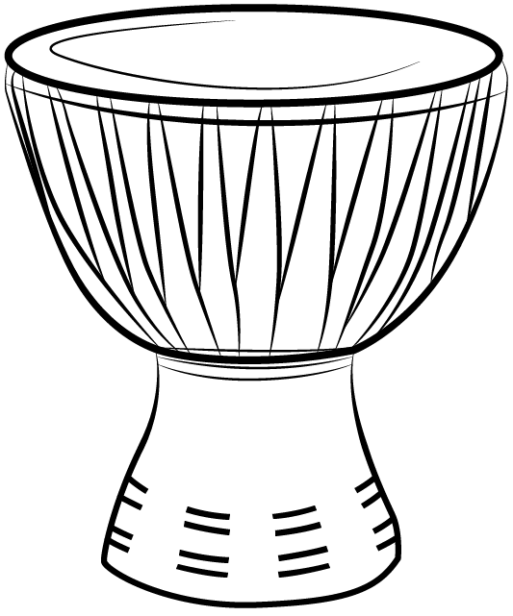
Decorate with a pattern and paint.
String
Plastic strawberry punnet
Stretched balloon for the skin.
Empty pringles can – cut the bottom off to allow sound to travel.

Task 2:

Using your design make your Djembe drum! Use materials you find around the house and stick to your original design as closely as you can! Make sure to take photos of you making your drum and your finished product.

Task 3:
Evaluate your drum. Have a go at playing your Djembe drum then evaluate your product by answering these questions in your book.

- What I found tricky about making my drum
- My Djembe drum sounded
- My Djembe drum looked like this
- My finished product was close to my original design yes or no.
- What I would do differently next time.
- Give your Djembe drum a score out of 5.

Task 4:

Learning the Fanga rhythm from west Africa. Watch the video
https://www.youtube.com/watch?v=nuQFbD43P4k
Use your Djembe drum to practice playing the Fanga rhythm. When you think you’ve practiced enough and your Djembe drumming is perfect ask an adult to video you playing the Fanga and send it to me at: lbarnett@polruanprimary.co.uk

If you haven’t been able to make a Djembe drum, use something from around your house. Perhaps a saucepan turned upside down?

