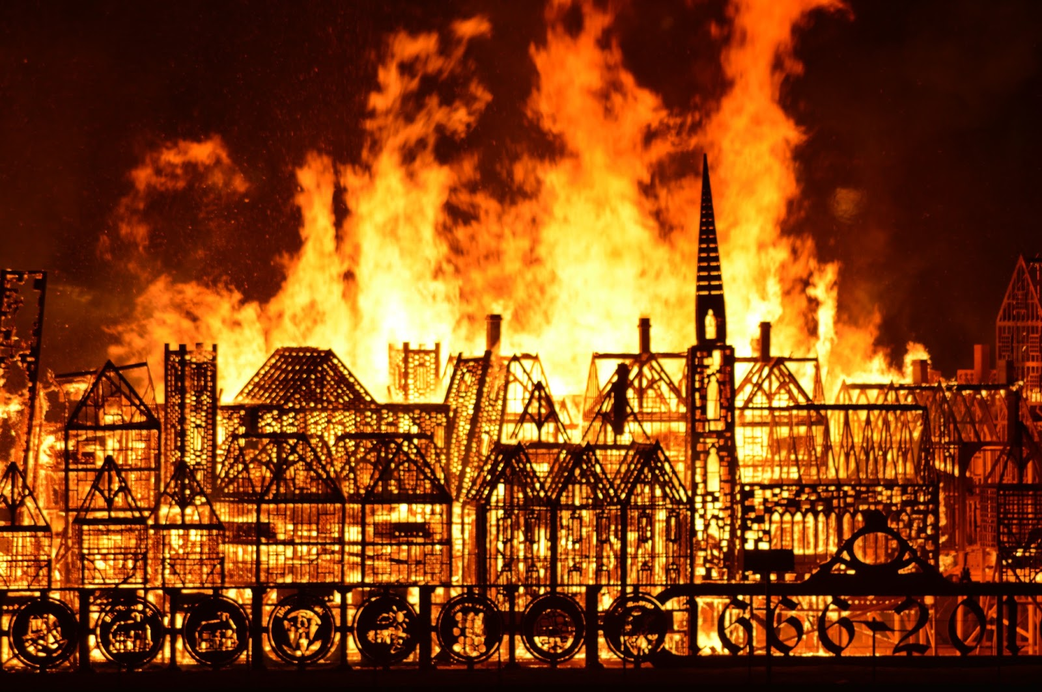
Term 5 Week3
The Great Fire of London
Tregeagle Class

English:

This week we are going to research a very important person during The Great Fire of London. He was called Samuel Pepys (pronounced ‘peeps’). Please research him using the power point, answer the research questions (make sure you check and use the correct year group questions) and then make a fact file about him (task one on the power point). Then complete task 2 and task 3.

How to do this:

- Use a single page in your books to write down the answers to the research questions below.
- Use the next single page in your book
- Draw a profile picture of Samuel Pepys in the middle of the page. Make sure you leave room for your fact boxes to go around him. Use subheadings, bullet points, labelled pictures etc.
- Write up your fact/information before you draw any boxes
- Colour in your picture and edge your fact boxes either using different colours so they stand out or draw your own patterned edges.
- Edit and improve your work. Check your sentences make sense, spellings are correct, and you have used capital letters, full stops and punctuation.
- Make sure you have dated each piece of work.

Research questions

Please use the correct year group set of questions.

Handwriting/Spellings

In your handwriting books, practice your handwriting and your spellings. Look at your spelling lists in the middle of your reading diary and copy three of them into your spelling book. Do two lines for each spelling (6 lines in total).

This is to be done every day for this week. Then next week you will pick three more.

