Geography

This week in Geography we will be continuing to focus on Kenya, one of the countries that make up the continent Africa and the setting for our story Mama Panya’s pancakes.

Task 1:

Watch this video clip carefully: https://www.bbc.co.uk/programmes/p0114nj6

Using what you have just learnt about Kenya, create a poster for the country. Try to include (using pictures and words)
What is unique about the country?
What is important to the country?
What are the landscapes like?
Include anything else that you have found interesting about Kenya.

Task 2:

Today we will be focusing on National parks and holidays! Discuss with an adult what you think a ‘National Park’ may be.

- Kenya has over 50 national parks and game reserves across the country.
- Within the parks and reserves are many different types of wildlife and habitats, such as wetlands, grasslands, forests, savannah and marine.
- A national park is a protected area of land where only tourism and research is allowed by humans. No humans live in national parks.
The Tsavo West and Tsavo East National Parks are the largest in Kenya.

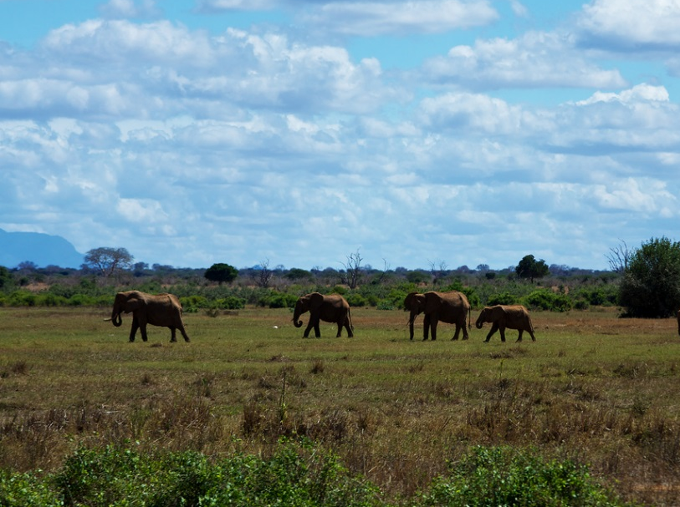

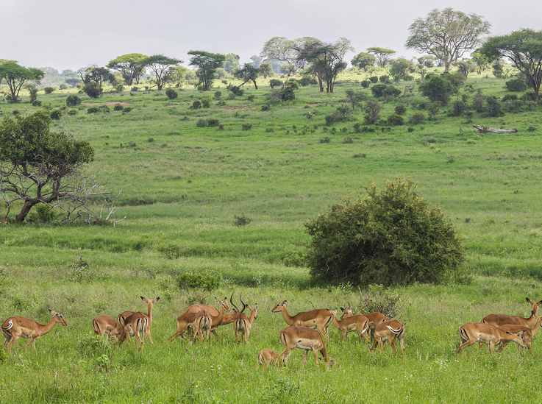

- The Maasai Mara National Reserve is famous world over for the large amount of wildlife including all members of the ‘Big Five’ which live there.
- The name ‘Mara’ means ‘spotted’, which is what the land looks like from a distance with trees, clouds and grass!
Watch this short video to learn more about Kenyan holidays and National parks.
https://www.bbc.co.uk/programmes/p0114ch0

Look closely at the map below.
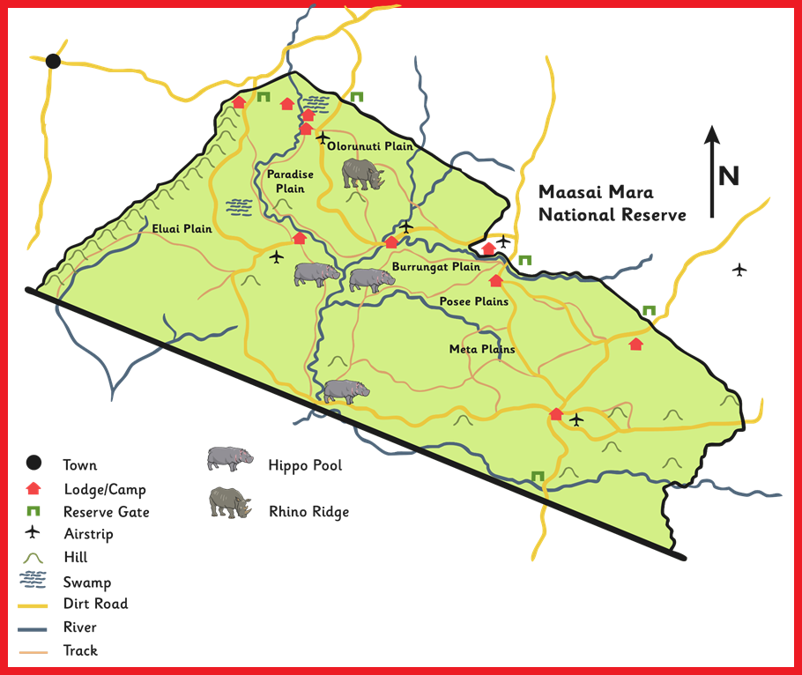

You are going to design your own National Park!
Turn your page landscape and make sure you include;
- Title
- Key
- Compass rose
- Map symbols
- Colour code
- Places to stay
- Physical features such as riveres or swmps, mountains
- Animal plains for the big 5; Lions, elephant, buffalo, rhino, leopard.
Task 3:
On your map can you plan a route to ensure that visitors to your National park visit each site. Write your directions using compass directions.

