Art

This week we are going to create African sunset silhouettes.
If you don’t have paints, create one using crayons or pencils. It’s all about colour mixing and enjoying being creative.

I have attached silhouette cut outs to the blog to use if drawing your own is a bit tricky!.

Example:

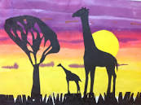
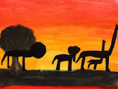

You will need:
- Thick A3 paper
- Yellow, red and orange paint
- Brushes and palettes for mixing
- Black card or sugar paper
- Scissors
- Glue
- Instructions:
- Using yellow and red paint, paint a thick, yellow stripe horizontally onto the bottom of the paper. You only need a small amount of red paint on your brush to mix into the yellow.
- Paint the next stripe of orange paint. Gradually add more red into the yellow and each time paint a horizontal stripe onto the paper until you have created a sunset!
- Leave to dry.
- You can either cut out one of the animal silhouettes provided or children could create their own animal silhouettes using black card or sugar paper. Animal stencils can be useful too or children could print out an animal picture from the Internet and draw around it.
- When the sunset is dry, attach the silhouettes with glue. Children could add mountains, trees, water or even people.

Please enjoy this activity it is designed to be an investigation into colour and lots of fun! I would love to see pictures of what you create!

