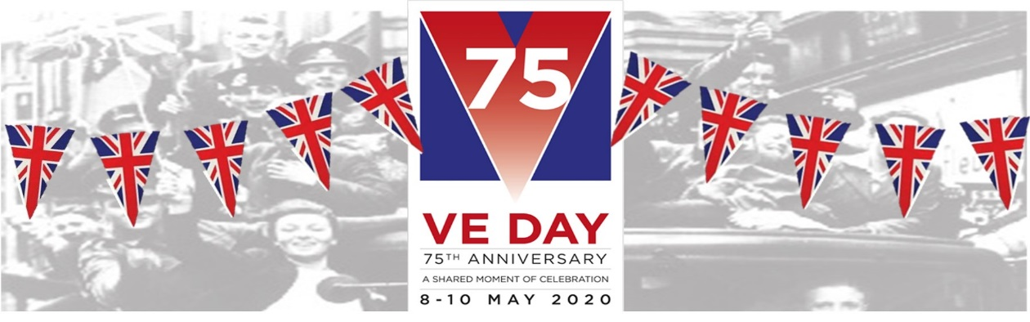
VE Day Celebrations Class 1 Home Learning Week beg 04/05/2020
VE Day was a very special day for our country 75 years ago on the 8th May 1945. That was the day that World War Two ended after five years, so everyone was very happy. Even the people who were not fighting in the war had been through a very difficult time. They were not allowed to go anywhere and there was not much food available. People had to grow their own food and do jobs which they would not usually have done.
This day became known as Victory in Europe Day – VE Day. To celebrate that the war had ended there were lots of street parties all over the country. People put tables out in the streets, made party food and decorated with bunting and flags to share their happiness with their families and friends.
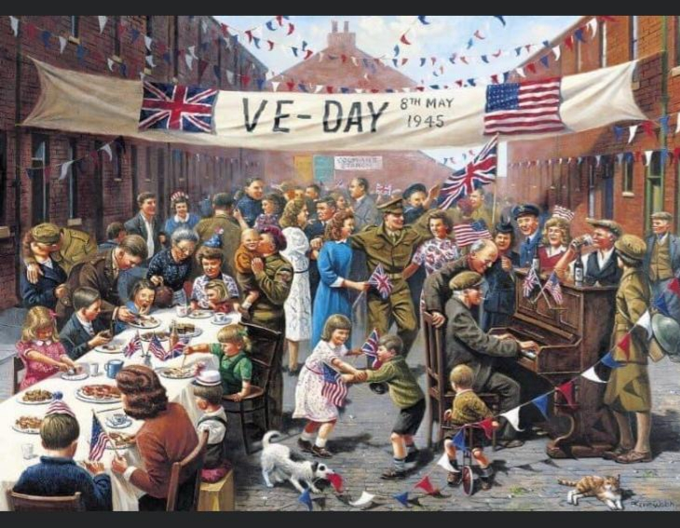
What do you notice about the picture? Can you tell that it is from 75 years ago? How? What are the people doing? What are they wearing? How do you think they feel?
To celebrate that the war ended 75 years ago, our country (the United Kingdom) will be holding celebrations all week. To help you celebrate with your families, see if you can complete any of these fun activities:

Ask a grown-up to research some facts about VE Day with you | You could use books or the internet (remember Smartie the Penguin’s safety rules).  https://www.bbc.co.uk/newsround/48201749  https://www.iwm.org.uk/history/10-photos-of-ve-day-celebrations
Make some bunting to decorate your celebrations  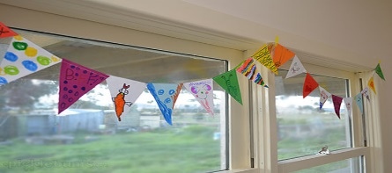 | Design your own or use the templates attached to the blog. What material will you use? How will you decorate them?
Make a Union Jack flag to wave | To help you, use the colour by number sheet attached. Did you know…The colours on the flag each represent something of the United Kingdom – white is for peace, red is for being brave and blue is for perseverance (like a keep-going kangaroo). Ask a grown-up to show you the countries of the UK on a map.
Plan a tea party menu to celebrate VE Day | Use your sound mats to write a menu for a VE Day tea party. You could decorate the menu too.
Make an invitation to ask someone to your celebration | Who will you invite? (remember safe distancing rules). Use your sound mats to create a VE day party invitation.
Hold a VE Day celebration tea party with your family  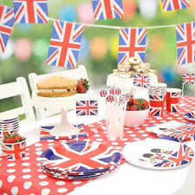 | You may cook some food from your menu, or just set up food which has been made for you. Hang your bunting, dress up and wave your flags and take a picture to send to Mrs Barnett.

