DT

This week we will be studying the Maasai tribe. In geography you will learn about the Maasai tribe culture. A necklace is a piece of jewelry that the women wear – the more bead women wear the richer they look!

Task 1:

Look closely at these pictures of Maasai necklaces. For these tasks you will need:
- Paper plates/card
- Scissors
- Bright coloured paints/felt tips/pencils/crayons
- Optional: Pasta, wool, beads, straws to decorate.
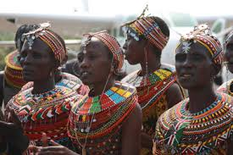
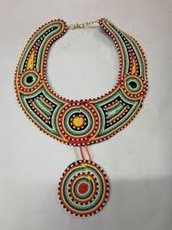

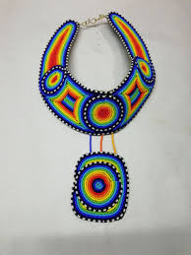

Design your own Maasai necklace, colour
and label. Can you include an African pattern
in your design? There are some below to help you
.

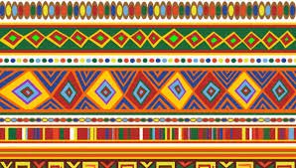
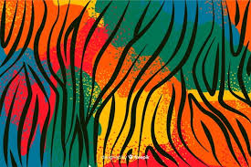

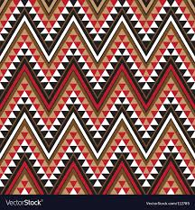
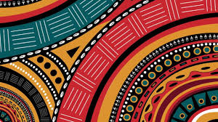

Task 2: Follow your design to make your Massai
Necklace. Use the suggested list above or
Whatever you can find in your house! Most importantly Have fun!!

Task 3: Evaluate your necklace. Have a go at wearing your Maasai necklace and show it off! Then evaluate your product by answering these questions in your book.

- What I found tricky about making my necklace
- My Djembe drum looked
- My Djembe drum looked like this (draw a picture)
- My finished product was close to my original design yes or no.
- What I would do differently next time.
- Give your necklace a score out of 5.

