Geography

This week in Geography we will be continuing to focus on Kenya, one of the countries that make up the continent Africa and the setting for our story Mama Panya’s pancakes.

Task:

Last week you learnt about ‘the big five’. This week we are going to learn about Maasai culture. With an adult read through the following information and discuss the pictures. Create an information poster describing what you have learnt about the Maasai tribe. Your poster should include:
- Where the tribe live/what it is like?
- Who makes their house/what are they like?
- What is important to them?
- What are the typical roles of people in the tribe?
- What are their clothes like?

The Maasai tribe.

The most popular reserve in Kenya is the Maasai Mara National Reserve, which can be found in the south west of the country. It is named in honour of the Maasai tribe who live in the area.
The Maasai Mara National reserve is famous world over for its large amount of wildlife, including all members of the ‘Big Five’.
The name ‘Mara’ means ‘spotted’, which is what the land looks like from a distance with trees, clouds and grass!
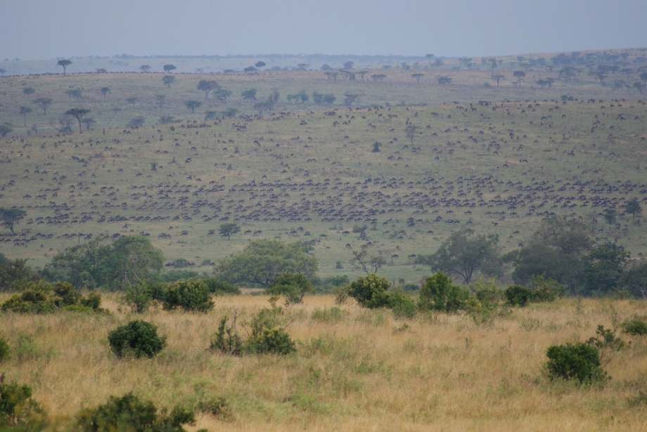
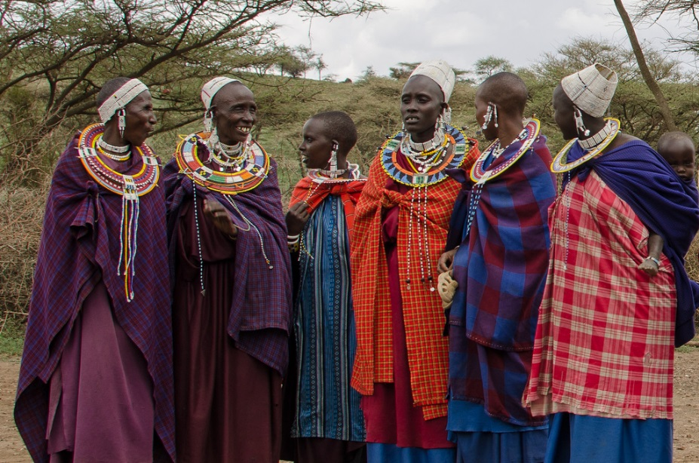

.

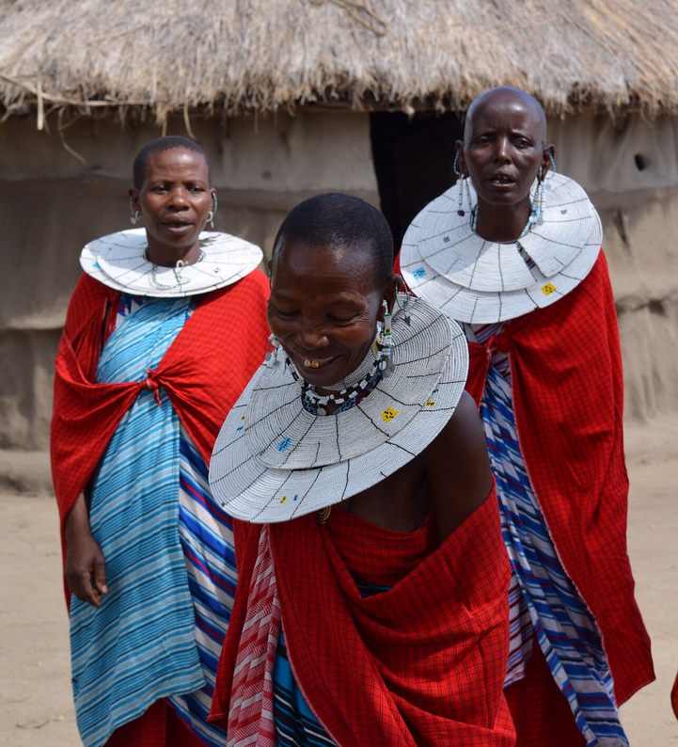
The Maasai tribe live in the African savannahs. The Maasai tribe share the same ideas and way of life. They use the land as their home and all live together.

The Maasai live in the Maasai Mara, which is a very large savannah and home to many of the great species of wildlife and plants.

The Maasai people live in mud huts made by the Maasai women.

They are made from mud, sticks, grass and cow dung.

The Maasai families live with their animals too. They are very careful to protect them from the big predators that roam the savannah.
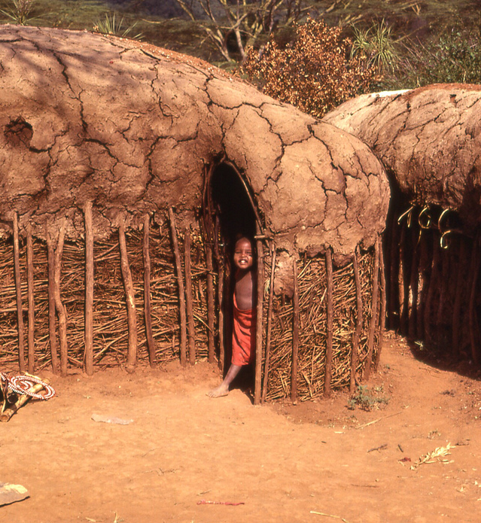

The Maasai people own large herds of cows, goats and sheep. Animals are very important to the Maasai people. They drink the blood and milk from the animals and use them for meat too.
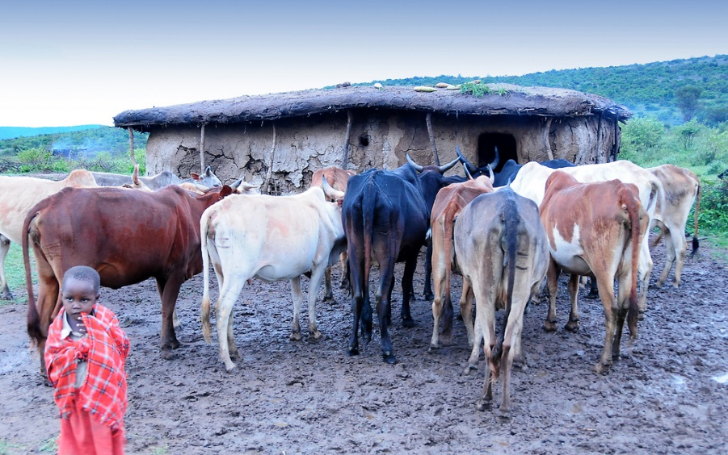
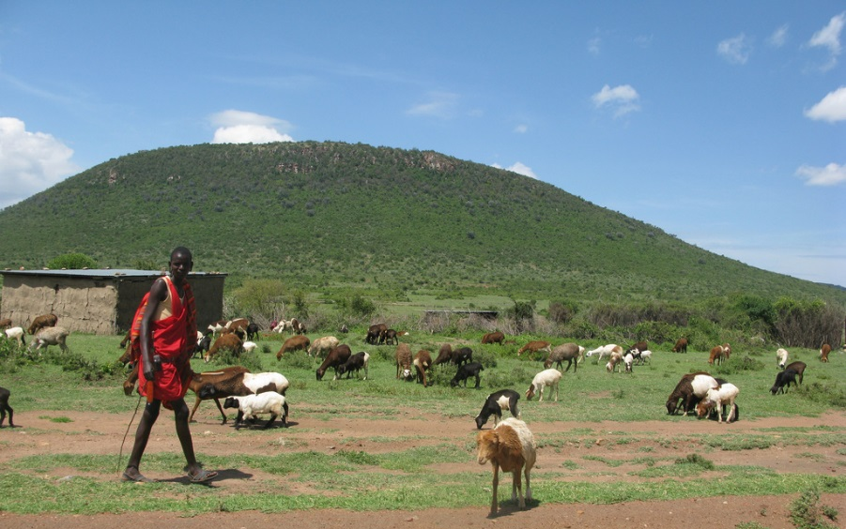

Maasai men are traditionally in charge of their tribe. They wear bright red clothes. Red is their favourite colour. The Massai men go out to hunt animals to provide food for their families.

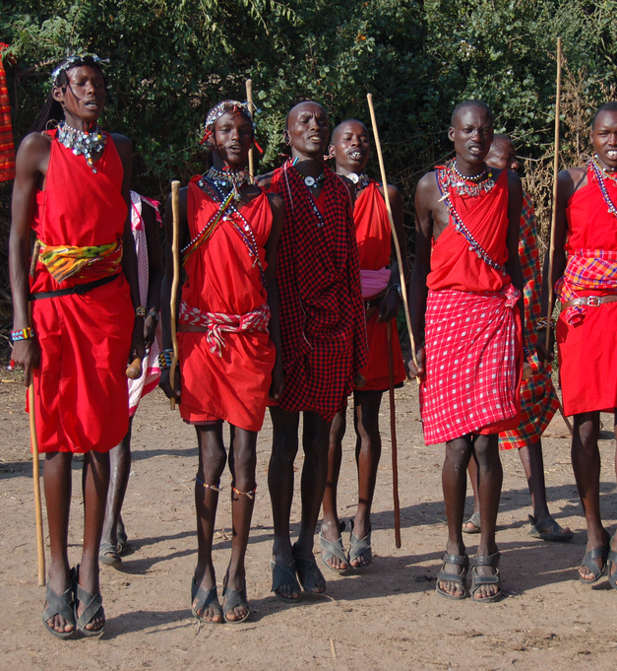

Maasai women traditionally look after the children in their families. They wear lots of jewellery, such as beads. The more beads that they wear, the richer they look.
