DT

Following on from your learning about the Maasai tribe culture week, this week we are going to design, make and evaluate our own Maasai hut. There are a couple of tasks that you can do over the week – spread them out or do them all at once whatever is best for you and your child.

Task 1:

In your book – design your own Maasai mud hut. Below are some pictures to help you.
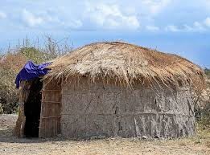
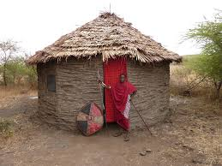

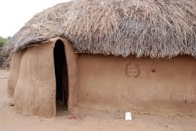
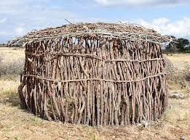

Label your design (using a ruler!) to show the parts and the materials you could find around your house to make your Maasai hut.

Example:
Natural materials, sticks, grass.

African pattern to decorate – paint.

Empty pringles can – cut an arch to make the door.

Pipe cleaners to make the arch.

Challenge: Can you include an African pattern on your design?

Task 2:

Using your design make your Maasai hut! Use materials you find around the house and stick to your original design as closely as you can! Make sure to take photos of you making your hut and your finished product.

Task 3:
Evaluate your hut by answering these questions in your book.

- What I found tricky about making my hut
- My hut looked like this (draw a picture or take a photograph)
- My finished product was close to my original design yes or no.
- What I would do differently next time.
- Give your Maasai hut a score out of 5.

