Geography

This week in Geography we will be continuing to focus on Kenya, one of the countries that make up the continent Africa and the setting for our story Mama Panya’s pancakes.

Task 1:

Last week you learnt about Maasai culture. This week we are going to make comparisons between Kenya and England.

Split your page into two columns. Label one Kenya and one England.
Look at the following pictures and decide if they are a picture of Kenya or England. Put each picture in the appropriate column (either cut and stick or draw).

Choose one picture of Kenya and one picture of England. Label the human and physical geographical features that you can see, use a different colour for each.

Human features – features which are man-made e.g. houses, church, roads, bridges, dams.

Physical features – features which are made from natural forces e.g rivers, oceans, mountains, valleys, rocks.

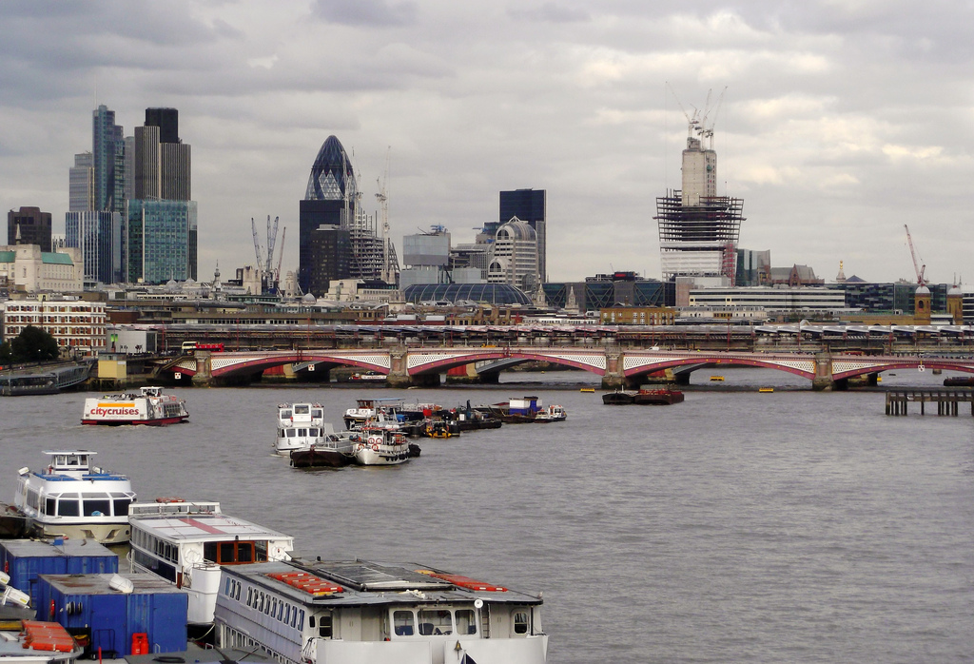
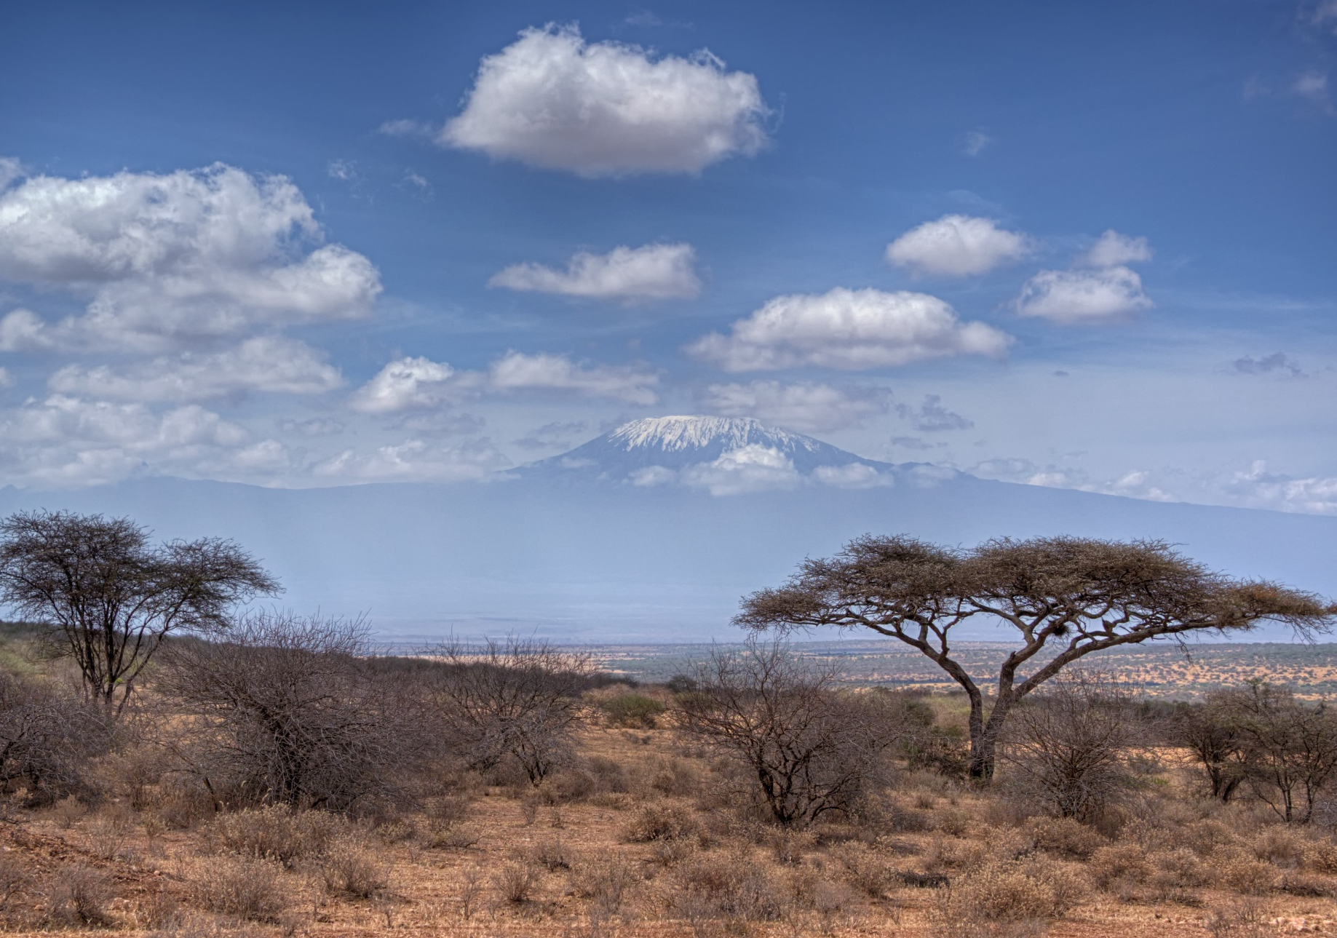

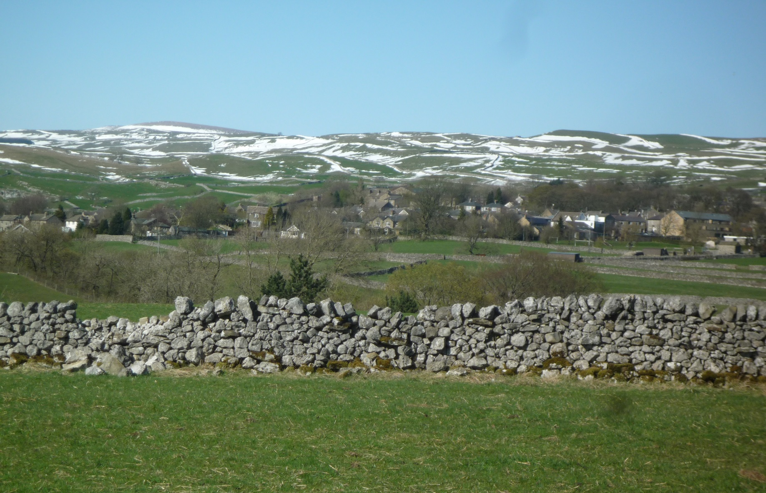
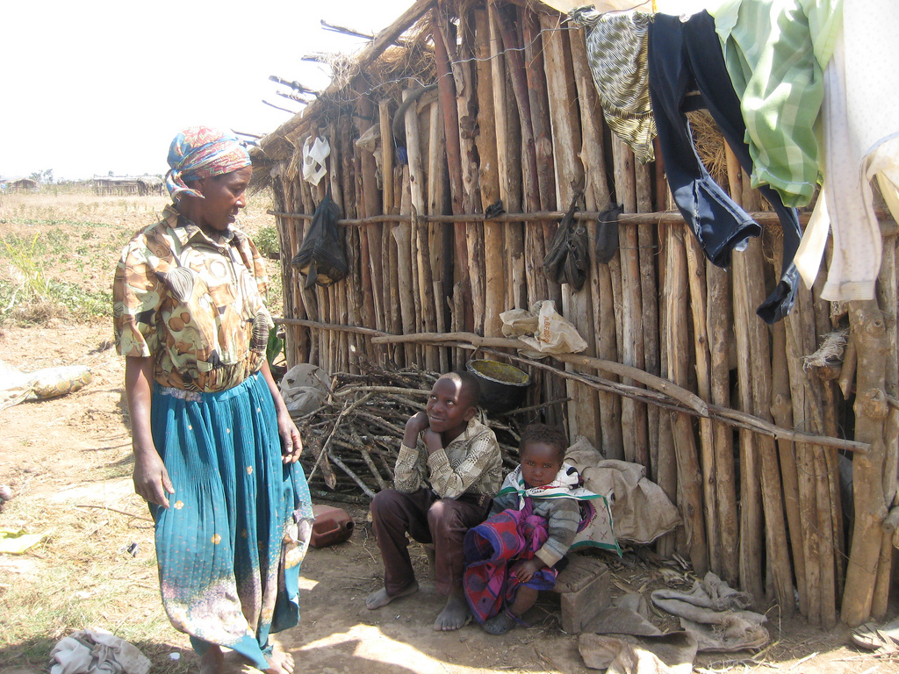

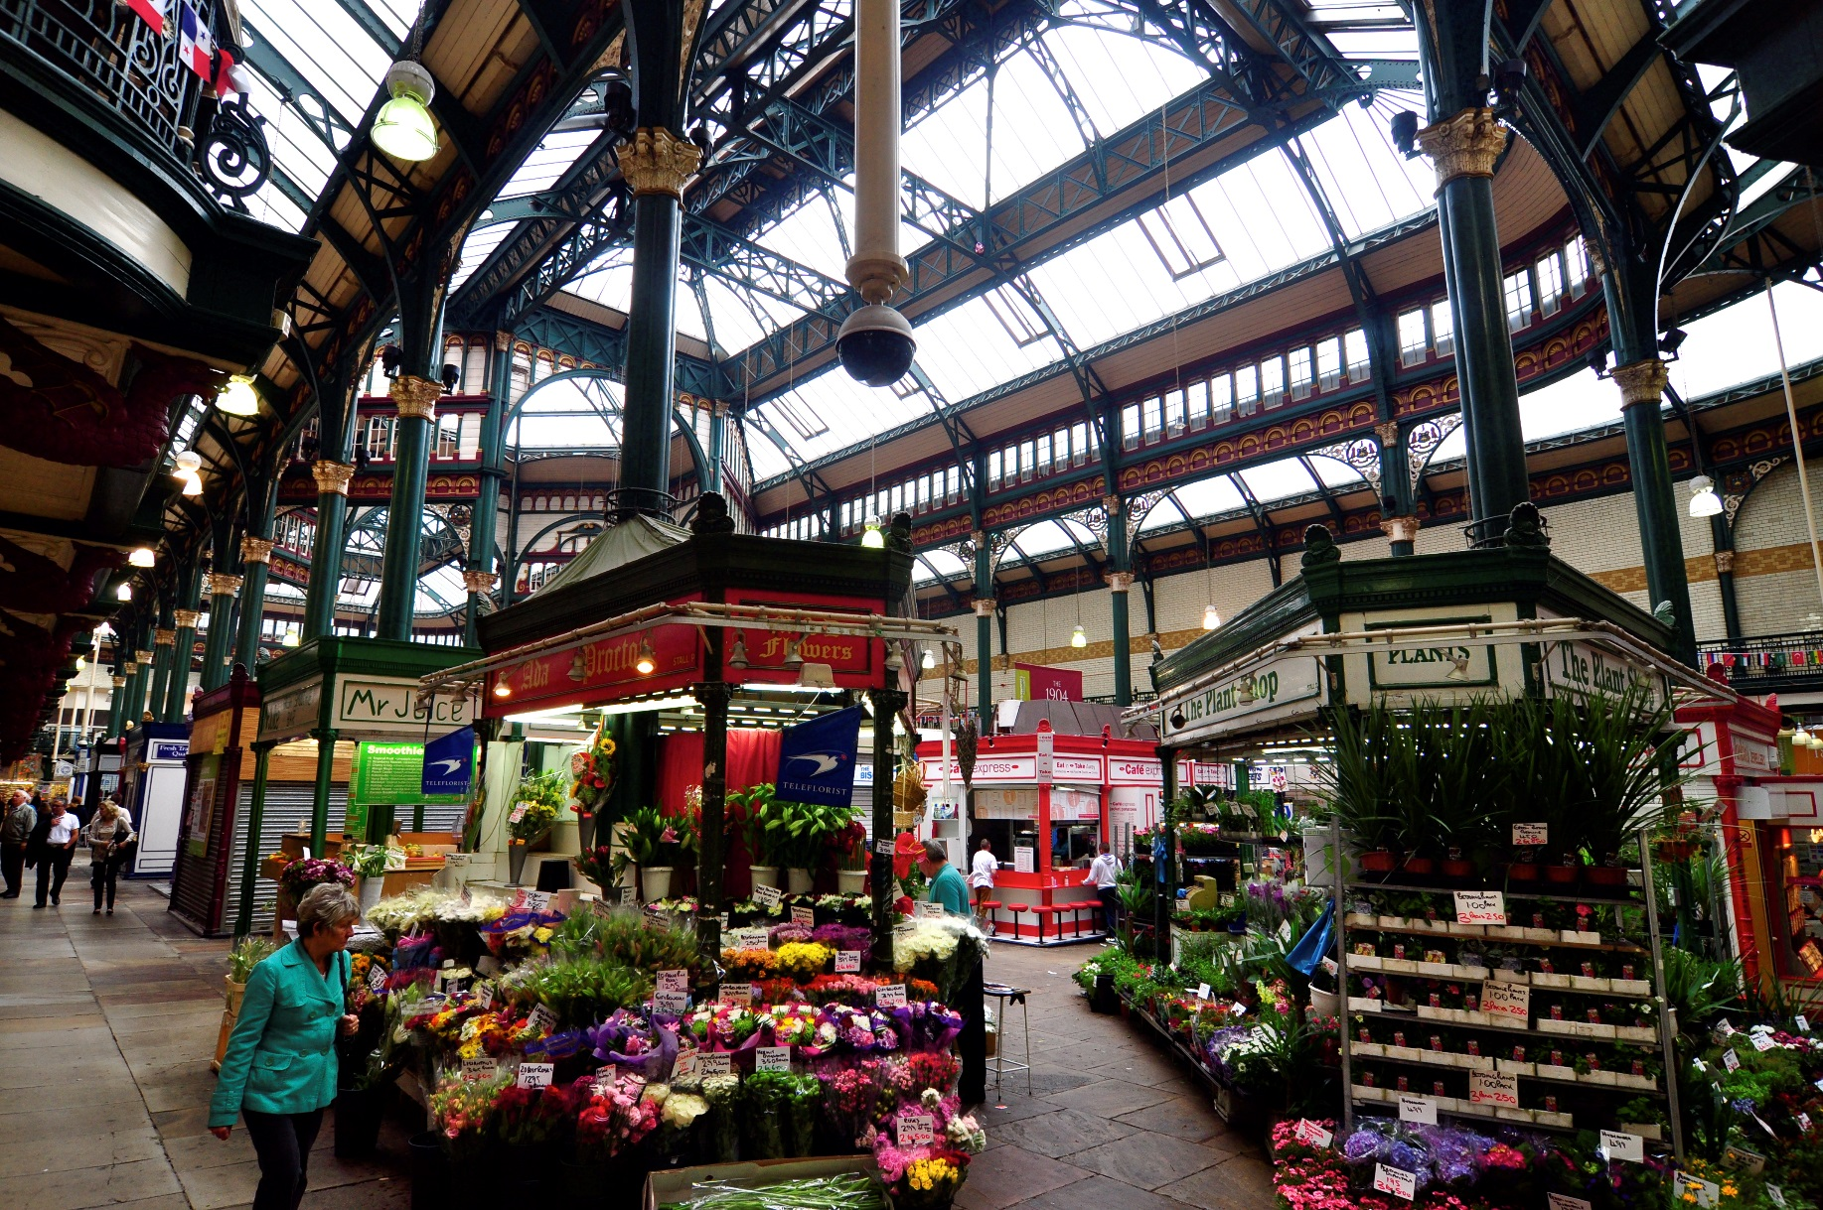
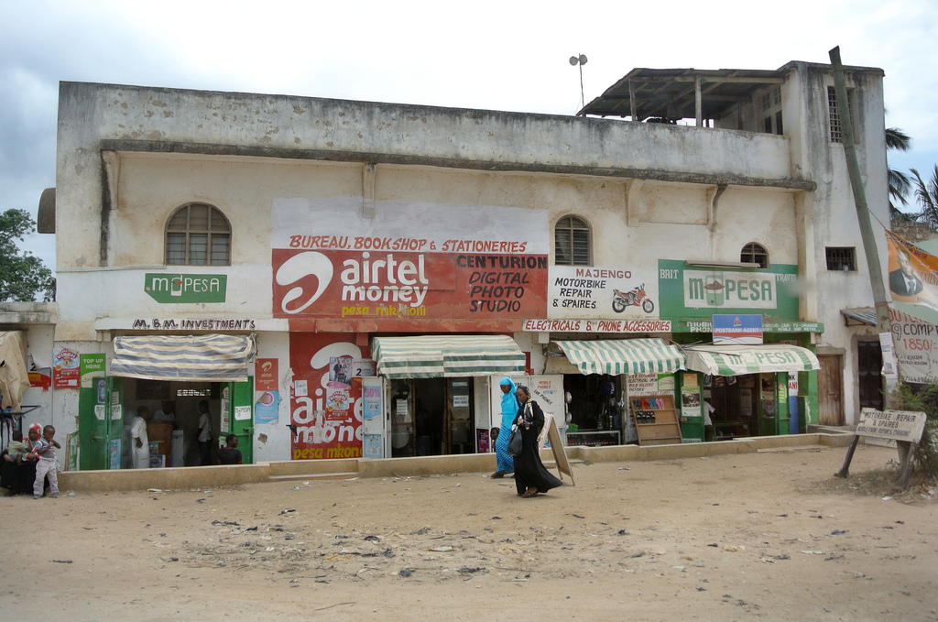

Task 2:

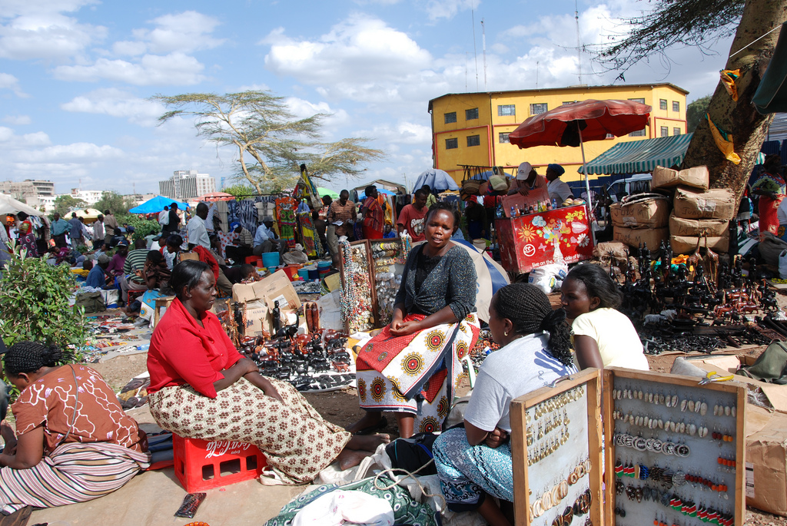

.

Task 2:

We are going to learn about what life is like for a child in Kenya.
We are going to watch a video about Evangeline, who is a young girl who lives in the countryside in rural Kenya, near Mount Kenya.

Follow the link below to watch the clip as you are watching, think about these questions:
- What is similar to my life in the UK?
- What might be different? Why?

https://www.bbc.co.uk/bitesize/clips/zgmn34j

Write a short diary entry as Evangeline, what does she do during a normal day.

Discuss with an adult how Evangeline’s day is different and similar to yours.

