DT

This week we will be studying the history of flight. There are a couple of tasks that you can do over the week – spread them out or do them all at once whatever is best for you and your child.

Task 1:

In history and English you will learn about the Wright brothers and Amelia Earhart.

In your book – design your own Airplane. Label your design (using a ruler!) to show the parts and the materials you could find around your house to make your airplane.

Example:
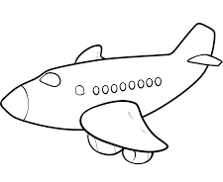
Kitchen paper tube for the body.
Egg carton section to make the tail

Empty plastic water bottle for the nose.
Lollypop sticks 4 taped together to make wings.

Decorate with windows – pens.

Task 2:

Using your design make your Airplane! Use materials you find around the house and stick to your original design as closely as you can! Make sure to take photos of you making your drum and your finished product and test it to see if it flies!

Challenge: Use a construction kit that you have at home (lego) to make an airplane. Which method is easier? Why?

Task 3:
Evaluate your airplane. Have a go at flying your airplane then evaluate your product by answering these questions in your book.

- What I found tricky about making my plane
- My airplane flew
- My airplane looked like this (draw a picture or take a photograph)
- My finished product was close to my original design yes or no.
- What I would do differently next time.
- Give your airplane a score out of 5.

