History

This week in History we will begin by looking at the history of flight.

People have experimented with different ways to fly for many years.
Most were not successful!

Follow this link to watch some of man’s early attempts at flying https://www.youtube.com/watch?v=gN-ZktmjIfE

The hot air balloon was invented by Montgolfier brothers in 1783. It has become the oldest invention that can successfully take people into flight.
The illustration below shows the first manned hot air balloon flight in Paris, 1783.

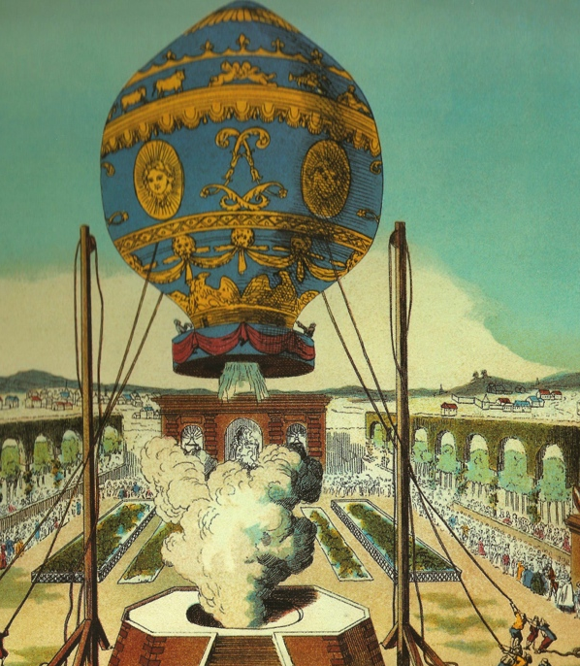

Orville and Wilbur Wright were two brothers, born in America. Their interest in flight began when their father bought them a toy ‘helicopter’. They made and sold bicycles but then began to experiment with creating their own flying machine! Their first aeroplane, the Wright Flyer, successfully flew in front of 5 people in 1903.

Task 1:

Look carefully at the images below. Can you spot any similarities or differences between the Wright Flyer and a modern aeroplane?
Record these similarities and differences in two lists.

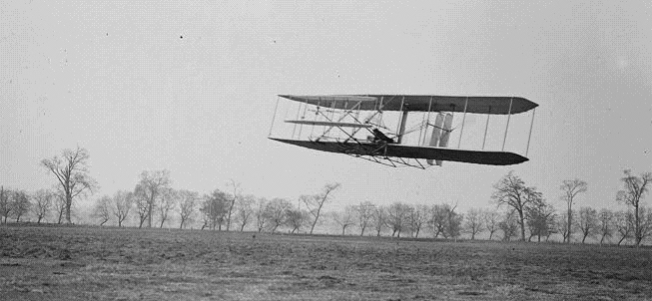

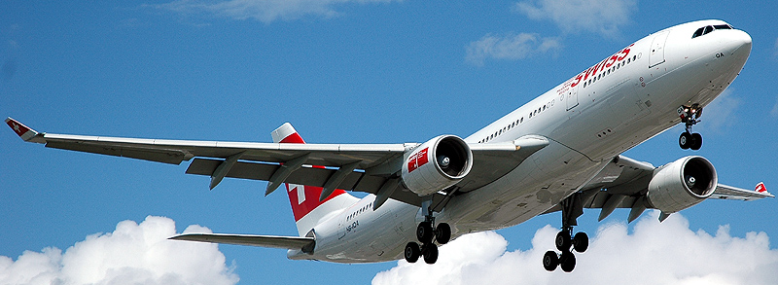

Task 2:

In our previous task we looked at similarities and differences between the Wright flyer and a modern aeroplane. Today we will be creating a timeline for the history of flight.
Follow this link to watch a short video about the Wright brothers and the history of flight: https://www.youtube.com/watch?v=fZyZxDWjkZ0

Turn your book landscape and write your titile ‘A history of flight’ (remember to underline it!). Draw a timeline across your page and split it into four sections.

This timeline will cover 400 years.

Once you have finished it should look something like this:

1700
1800
1900
2000

Take a guess at where the following events occurred using what you have learnt so far to guide you and add them onto your timeline.

- First flight of a hot air balloon
- First airliner flight carrying passengers
- First flight of an aeroplane
- First flight into space
- First flight of an helicopter

Once you have had a guess and added these events to your timeline research them to find out the dates that they occurred. Add the dates onto your timeline. Did you get the events in the correct order?

Task 3:
In our two previous lessons we have looked at the history of flight and the Wright brothers – significant inventors and explorers! In todays lesson we will be thinking about what makes a person ‘significant’.

- Have a look at the pictures below
- Do you recognise any of these people?
- Are there any you do not recognise?
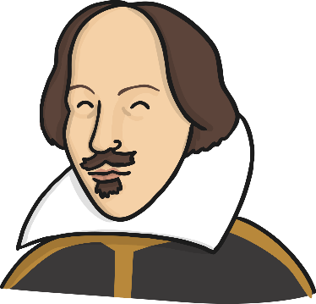
- What makes these people important?

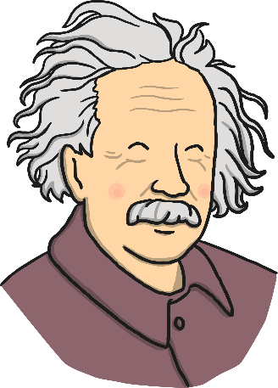

Talk with a partner about who is important in your life
this could be anybody! What makes these people important to you?

Here is a list of reasons why people might become important. Which do explorers fit into? There could be more than one!
Reasons for being significant. If s/he:
- Changed events at the time they lived.
- Improved lots of people’s lives or made them worse.
- Changed people’s ideas.
- Had a long lasting impact on their country or the world.
- Had been a really good or very bad example to other people on how to live or behave.

Your task is to look at the pictures of significant people below and sort them into groups. How could we sort these significant people into different groups? Why are they important? You could use the reasons above to sort them or use your own reasons.

Usain Bolt

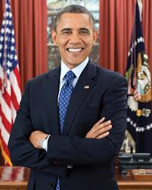
Barack Obama
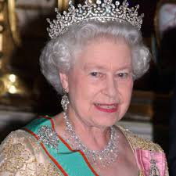 Queen Elizabeth II

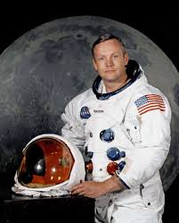 Neil Armstrong

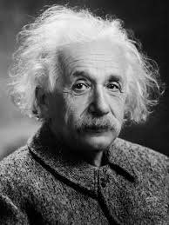

Albert Einstein

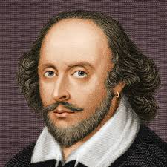

William Shakespeare
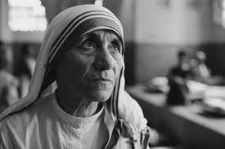

Mother Teresa
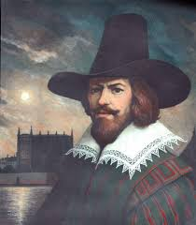

Guy Fawkes

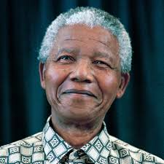

Nelson Mandela
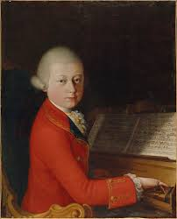

Wolfgang Amadeus Mozart

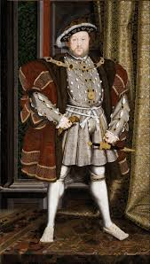

Henry VIII

David Beckham

You could cut these pictures out, sort them into groups and stick them into your book or draw the people yourself. Don’t’ forget to label your groups!

Are there any significant people you know of that you would like to add?

