World Ocean Day - Surprising Sharks by Nicola Davies Home Learning Week beg 01/06/2020
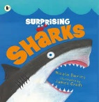  First, watch the video of the book being read: https://www.youtube.com/watch?v=JwkKDzdGXOo | Design your own shark: There are some sharks in this book which remind us of tools. Can you design your own new type of shark to add to a monster’s toolkit? Which tool will you base it on? What colour will it be? Where will it live? What special powers might it have? What makes it the same/different from other sharks?
Acrostic poem: After reading this book, make a list of words which you think describe sharks. Then choose the most exciting words to write an acrostic poem which spells out the word. Here is an example:  Secretly stalking their prey  Hammerhead sharks look like a tool from a monster’s toolkit  All shapes and sizes  Rough skin  Killing and hunting  Surprising creatures | Understanding the world: Watch the World Ocean Day video about the water cycle, ‘The Story of a Little Drop’: https://www.youtube.com/watch?v=U3OnMZt7RpM Our water comes from the clouds in the sky, as part of the water cycle, so  go outside and lie flat on your back, to look at the clouds. What shapes can you see? Which direction are they heading in? How do they make you feel? Use complete sentences to describe your observations to a grown up. You could draw a picture to show what you can see or how you feel when you watch the clouds.
Labelling activity: Look at the diagrams of the inside and outside of a shark in the book. Then draw your own two diagrams, write a title and then label to show the different parts of the inside and outside of a shark. Talk to a grown up about what you have learned about each part and sound out to write sentences which give information. You may want to draw your own shark or use the labelling sheet attached to the blog. | Art activities: Make a paper plate shark or a peg shark. Can you use a paper plate and a peg to make sharks like this:  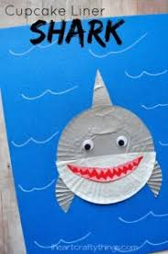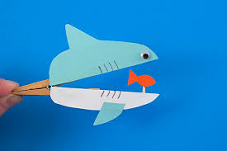
Shark Counting: Count how many different sharks are mentioned during this information book. You could ask a grown up to show you how to keep a keep a tally and add them up at the end. I wonder how many you will discover! Send me your answers and I will let you know how many I have found next week.  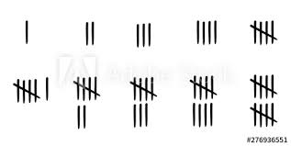 | Shark Sharing: Your number of the week is 16 – use the attached sheets and 16 shells (or other objects) to see how many ways you can share 16. What is half of 16? How many other ways can you share between yourself and one other person? If you have 10 shells how many will the other person have? Challenge: write your findings as number sentences.
 | Shark quiz: complete the attached quiz – ask a grown up to read the questions and see if you can use your newly learned facts from the book to answer them. You are now a shark expert!

