ART

Our great explorer this week is Ibn Butatta from Morocco, Africa. Africa is well known for its individual art.
For hundreds of years, African art has been strongly influenced by the environment and natural surroundings.
The vast richness and variety in the environment are ideal for encouraging creativity.
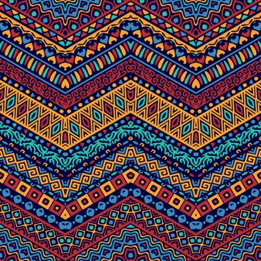

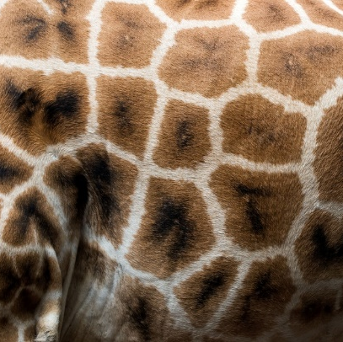

African mats, rugs and baskets, like those made in countries such as Rwanda and Burundi by the Tutsis, are made by hand using weaving and sewing techniques.

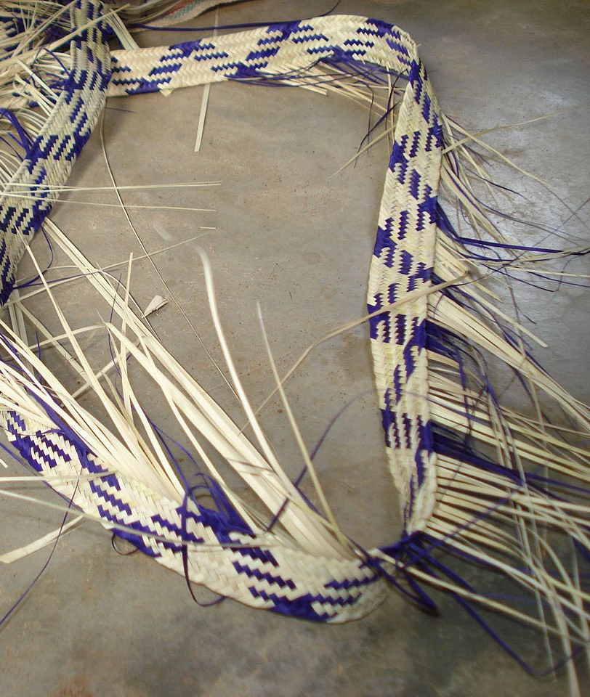
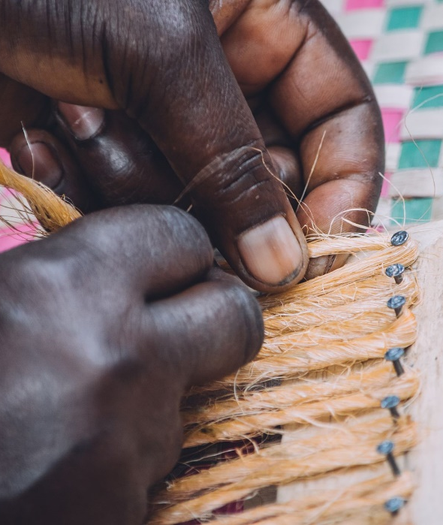
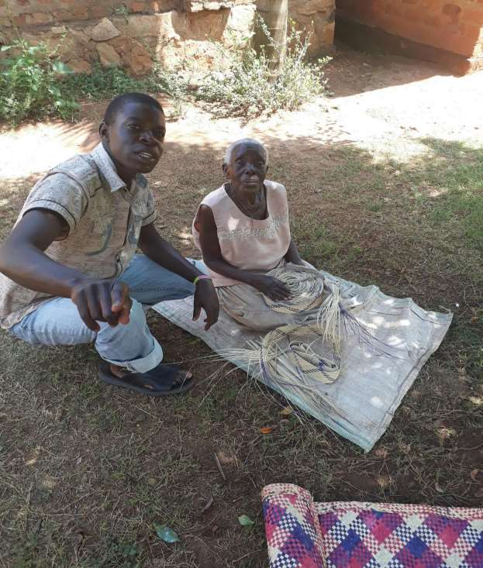

Patterns used in African art fall into two groups:
- Geometric – patterns that use zigzags, chequerboard, curved lines, spirals and circles.
- Symbolic – patterns that use images which have some symbolic meaning for the artist and the person using the art, whether it be on a piece of clothing or a building. These images can include crescents, stars, flowers, seeds, trees and pods.
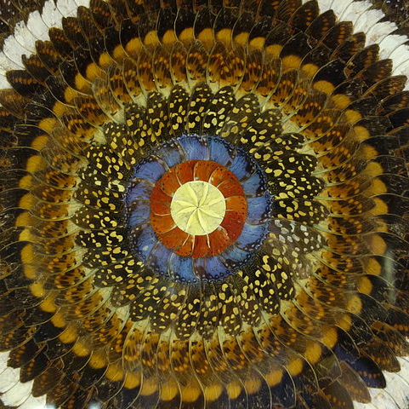

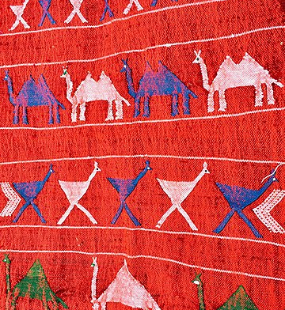

It’s easy to see where the inspiration for art comes from in Africa.

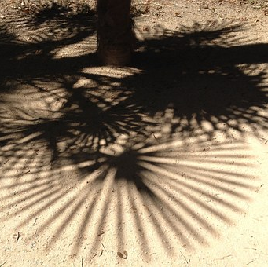
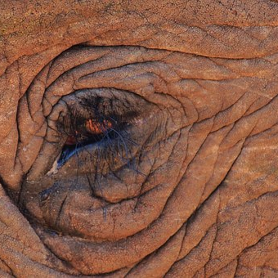
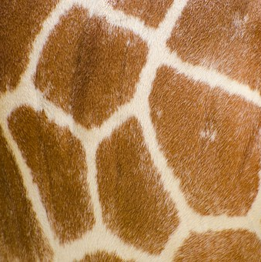

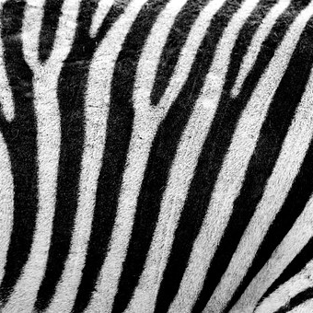
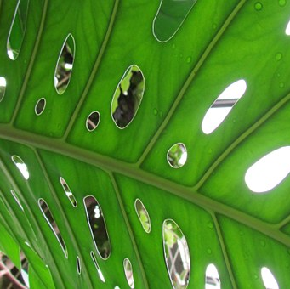
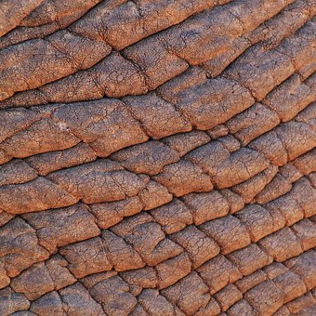

Repeating, colourful patterns are everywhere from baskets and rugs to jewellery and clothing.

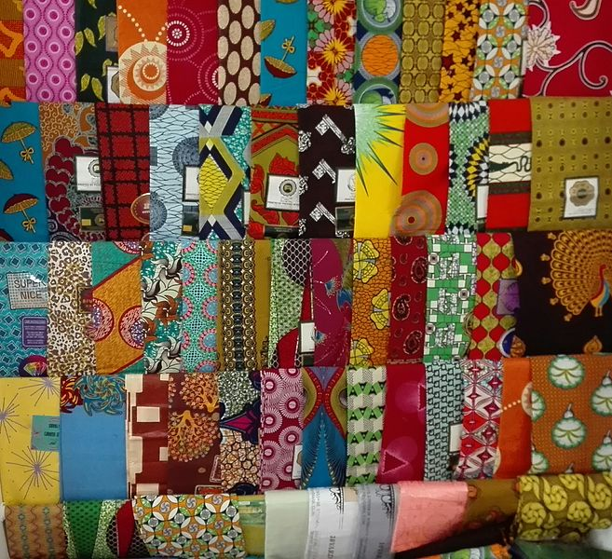
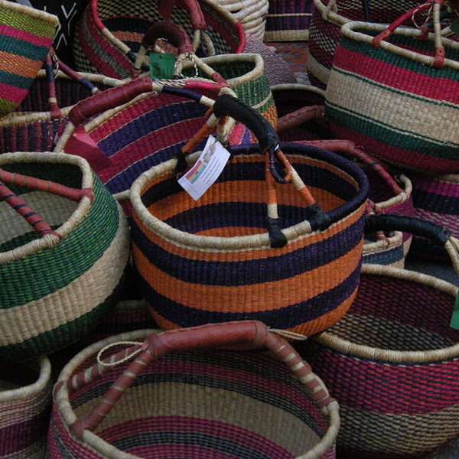

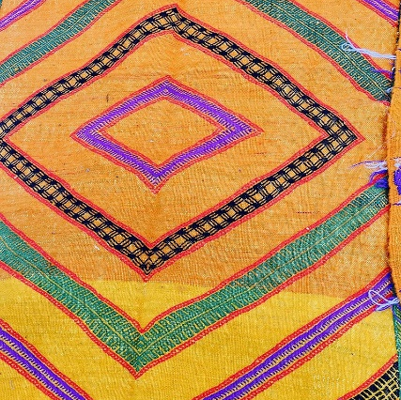

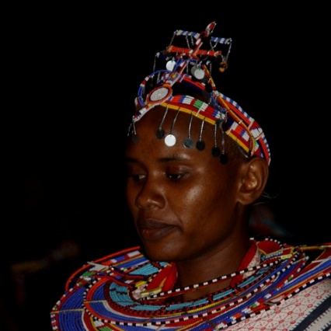
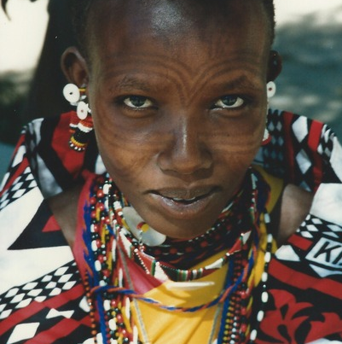

Task:
See if you can get inspired by your surroundings to create a pattern using bold colours.

Go outside and see what patterns you can see and how they can be used in a piece of artwork.

Take a photograph of your pattern and send it to me.

Remember the patterns need to be repeating! You need to use the same shapes and colours and repeat them three to four times.

If you find it a bit tricky to draw/create your own repeating pattern I have attached some blank repeating patterns to the blog to help you. There are also some examples of repeating patterns and safari patterns to give you some ideas. These are in colour so you can see how to repeat the colours and shapes. Have fun!

