Geography

This week our great explorer is Ibn Bututta who was born in 1304 in Morocco.

Task: Create a fact file on Morocco.

Below is some information and pictures of Morocco for you to read (with adult support if needed) and use. You can include whatever information you would like to about the country. Attached to the blog is a blank fact file that you could use to layout your ideas or you could create one of your own.

Don’t forget your fact files should have:
- A title
- Subheadings
- Paragraphs (year 2)
- A picture and caption

Morocco is a country in the north-west of Africa. Its official name is the Kingdom of Morocco.
The Mediterranean Sea is located to the north of Morocco and the Atlantic Ocean is located to the west.
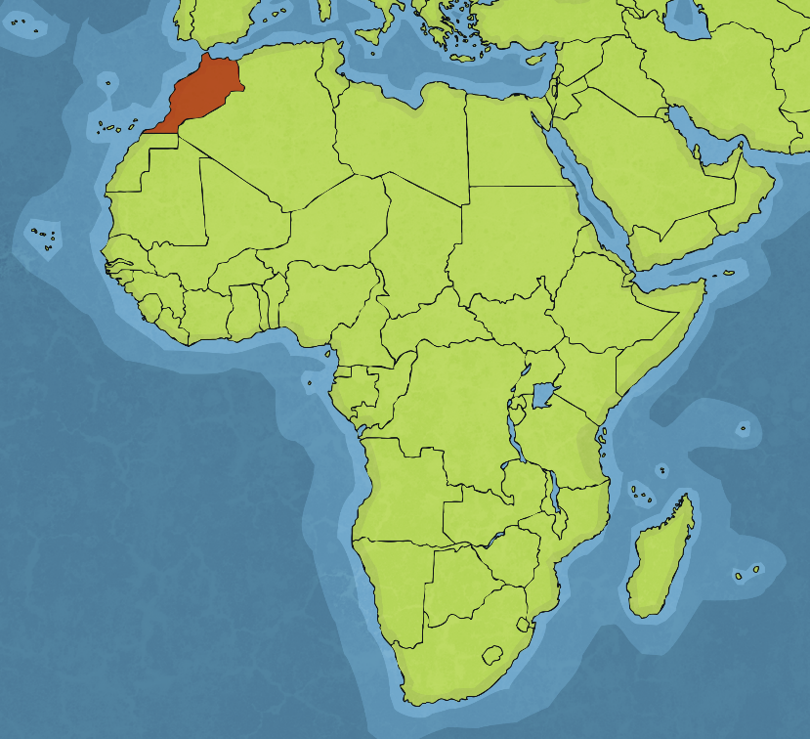
Atlantic
Ocean
Mediterranean Sea

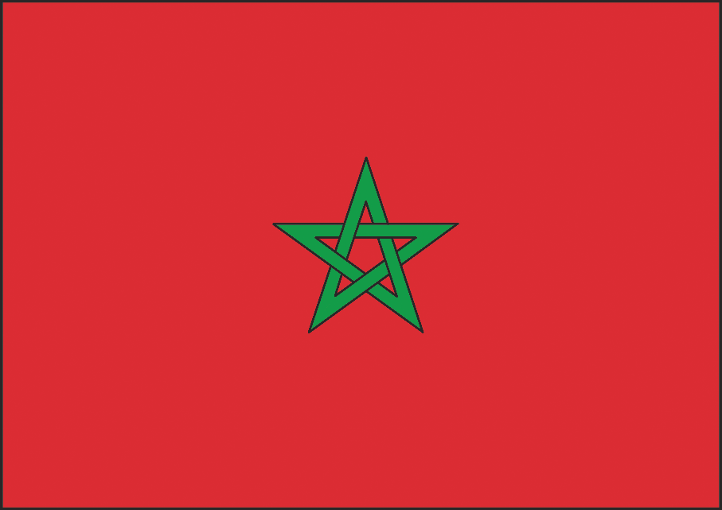
The Moroccan flag has a green, five-pointed star (a pentagram) on a red background. The red background represents bravery, strength and valour. The star has five points which represent love, joy, wisdom, peace and hope.

The landscape of Morocco is very varied.
It is largely mountainous and home to the Atlas Mountains, which stretch 2 500km across the north of Morocco, through Algeria and into Tunisia. Toubkal Mountain, which is part of the Atlas Mountains, is the largest peak in North Africa at 4167 metres tall.

In contrast, the south-east of Morocco is part of the Sahara desert, the largest desert in the world.
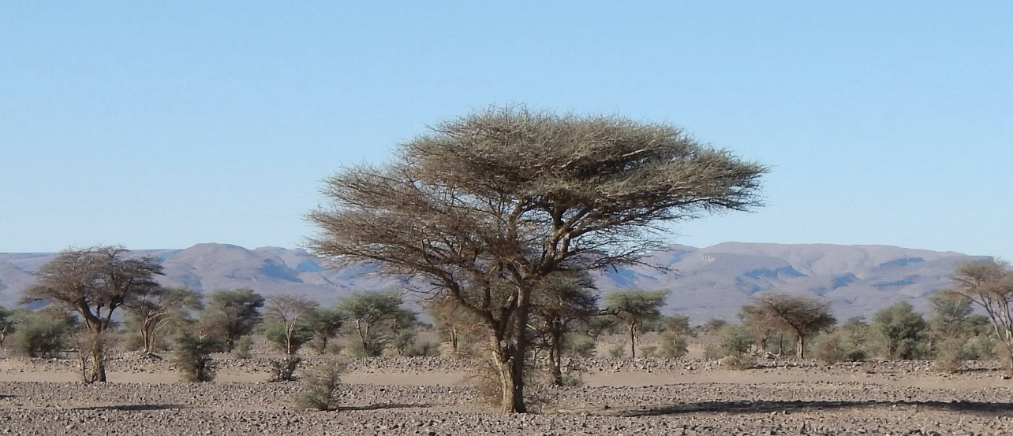

Population: 35.7 million
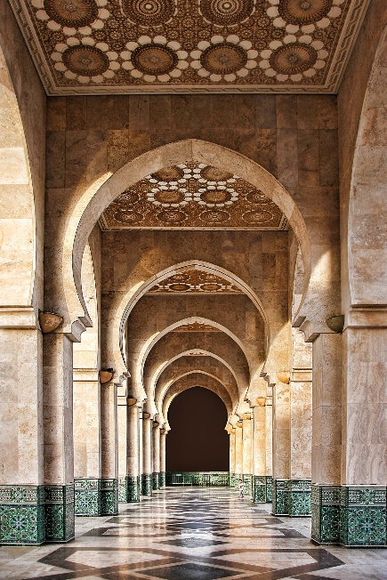
Major Cities: Rabat (Capital), Casablanca, Marrakech, Fez, Meknes, Tangier
Official Languages: Arabic, Berber, French, Spanish
Major Religion: Islam
Currency: Moroccan Dirham (MAD)

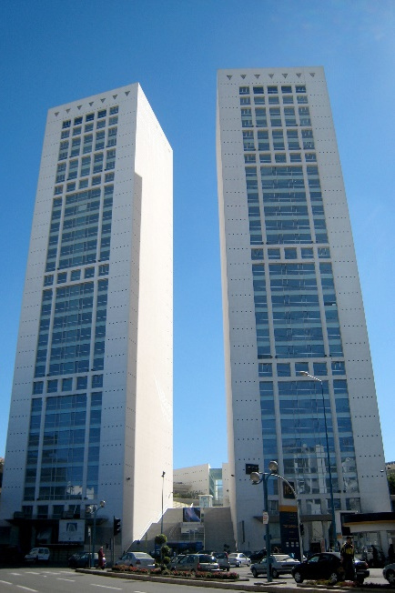
Moroccan architecture has been influenced by many sources over thousands of years. Influences from Arab culture, Spain, Portugal and France, as well as religious influences, have resulted in a mixture of styles.

Sleek, modern designs are becoming more common in the larger cities, such as Rabat and Casablanca.

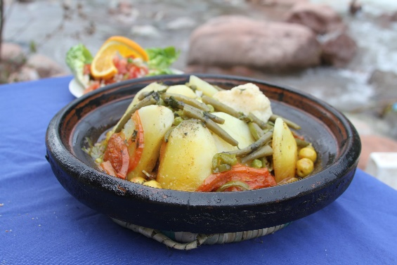
Tagine
A stew that can include meat and vegetables cooked in a special pot.

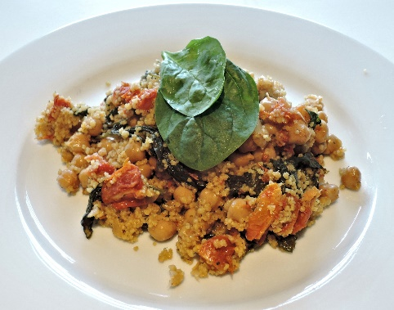

Couscous
Small steamed balls of wheat, often mixed with vegetables and spices.

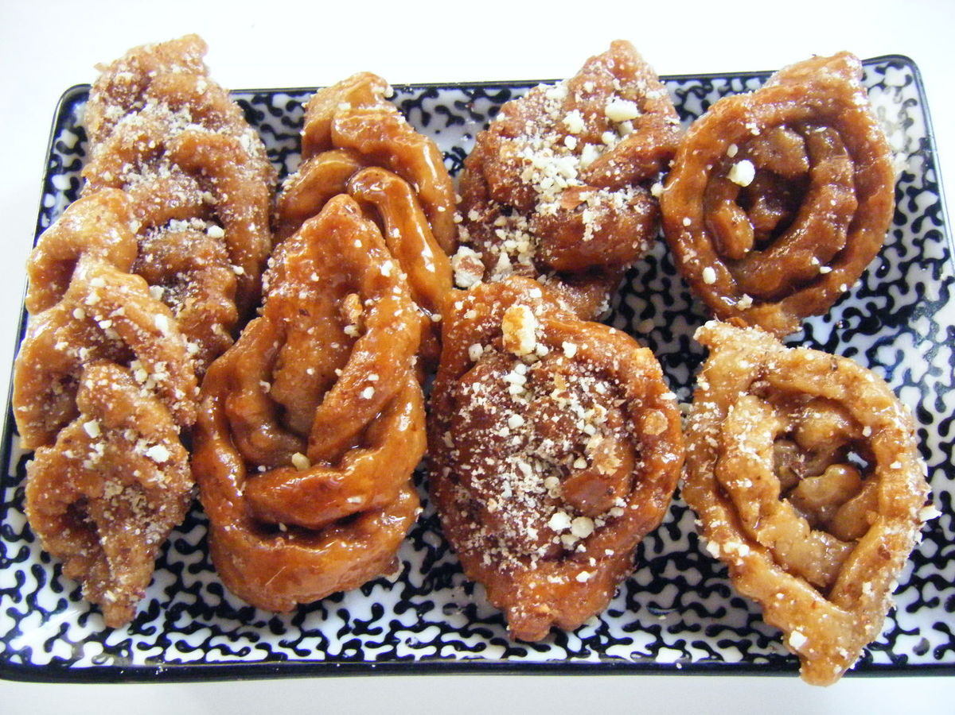
Chebakia
Fried pastries in the shape of a rose, covered in honey and sesame.

Education is free in Morocco. By law, all children must attend school from the age of four until the age of 13, after which children can choose whether to continue their education.

Here are some links you could follow to find out more:

www.oddizzi.com/teachers/explore-the-world/places/africa/morocco/

https://wiki.kidzsearch.com/wiki/Morocco

https://www.ducksters.com/geography/country.php?country=Morocco

https://www.sciencekids.co.nz/sciencefacts/countries/morocco.html

https://www.kids-world-travel-guide.com/morocco-facts.html

