History

This week in history we will be learning about the ‘first great explorer’ Ibn Buttuta.

Follow this link to watch a short video about his life and travels.

https://www.youtube.com/watch?v=Qo7mBnslYQ8

Ibn Battuta (1304 – 68) was a great explorer who was born in Tangier, Morocco. He spent nearly 30 years travelling! It is estimated that he travelled over 73,000 miles visiting the equivalent of 44 modern countries in his lifetime.

Travelling this much was very unusual at the time he lived and on his journeys he met people from very different cultures.

Task: Below are some stories from Ibn Bututtas travels. Choose one to read through - pick the title you like the most! Read it with an adults support then; use a whole page in your book to draw a picture representing the story you have read. What would the landscape be like? What would the buildings be made from? What would people be wearing? I’ve added a few pictures to help you.

Remember! Ibn Bututta lived between 1304 and 1368 over 700 years ago – everything would be very different to our modern day world.

Give your picture a title using the title of the story. Don’t forget to take a picture and send it to me: lbarnett@polruanprimary.co.uk

Story 1: The Pearl Fisheries in the Persian Gulf

On our journey to Qalhat (in Oman), my friend and I decided to leave the crew of my ship, and continue on foot. This decision almost cost us our lives. Our guide that we had hired to take us there plotted to kill us and steal our clothes and valuables. Luckily, I had my spear and managed to control the would-be robber. Finally, after becoming sick and with swollen feet, we arrived at Qalhat. We stayed with the governor for six days and recovered. From there, we continued to the Persian Gulf.

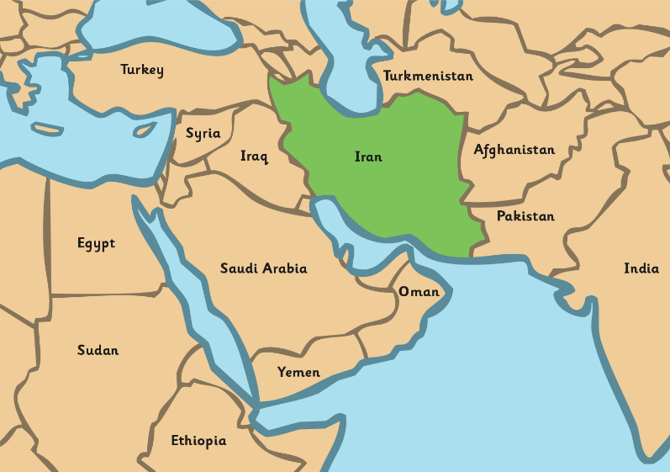

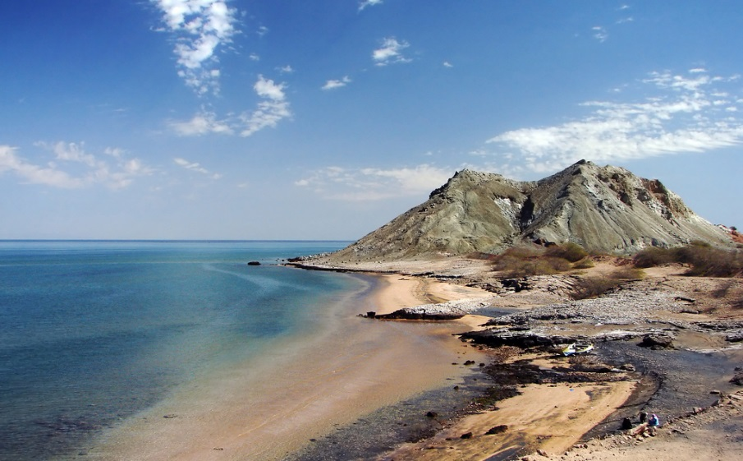

There, many boats with divers and merchants came to the pearl fishery. The divers put a mask made from tortoiseshell over their faces and also something looking like scissors (also made from tortoiseshell) which they fasten to their nose. They tie a rope around their waist and dive into the water. At the bottom of the sea the divers collect shells and put them into a bag which they carry around their neck.

When they come back to the surface, the divers take the shells out of their bags and open them. Inside the shells are pieces of flesh which are cut out with a knife, and when they come into contact with the air, they become hard and turn into pearls. Big and small pearls are gathered together. Some are given to the Sultan and the rest are sold to the merchants in the boats.
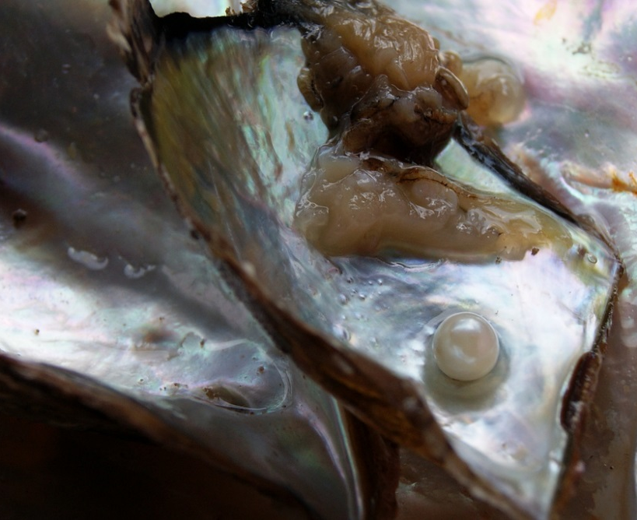

Story 2: Escape From India!

I arrived in Delhi in 1334, needing to find work and money. I worked as a judge for the Sultan Muhammad Tughluq for 7 years until 1341. He showered me with gifts and money, but he was a cruel men. He tortured people in the most horrible way. The Sultan began to suspect that I was plotting against him, and he kept me under guard for nine days. I had to go to live in a cave for five months to prove that I was worthy of the Sultan’s trust. When I returned, the Sultan asked me to go to China to become an ambassador there. He knew my love of travelling, and although the journey was going to be dangerous, I could not refuse.

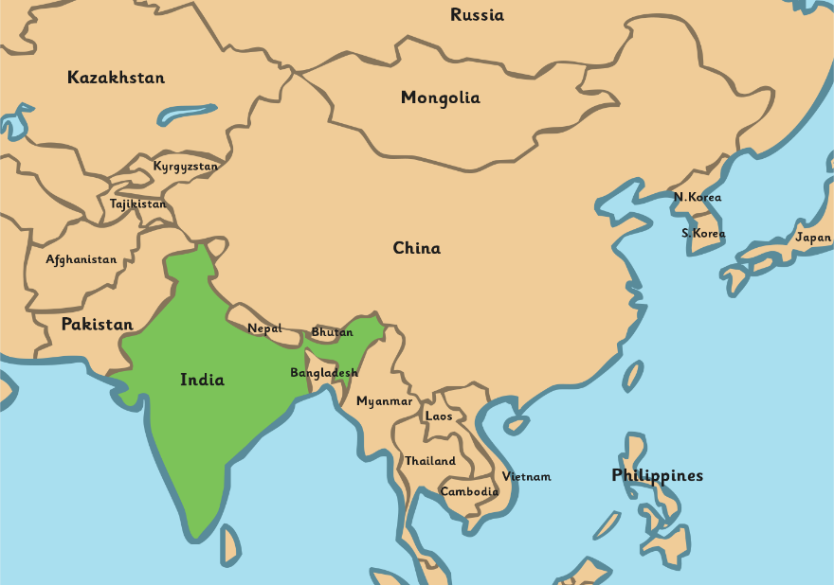

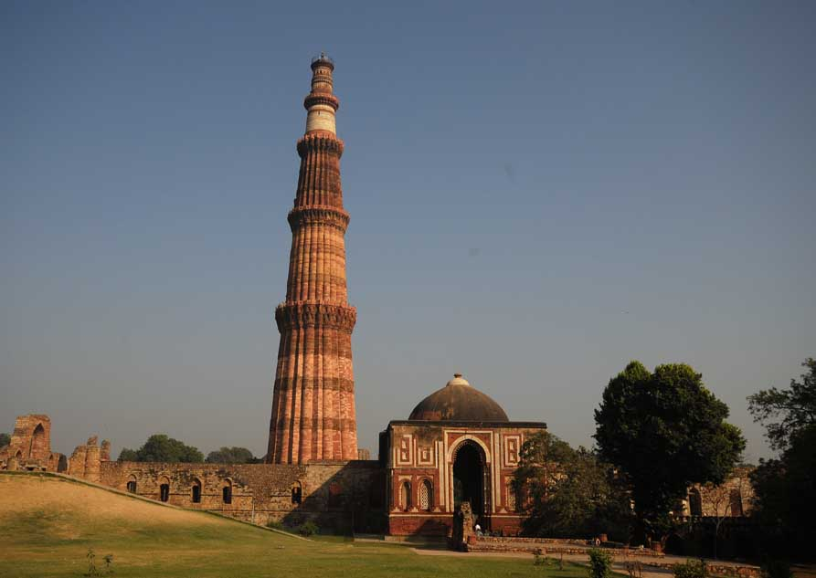

A few days outside of Delhi, we were attacked by bandits and I was separated from my companions. Ten horsemen chased me across the fields. I was able to escape by jumping into a ditch. However, days later, I was robbed of everything except my shirt, trousers and cloak. Luckily, as I had nothing left to rob, my captors let me go in exchange for my clothes. Exhausted, barefooted, and wearing nothing but my trousers, I was rescued by a man who carried me to his village.

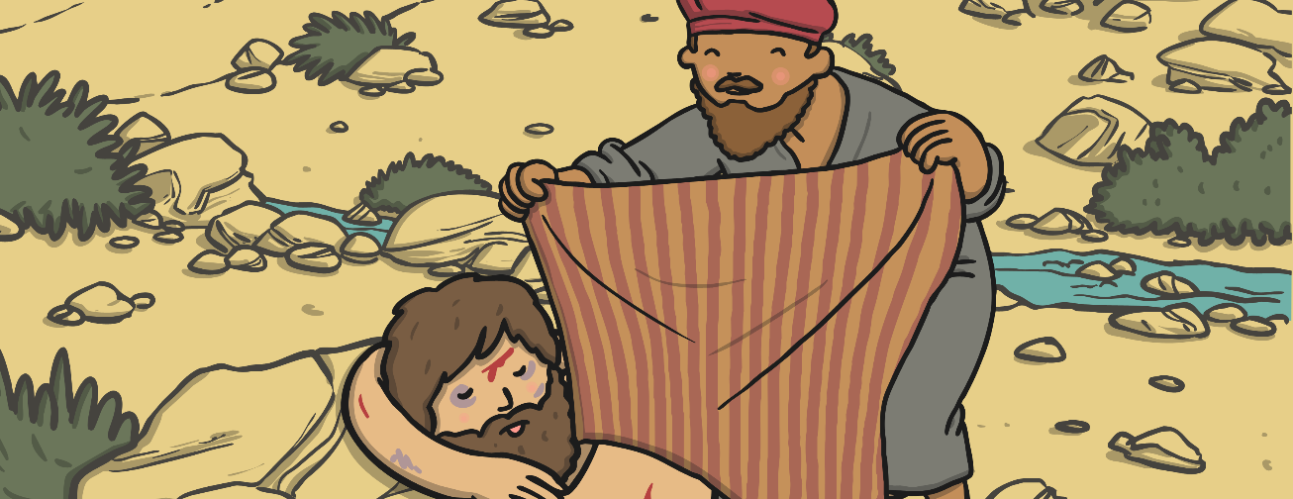

Story 3: Painters in China

The Chinese are very skilled craftspeople. One day I went through the painters’ bazaar to the Sultan’s palace with my friends. When I came back from the palace I walked through the bazaar again and saw that there were pictures of myself and my friends hung on the walls. They were amazing and looked just like us. We learned that when we were at the palace the painters had watched us and begun their paintings.

It is the custom in China to paint everyone who visits them. If a foreigner does something bad, they send his painting around the country and look for the foreigner. When someone is found who looks like the painting, they arrest him.

