RE

Our great explorer this week is Ibn Buttata born in Morocco, Africa.
The main religion practiced in Africa is Islam.
This week we will study the five pillars of Islam that Muslims believe in.

Watch this short video to find out more:

https://www.bbc.co.uk/teach/class-clips-video/religious-studies-ks1-the-five-pillars-of-islam/zv84jhv

Below is some more information on the five pillars of Islam.

The Five Pillars of Islam are duties which many Muslims carry out as the foundation of their Muslim life, and to live in a good and responsible way.

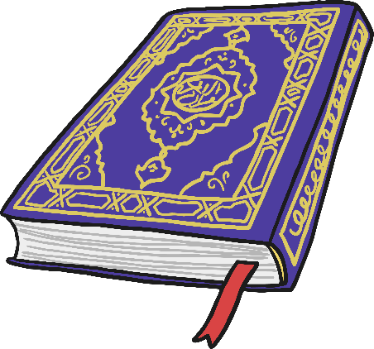
Pillar One: Shahada
(Declaration of Faith)
This pillar is the main belief of all Muslim people and it is a declaration of their faith. The English words are:
“There is no god except Allah, Muhammad is the messenger of Allah.”
Muslims say this when they pray. Anyone who says these words and means it can become a Muslim.

Pillar Two: Salah
This pillar is prayer. Muslims pray five times a day and follow a special ritual to do so. First they must wash in symbolically clean water.
All the prayers must be said at certain times of the day.

Fajr | Morning, between dawn and sunrise
Zuhr | Mid-day or early afternoon.
Asr | Late afternoon.
Maghrib | Evening, around sunset.
Isah | Night, before going to bed.  Pillar Three: Zakat (giving)
This pillar is about looking after other people. Muslims give up a share of their wealth each year to provide for those less fortunate.
The word ‘zakat’ means to purify or cleanse. As a person gives away a share of their wealth they become cleansed from selfishness and greed.

Pillar Four: Sawm (fasting)

This pillar is about Ramadan.
For 30 days Muslims fast, they do not eat or drink anything during daylight hours.
The fast is to remind them how difficult it is to be poor hungry and thirsty. It reminds them to thank Allah for the gift of the Qur’an and not be greedy.

Pillar Five: Hajj
(pilgrimage)
Muslims have a duty to make a pilgrimage to Makkah at least once in their life. Often whole families will save to send one person at a time.
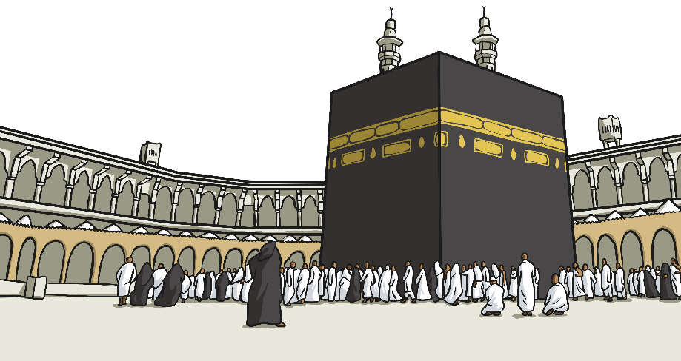
Muslims go on the pilgrimage to bring together the community and strengthen it.

Task:

Choose one of the five pillars of Islam and draw a poster and explain why that pillar is important to Muslims.

