Amelia Earhart and Early Aviation
Who Was Amelia Earhart?
Her Childhood
Amelia lived with her father, mother and her younger sister, Grace Muriel (Muriel). She enjoyed adventures and was quite a tomboy. She and her sister would climb trees, hunt rats and ride their sledge down hills on their tummies!
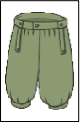
Most unusually for this time, the Earhart sisters were allowed to wear bloomers, which the other girls in the neighbourhood were not allowed to do. They enjoyed the freedom that they did not have when wearing dresses. Their mother encouraged them to be different and not to do what was expected of young ladies at that time.
As well as a love of adventure, Amelia Earhart was also very interested in successful women, who worked in jobs usually associated with men.
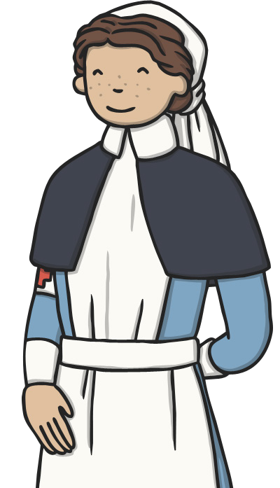DID YOU KNOW?
After senior school, she worked as a nurse’s aide in Canada, caring for the wounded soldiers in the First World War. She eventually became a social worker.
Her Big Adventure
Amelia Earhart was given her first plane ride on 28th December, 1920.
She had her first flying lesson when she was 23 years old.
In July 1921, she bought her first plane. It was bright yellow and she named it "The Canary".
In October 1922, she broke the women's altitude record.
In May 1923, she got her pilot's licence - the 16th woman in the world to receive one.
In June1928, she became the first woman to fly across the Atlantic, alongside two other male pilots.
In May 1932, she became the first woman to fly solo across the Atlantic.
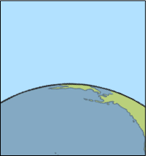

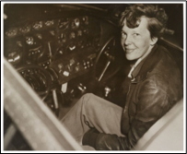

Amelia Earhart sitting in the cockpit of the Lockhead electra plane she last flew.
A Sad End
On 20th May 1937, Amelia and her navigator, Fred Noonan, left Oakland USA and began her biggest adventure, to fly all around the world.
This would be a journey of 29 000 miles and was to end at the same place it had started.
On 2nd July 1937, Amelia and Fred Noonan tried to make the next flight of their trip, from New Guinea to Howland Island in the Pacific.
However, the weather was bad, with cloud and rain showers. The island they were hoping to land on, Howland Island, was extremely small, so two American ships (who were on the path they would be flying) were ordered to burn every light to act as markers to guide them in.
Sadly, due to poor weather and low fuel, Amelia Earhart and Fred Noonan never made it to Howland Island.
A lighthouse was built on Howland Island in her memory.

Early Aviation Facts
1783
The hot air balloon was invented by the Montgolfier brothers. It has become the oldest invention that can successfully take people into flight.
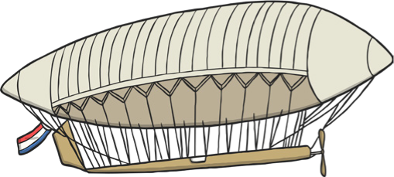
1884
The first sucessfully navigated airship, La France, was built by Chales Renard and Arthur Krebs. It was under its pilot's complete control.
1903
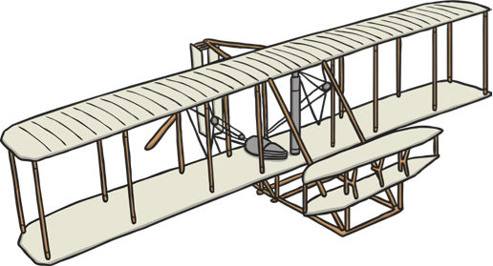
The first flight of an aeroplane was in the Wright Flyer. It was invented by Wilbur and Orville Wright and successfully flew in front of 5 people.
1927
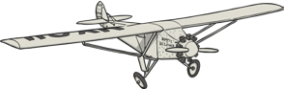
The first solo flight across the Atlantic Ocean was completed by Charles Lindbergh. It took 39 hours and 14 minutes of flight time.
1996
Concorde flew across the Atlantic Ocean from New York to London in its fastest time. It took 2 hours, 52 minutes and 59 seconds of flight time!
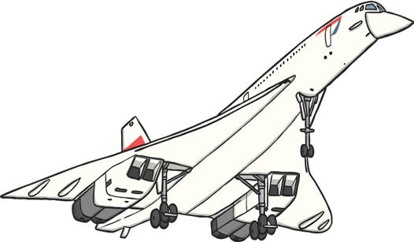

DID YOU KNOW?
The Wright Brothers decided who would pilot the first flight by flipping a coin. Wilbur won the toss and made his attempt on 14th December 1903. However, he was unsuccessful, so Orville Wright became the one to make the successful flight three days later.

