Art

Christopher Columbus used to travel by boat – we are very lucky to live in Polruan where we see various boats of different shapes, sizes and adventures!

Task:
In art this week we are going to complete an observational drawing of Polruan harbour.

Go outside or position yourself so that you can see the harbour. Use your pencil to create an observational drawing of Polruan harbour.
Remember to draw only what you can see.

Here are some hints and tips to help you when you are drawing:

Scale
Take a look at the different parts of the object you are drawing.
Which parts are small?
Which parts are large?
How do the sizes of the different parts compare to each other?
Try and draw the objects in proportion with each other.

Light and shade
Look at the shadows on what you are drawing.
Where is the light source?
What shadows can you see?
Which are the light areas and which are the dark?

Keep checking
Make sure you keep looking at what you are drawing and checking your drawing against it. Are the proportions correct?
Have you missed anything?

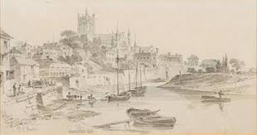
Send your drawings to me: lbarnett@polruanprimary.co.uk

