History

This week in history we will be learning about the great explorer ‘Christopher Columbus’. Below is some information for you to find out about Christopher Columbus.

Christopher Columbus was born in 1451 in Italy. His father was a wool merchant. He was born into a time period called the Renaissance. Lots of people were building new ships to explore different parts of the world. Columbus’s first trip on the sea was when he was 13 years old.
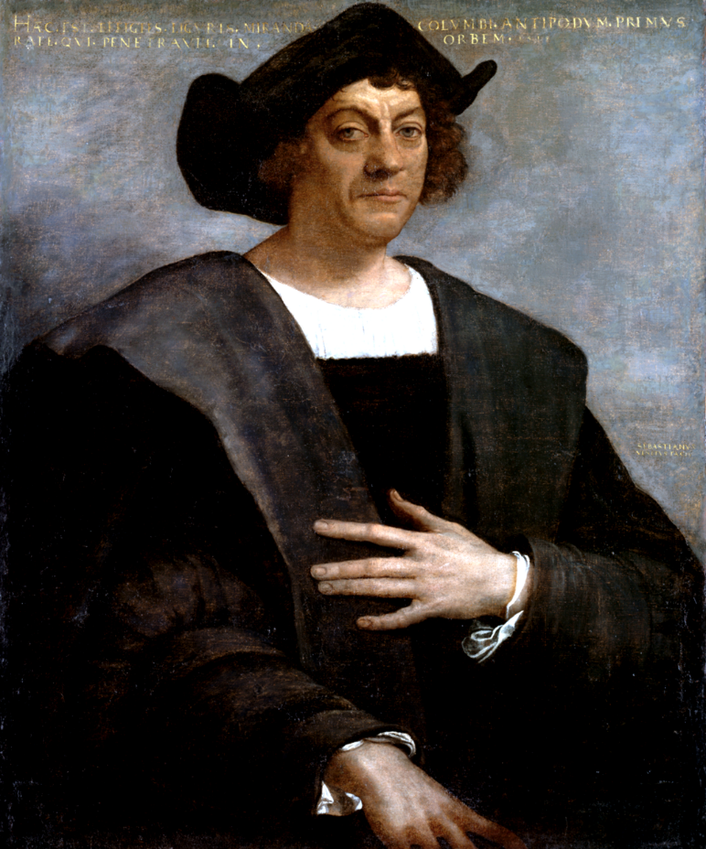

Christopher Columbus lived at a time when people in Europe did not know that the continents of North or South America existed!

- Christopher Columbus learnt to sail in a wooden ship with sails.
- He learnt to find the way at sea by using the stars and the sun.
- He went to live in Portugal and sold maps with his brothers.
- He had a dream to travel west and go to China.

To follow his dream, Christopher Columbus need money, so the King and Queen of Spain gave him money to buy ships. He set sail on 3rd August 1492 with three ships.

Life on the Ships
The men had no cabins to sleep in, so everyone had to sleep on deck. The ships let water in all the time, and the men had to work pumps to keep the ships afloat!
They were on a voyage into the unknown, they did not know where they would land.
How would you feel about this?
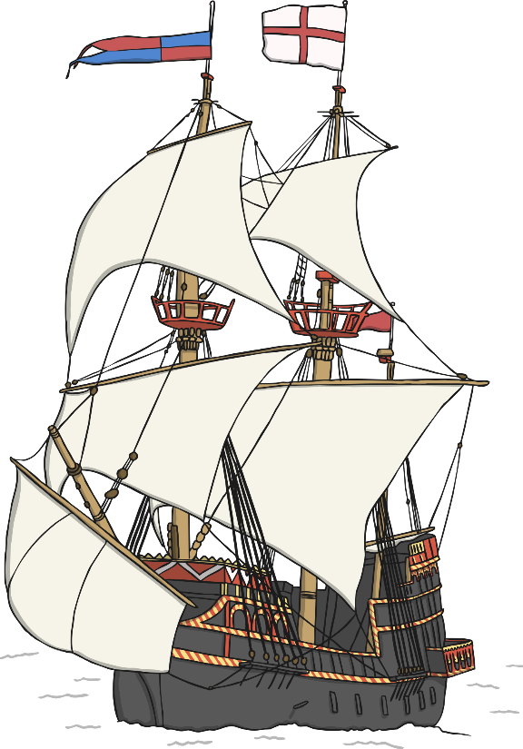

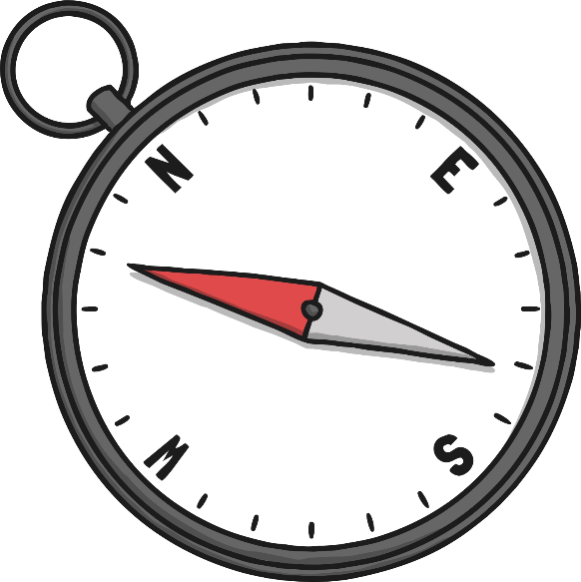

.

- Christopher Columbus used a compass to help him find his way.
- The trip took them longer than expected and they got a bit scared.
- They could find no land, all they could see was ocean.
- They were running out of food and water.
- After 36 days, one man spotted an island, it was in the Bahamas.

Task 1: Close your eyes and imagine; how would you feel at sea all day?
How would you feel when you finally saw land?

Turn your page landscape, draw the landscape that you can see (the Bahamas) from your boat. Draw the outline in pencil and then colour in. What colours would you be able to see?

Don’t forget to send me a picture of your finished landscape lbarnett@polruanprimary.co.uk

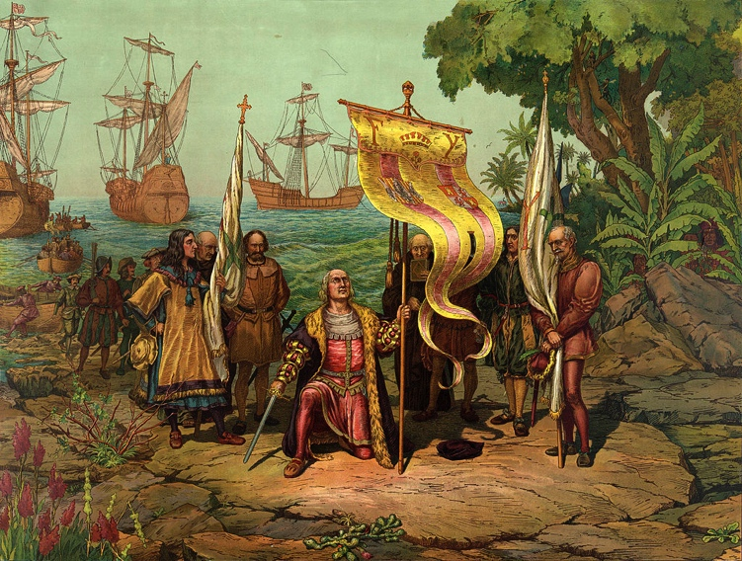

Christopher Columbus sailed onto Cuba and discovered new lands. They called it ‘The New World’.
Native Americans lived on the islands, but Christopher Columbus called them Indians because he thought he had landed in the ‘Indies’.

- Christopher Columbus’s biggest ship was less than 23m long.
- Before Christopher Columbus had been to America, no one in Europe had ever tried a tomato or potato before.
- The sailors ate stew made from salt, meat and bones.

Christopher Columbus did not discover America, but he started regular contact between Europe and America.
The Vikings had landed in America 500 years before (Christopher Columbus did not know this).

Watch this short video to find out more on Christopher Columbus:

Task 2:

Imagine you are Christopher Columbus, on your return to Spain following your first voyage to the New World; your ship enters a severe storm. Quickly, you write a message to Queen Isobel (sealed in a bottle) telling her what you had discovered.
- How would you be feeling?
- What have you discovered?
- What were the conditions on the ship?

Attached to the blog is a message in a bottle writing frame for you to write your message on or you could draw your own in your book.

Task 3: Create a fact file on Christopher Columbus.

Using everything you have learnt about Christopher Columbus this week create a fact file on him to each others. Attached to the blog is a blank fact file that you could use to layout your ideas or you could create one of your own.

Don’t forget your fact files should have:
- A title
- Subheadings
- Paragraphs (year 2)
- A picture and caption

