History

This week in history we will be learning about the great explorer Neil Armstrong. Below is some information about his life and adventures.
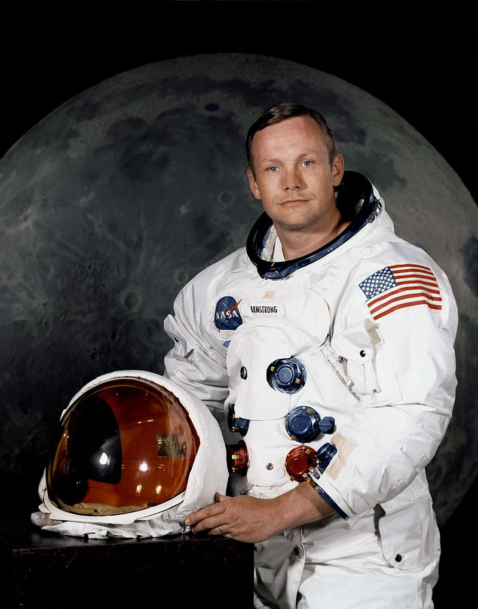
Neil Armstrong was a famous American astronaut.
He is famous for being the first man on the Moon.

He was born in 1930, in the
state of Ohio in America.

He was 15 years old when he
got his first pilot’s license.

After attending university he became a test pilot and flew over 200 different aircrafts in his career.

He was accepted to be part of the NASA Astronaut corps in September 1962.
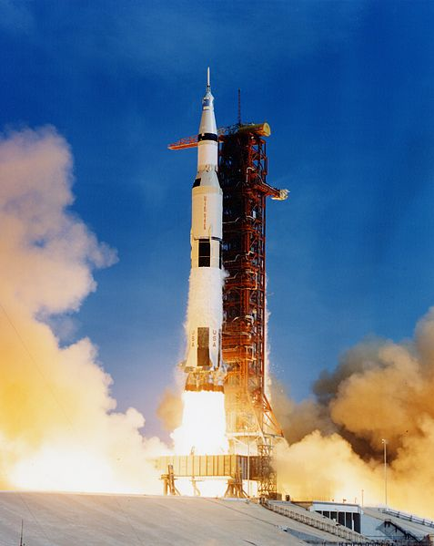

His first trip into space was aboard Gemini 8.

Then in 1969 he went aboard Apollo 11 and became the first man to walk on the Moon.

On December 23, 1968, Neil Armstrong was offered the chance to command the Apollo 11 mission. This would be the first manned landing on the Moon.
After months of practice and preparation, the Apollo 11 mission launched from the Kennedy Space Centre in Florida on July 16th 1969.
Neil Armstrong and Buzz Aldrin landed on the moon, while a third astronaut, Michael Collins, stayed on the spacecraft. Neil became the first man to walk on the Moon on July 21st 1969. The astronauts arrived back on earth on
July 24th 1969.
He died in 2012 in Ohio, America

Task 1:

Turn your page landscape; write the title Neil Armstrong timeline (and underline it with a ruler!). Draw a timeline across the middle of your book beginning in 1930 when Neil Armstrong was born and ending in 2012 when he died.
Use the information above to create a timeline of important dates in Neil Armstrong’s life.

Here are the events you should include:
- Birth
- Getting his pilots license
- Being accepted into NASA
- Mission to the moon departure and return
- Death

Task 2:

Last week we learnt about another great explorer – Christopher Columbus.
Below are two pictures one of Christopher Columbus and one of Neil Armstrong. What are the similarities between them? What is different about them? Discuss what you notice with an adult.

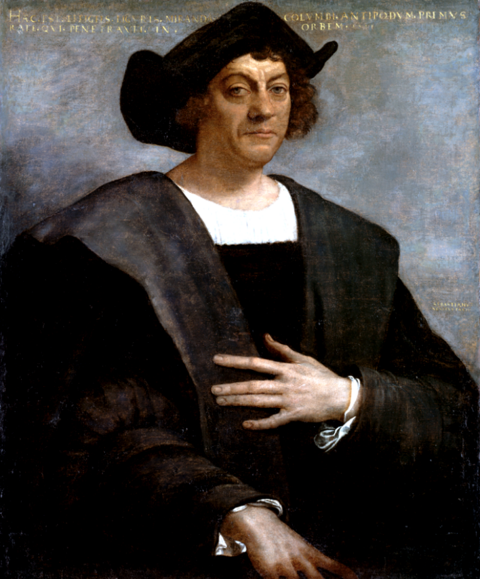
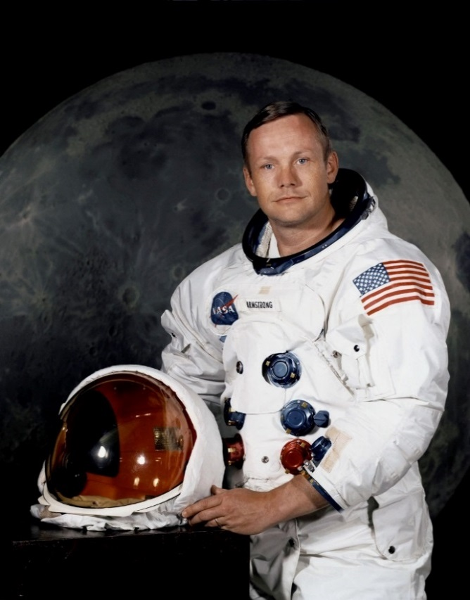

Split your page into two columns and label one similarities and one differences.
In each column list what you notice.

Example:

Similarities | Differences
- Both have a hat/helmet | - Different clothes

Task 3:

Both great explorers had tools and special equipment to help them on their missions. Split your page into two columns and label one Christopher Columbus and one Neil Armstrong. The pictures below show the different equipment or places that they explored. Sort the pictures into each column – thinking about which explorer would have used them or visited. You can do this by cutting and sticking the pictures or drawing your own.
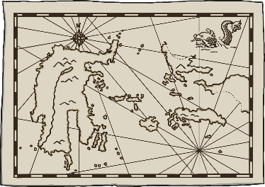
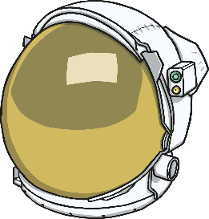
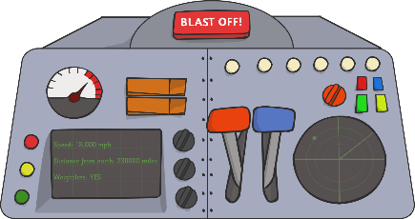
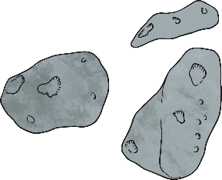
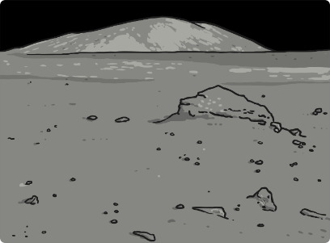
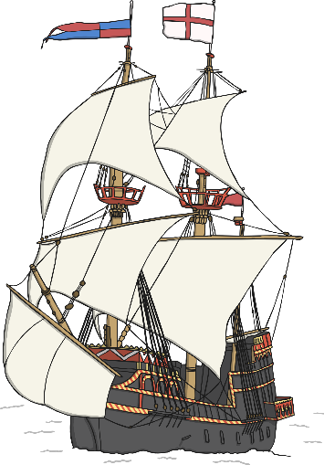

Task 4:
How was Armstrong’s mission similar and different to that of Columbus?

Watch these short videos about Neil Armstrong to understand more about his mission to the moon – can you hear his famous catchphrase “That’s one small step for man, one giant leap for mankind”

https://www.youtube.com/watch?v=eIYi-Zi-3oc

https://www.youtube.com/watch?v=eIYi-Zi-3oc&t=124s

Answer the following questions

- What did Armstrong want to do? How was this similar to what Columbus did?
- What was different about how they were going to complete their mission?
- What was the same or different about what they could use to help them?
- The Americas were important to Columbus because…
- The Moon was important to Armstrong because…
- A rocket was used by Armstrong because…
- A ship was used by Columbus to…

