ART

Our great explorer this week is Captain Robert Falcon Scott who explored the Arctic.

- The Arctic is in the Far North.
- The North Pole is in the Arctic.
- The Arctic has very few plants because it is very cold there.

Task:

Look at three pictures of the Arctic below and choose your favourite.
Which colours have been used? Are there different shades of the same colour? How does the picture make you feel.

Using this picture, turn your page landscape and copy it. Create the outline using a pencil first and then fill in the colours as close to the original as you can. You can fill the colours using whichever media you prefer paint, pencil, crayon, chalk, it’s completely up to you!
You may have to mix some colours to match the shades in the original picture.
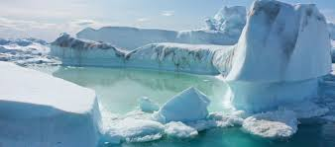

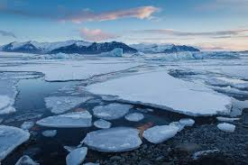

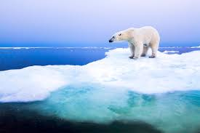

Have fun! Don’t forget to send me pictures of your finished pieces!

lbarnett@polruanprimary.co.uk

