History

This week in history we will be learning about the great explorer Robert Falcon Scott. Below is some information about his life and adventures.

Captain Robert Falcon Scott was born in Devon in 1868 and became an officer in the Royal Navy.
- He led two expeditions to Antarctica. The first took place between 1901 – 1904. in 1910, he sailed out for his second voyage there.
- The purpose of the expeditions was to find out more about the animals, the weather and the land of Antarctica.
- Scott and his fellow explorers also wanted to be the first to reach the South Pole.

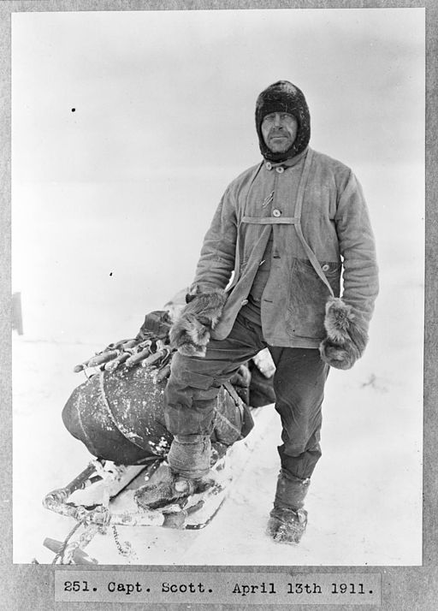

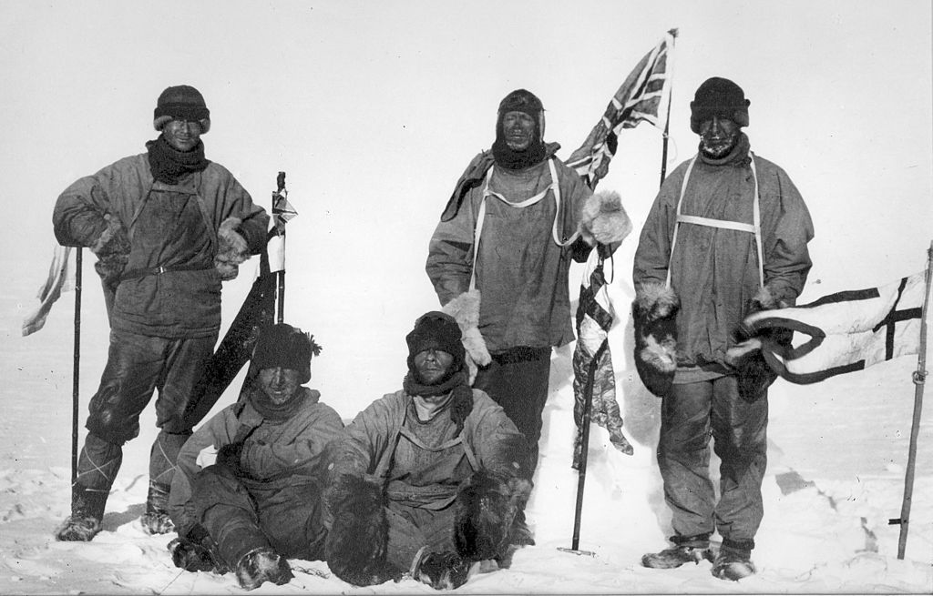

What happened to Captain Scott?

Scott set out on his journey with the latest technology including mechanical sledges. When the technology failed, he had to rely on the few dogs he took in case of such an emergency. Most of the men pulled the sledges by themselves, which was exhausting!

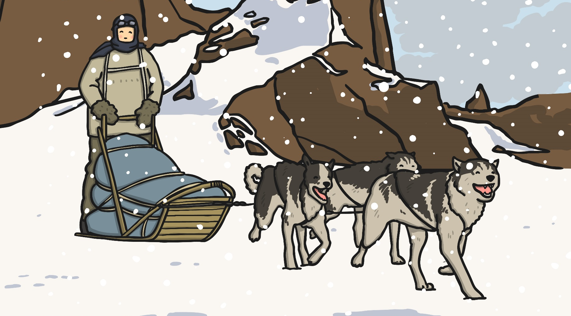
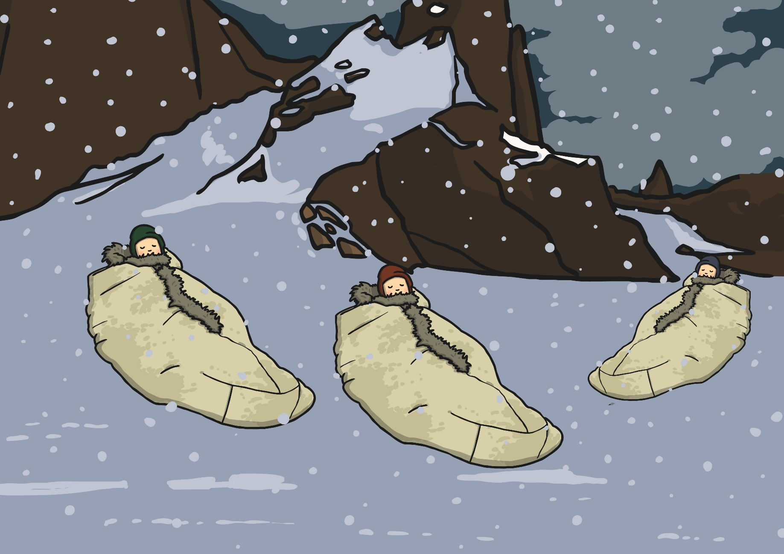
They slept in sleeping bags made from reindeer fur. However, they became wet and cold because the floors of their tents could not keep out the snow. They also struggled with frostbite and snow blindness.

When they reached the South Pole on 17-18th January 1912, they discovered that a team of Norwegian explorers had arrived before them.

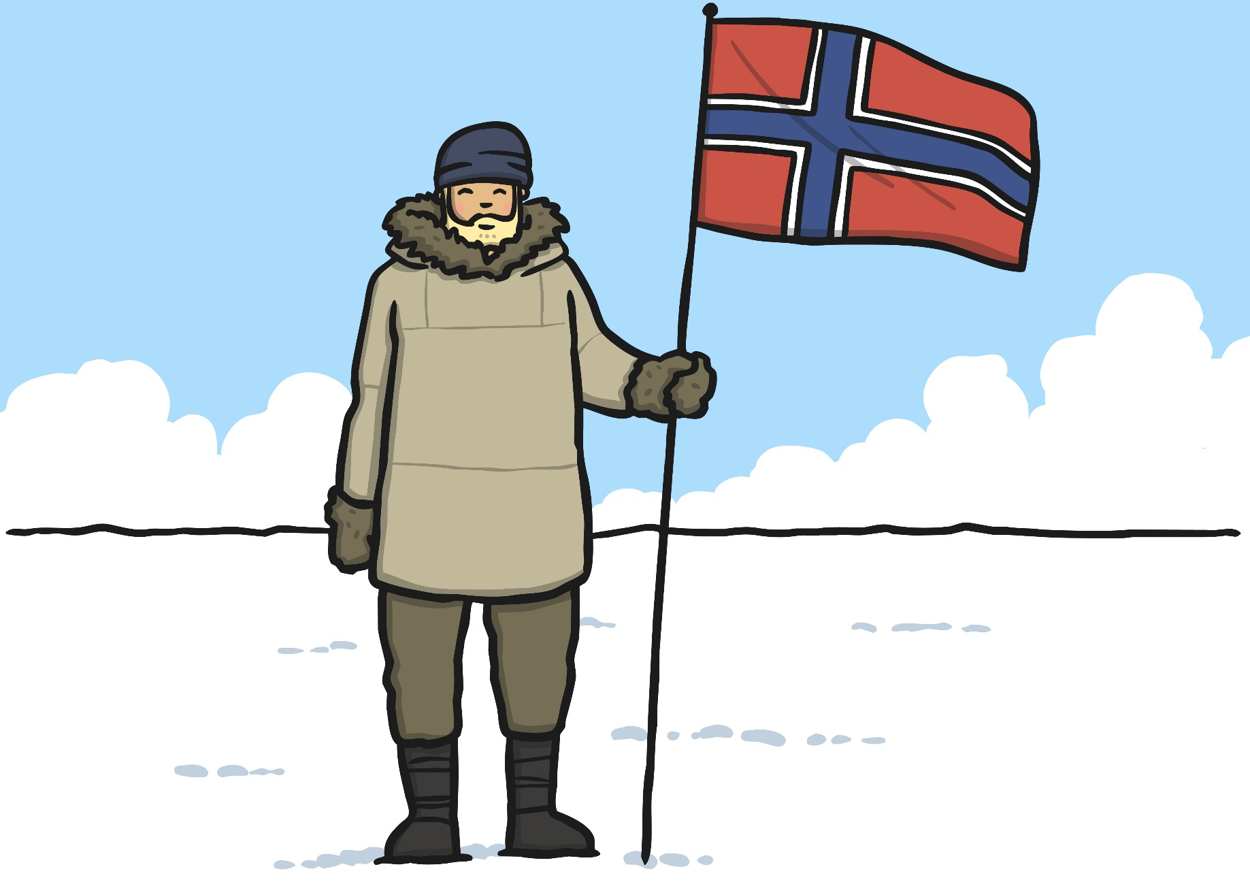

Scott and his companions had to travel back 800 miles through freezing temperatures and ice. They had a disastrous time with blizzards, gale force winds, poor clothing and little food.

Eventually they all died. Many months later, a search party found their bodies, wrapped them in their tent and buried them in the snow.

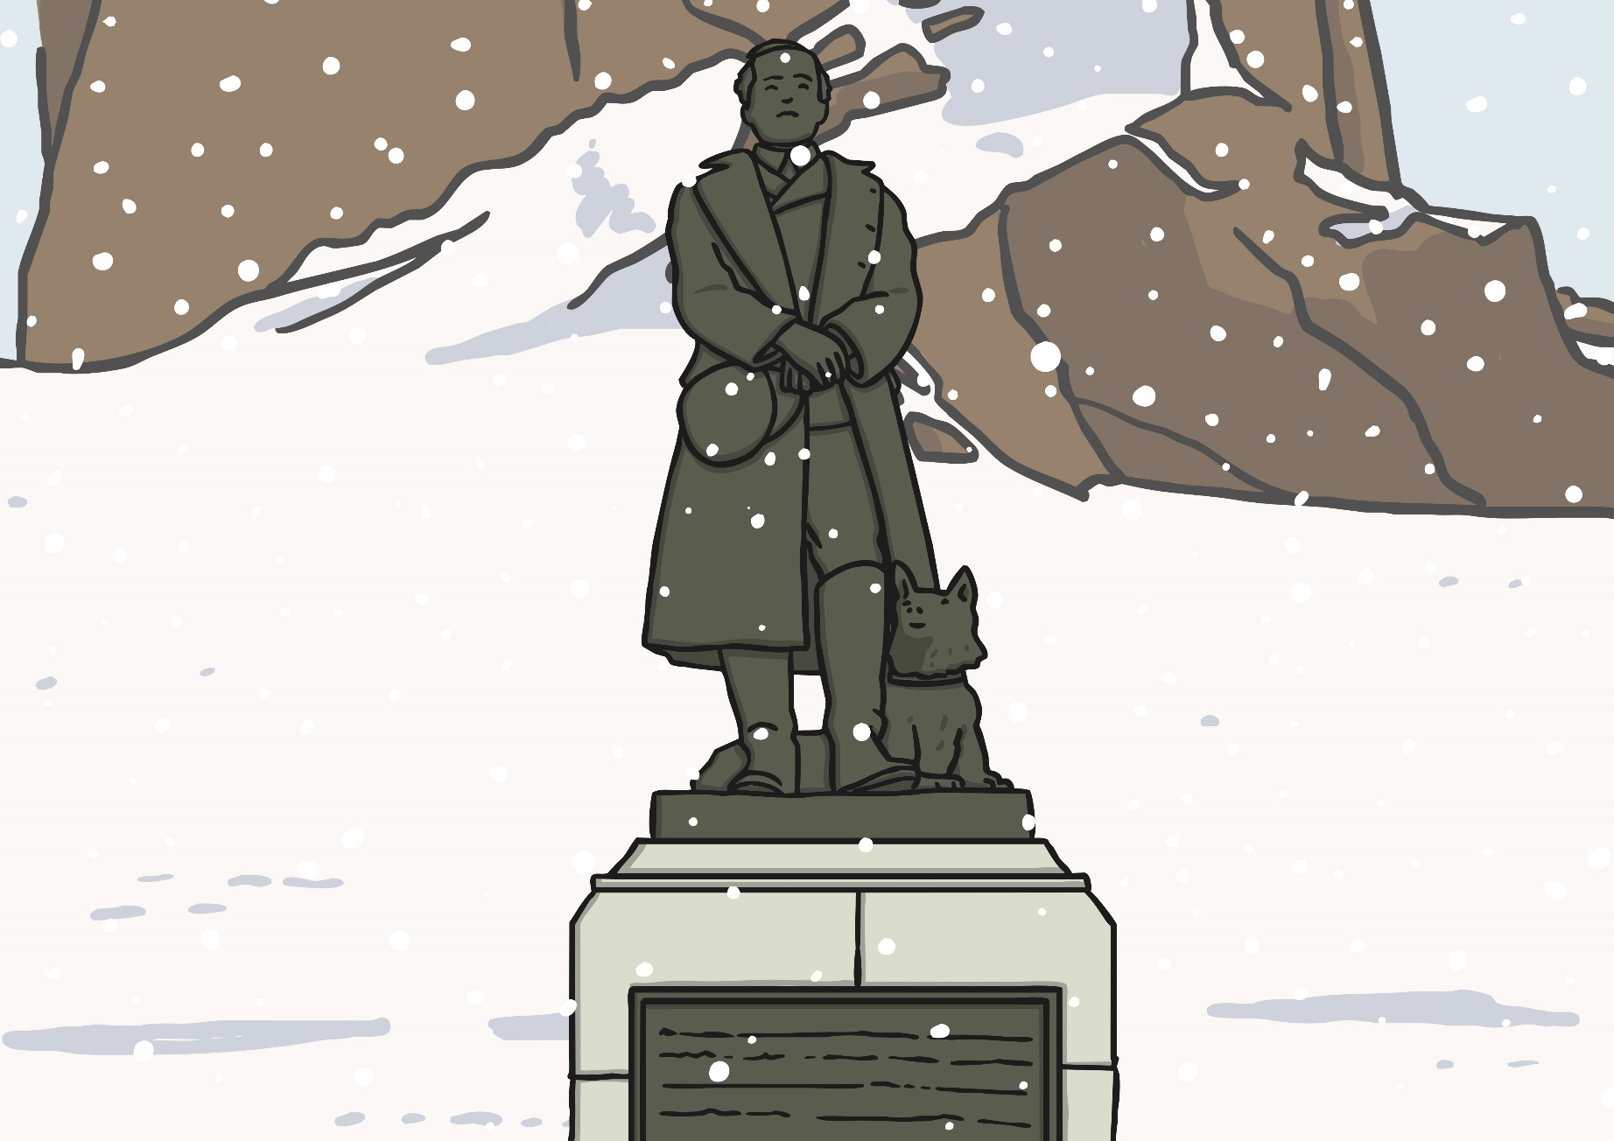

Task 1:

Captain Scott kept a diary to record what was happening for the entire journey through the Antarctic. Imagine you are returning from the South Pole after being beaten to it by the Norwegians. You have to make the 800 mile journey back to your ship. Think about: What will you use to travel? How are you feeling? What was the weather like? What will you do next? Write a diary entry as Captain Scott.

Remember diaries are written in the past tense and begin with ‘Dear diary’…

Task 2:

Follow this link to watch a short video about Captain Scott

https://www.bbc.co.uk/teach/class-clips-video/ks2-robert-falcon-scott/zdhdgwx

Use the ‘Comic book template’ attached to the blog to create a comic strip retelling the journey of Robert Falcon Scott in pictures.

