Geography

Our world is a big and beautiful place with lots of different environments – explorers have travelled far and wide to explore all these different kinds of environments.

We are very lucky to live in a world with so many different places.
People live in all of these different environments and this affects how they live their lives, the things they do, the clothes they wear, how they travel around and lots more things too!

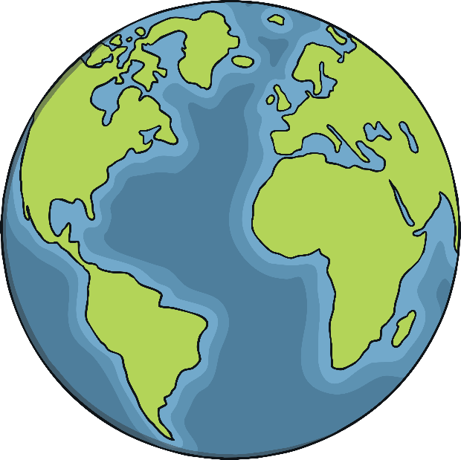

People all over the world live in different environments.
The environment in which people live affects how they live their daily life.
We can find out so much about the world in which we live by looking at how people live in
different places.
It also helps us understand and respect people who are different
to us.

Here are some different environments.

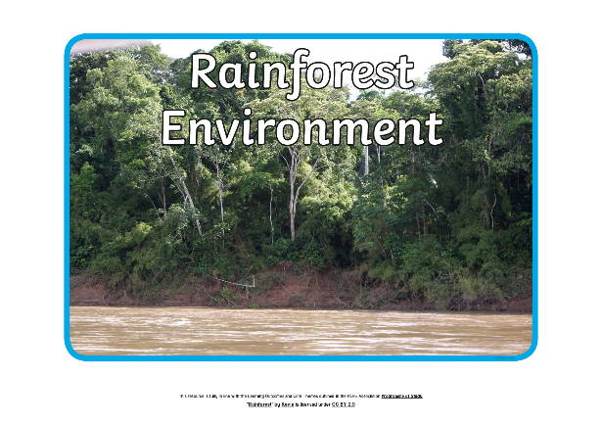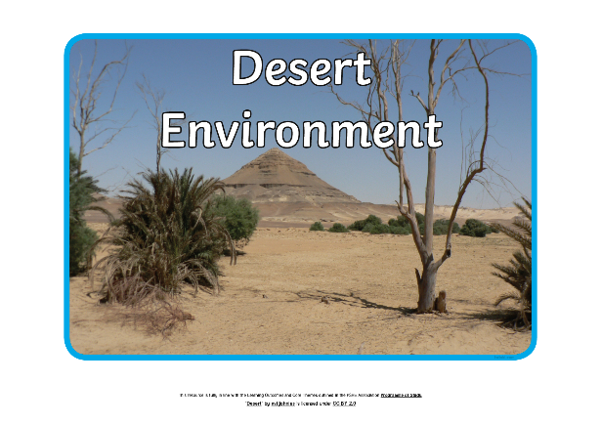

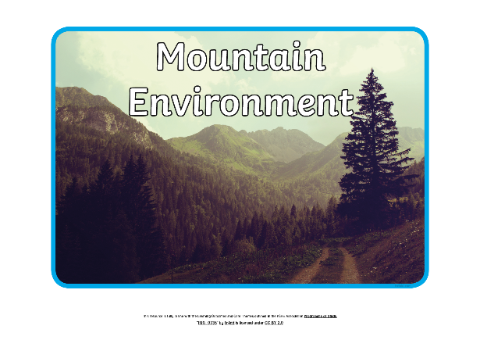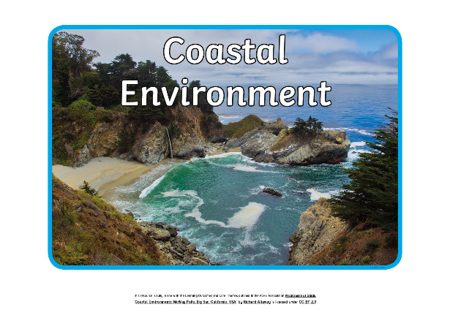

Task:

Chose one of the above environments and create a poster showing what it is like to live in that environment. Your poster should include a title, pictures and short sentences to goive the reader information about the environment.

Use these questions a guide to help you:

What is the environment like?
How do you think the people who live there might travel around?
What clothes might the people who live there wear?
What might people who live there do in their free time?

