Art/DT

Below is a picture of the inside of a cave. Can you name all the features?

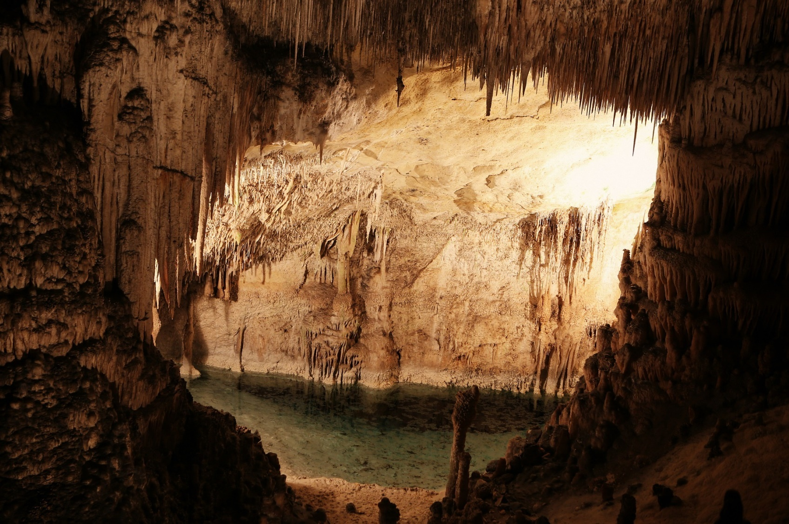
holes
pool
rough walls
stalactite
roof

Follow this link to learn more about what you may find in the bears cave:

https://www.bbc.co.uk/teach/class-clips-video/william-whiskerson-cave/zhxtscw

Task:

Look at the picture above, using this and what you have learnt from the video you are going to make the bears cave inside a box and add in these features. This task will take you two or three days so don’t rush!

You will need:

A box

You may need:
Tissue paper
Newspaper
Pipe cleaners
Cellophane paper
Foil paper
Sand
Wire
Paints and brushes
Scissors

Example:
