^{July 6, 2020}
Lisa Barnett (Polruan Primary Academy)

Great explorers
Canute class

For your English this week we will continue to study our new class text ‘We’re going on a bear hunt’. Below are four tasks based around the text.

Task 1:

An adjective tells us more about, or describes an object, person or place.
Read the sentences below and see if you can spot the adjectives.
- The man was old.
- Can I have a red pencil please?
- The huge, stripy tiger growled…
- Where is my new, green coat?
Follow this link to listen to the sounds you would hear inside the bears cave…(you only have to listen for a few minutes) https://www.youtube.com/watch?v=3Hwr_BaekgM
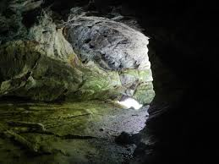
Look at this picture of a bears cave.

Rec: Using the picture and the sound clip write four bullet points to describe what you can see and hear inside the cave.
Use your sound mat.
Year 1: Write 2-3 sentences to describe what you can see or hear within the bears cave. Use the sound clip and picture to inspire you. Don’t forget your capital letters, full stops, finger spaces and adjectives.
Year 2: Write 1 – 2 paragraphs to describe what you can see or hear within the bears cave. Use the sound clip and picture to inspire you! Try to use pairs of adjectives and commas in a list to make your writing interesting.

Example:
I can hear some water dripping into the deep, dark pool over there.
Task 2:

Look at the last page of the ‘We’re going on a bear hunt’ story (the bear walking back along the beach). Look at the bears posture (how he’s standing) and the colours to the illustration (picture). Think about how the bear might be feeling.

Rec: Draw the outline of a bear in your book, write four adjectives to describe the bears appearance outside and four to describe how the bears feeling at the end of the story inside. Use your sound mat to help you sound out your adjectives.
Year 1: Draw the outline of a bear in your book, write six adjectives to describe the bears appearance outside and six to describe how the bears feeling at the end of the story inside. Use your sound mat to help you sound out your adjectives.
Year 2: Draw the outline of a bear in your book, write two sentences describe the bears appearance outside and two sentences to describe how the bears feeling at the end of the story inside. Try to use pairs of adjectives and commas in a list.
Task 3: Look at the poster below, is ‘We’re going on a bear hunt’ a story with repeating parts?
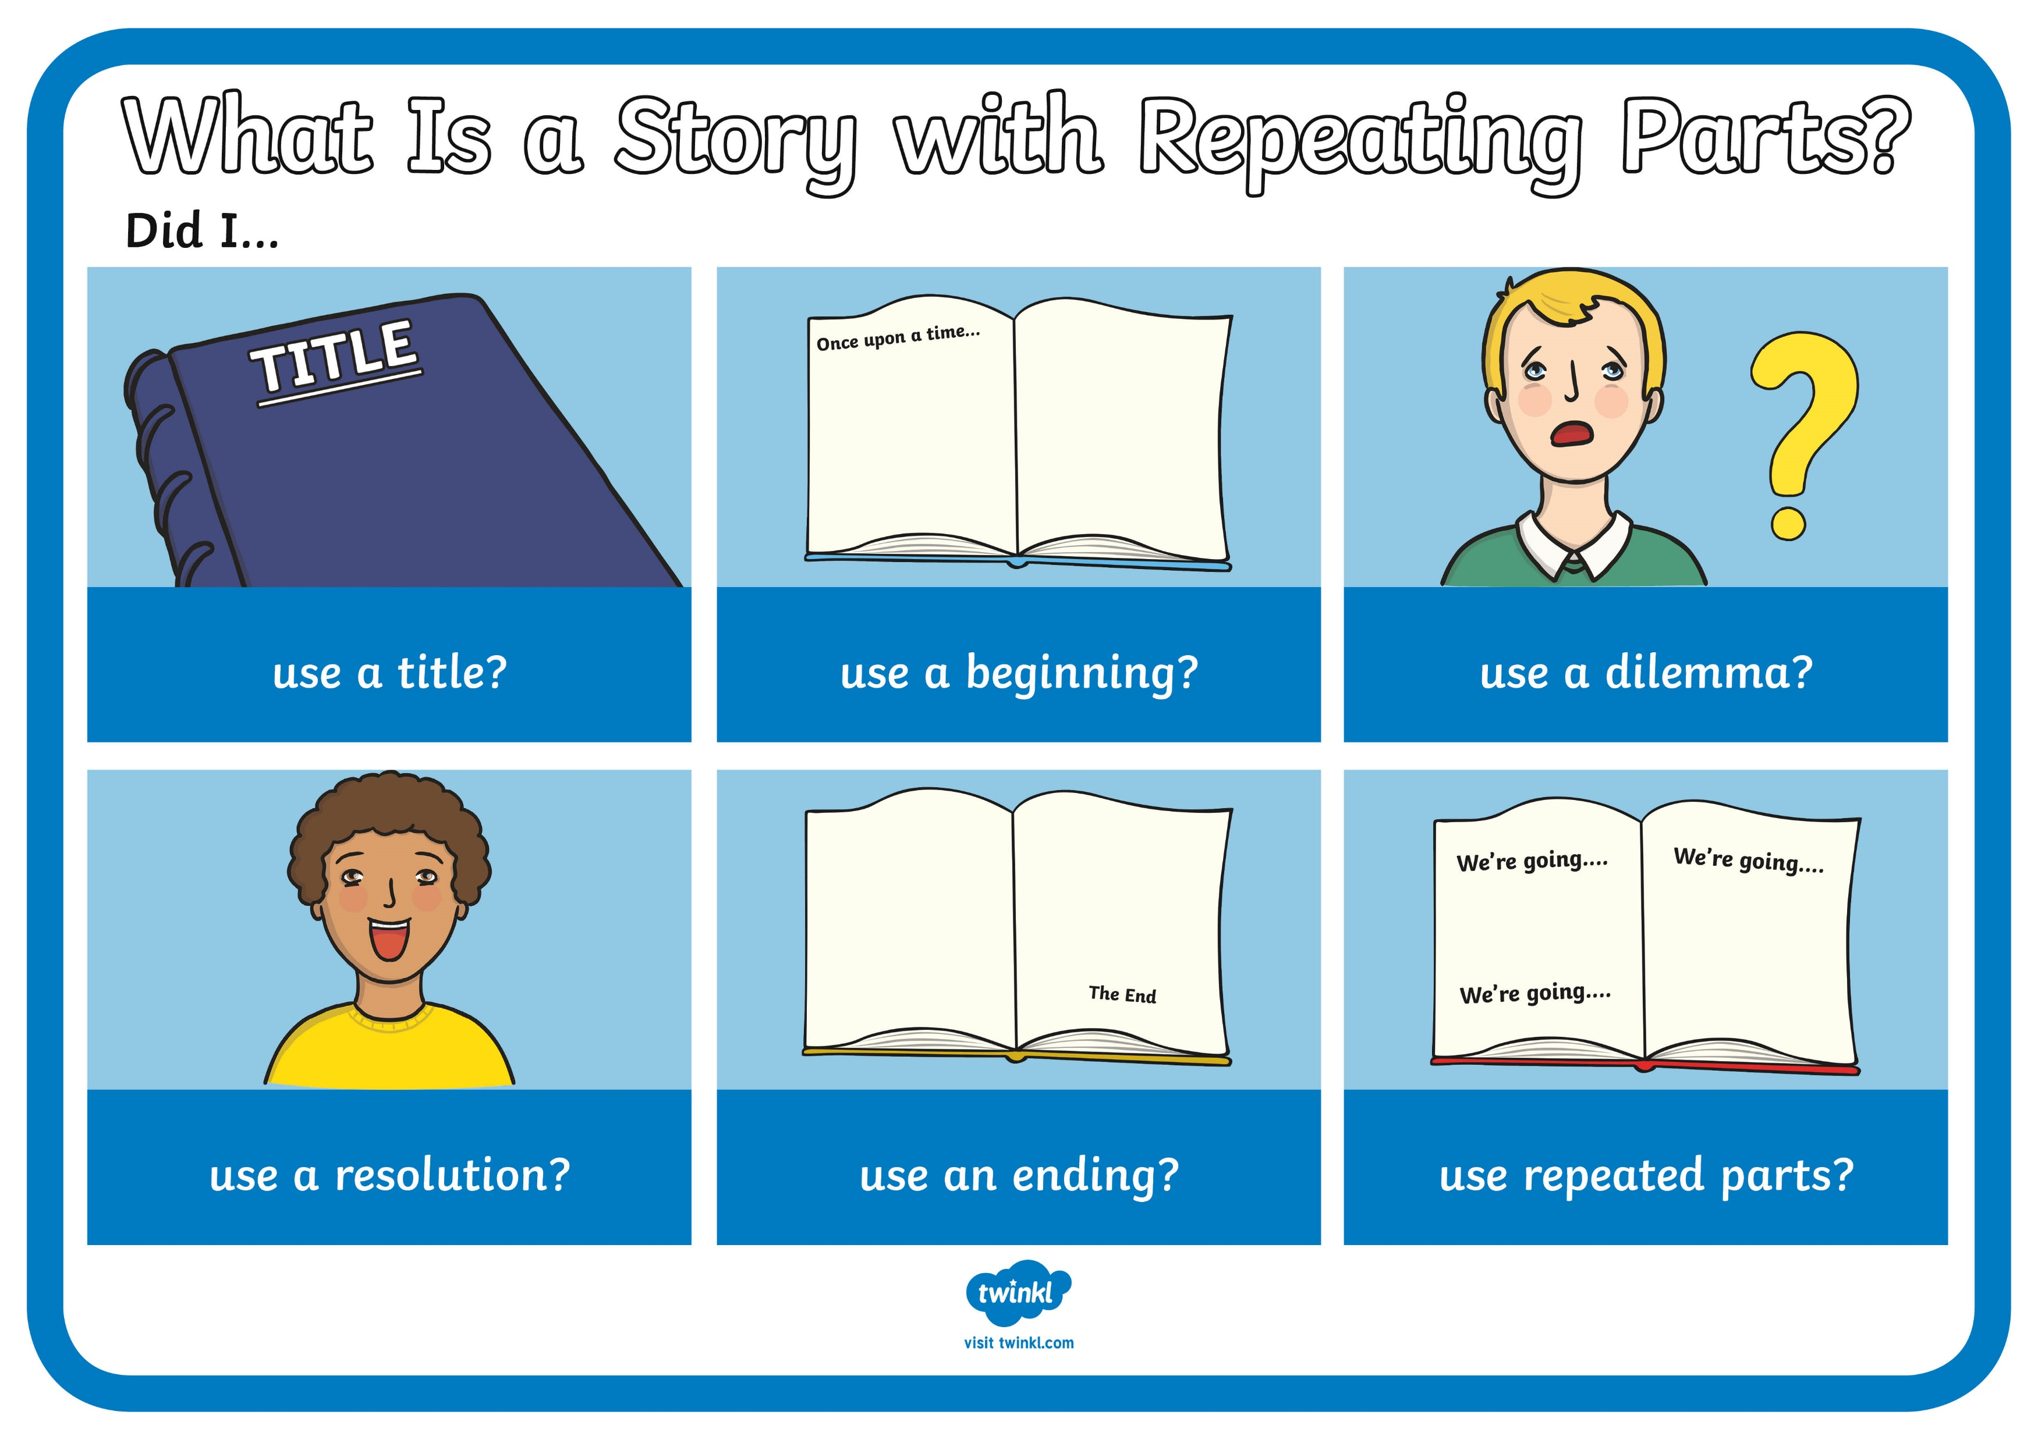

Today we are going to plan a story with repeating parts.

We are going to write our story as the bear. Imagine you have written a letter to a rabbit friend, inviting them to your bear cave for your birthday party. Our story will be about the bear delivering the invitation to the rabbit at his home ‘the burrow’ and the obstacles we face getting to ‘the burrow’. Attached to the blog is an ‘animal hunt story map’ activity sheet.
Rec: 1 star sheet think of 2 different obstacles to draw in the boxes. Choose a simple, suitable description and sound effect for each.
Year 1: 2 star sheet generate 3 different obstacles to draw in the boxes. Choose a suitable description and sound effect for each.
Year 2: 3 star sheet generate 3 different obstacles to draw in the boxes. Choose a suitable description and sound effect for each.
In the ‘What’s that?’ and ‘last illustration’ boxes you should show/draw the invitation being handed over when they see the rabbit in it’s home and finally, what the rabbit does when they have received their invitation (e.g. walking towards the bear’s cave/eating birthday cake with the bear/waving to the bear at the cave).

Task 4:

Over the next two days we’re going to write our story with repeating parts.
Use these sentence starters to write each part of your story.
- I’m going on
- I’m going to
- What a _____ day
- I’m not
- Oh no!
Follow these steps to write each obstacle of your story:
Beginning
Who are you looking for? What sort of day is it? How are you feeling?

Dilemma
What is the obstacle? (A thing or the weather?)

Resolution
What do you have to do, to get past the obstacle?

Once you have written each obstacle of your story you will then move on a write the ending.

Ending
What does the animal do?
Do they go to the party?
Do they do something else?
Who do you find?
Where do you find them? What do you do?

Near the end of your story, you should give the animal the invitation to the bear’s party.
Your story will end with either a picture of what your animal does at the bear’s party, or what they do instead.

