08/1 | PHONICS | ENGLISH | MATHS | BOARD GAMES | ACTIVE
WednesdayWWED | Pink group –  Learning challenge;  I can recognise, say and write the ‘t’ phoneme.  watch: https://www.youtube.com/watch?v=WTSbzsSfTgs  Practice writing the letter ‘t’ - please see letter formation rhymes below as a guide.  Play silly soup- find things around your home that begin with the initial letter sound ‘t’. Add them into a container or saucepan to make a ‘t’ silly soup.  Practise oral blending. Play What’s Missing. Look at the picture cards below - cat, pin, map, dog, pig, mug.  Sound talk a word e.g. C.A.T. Ask children to repeat the word in sound talk then blend together to make the word. Children look  to see if that item is there. Include the words shown in the pictures and some other items that are missing. E.g. dog,  pig, ship, map, pin, rat, cat, hat, mug.  Orange group –  Learning challenge: I can recognise, read and write the ‘ur’ digraph  Watch: https://www.youtube.com/watch?v=Q49YSWKPyVo  Then play sound buttons. Say each word by sound-talking e.g f.ur then blend. The children should write the word and then add the sound buttons for each sound underneath. Words: fur, burn, burp, curl, hurt, surf, turn, turnip  Finally, sound out and read the sentences below – they all contain our new diagraph.  Green group –  Learning challenge: I can pronounce the ‘ea’ grapheme in a variety of ways.  Watch: https://www.youtube.com/watch?v=vE7DSkaLb5s  then follow this link to play Acorn adventures https://www.phonicsplay.co.uk/resources/phase/5/acorn-adventures  Log in details are – Username: jan21 Password: home  Click on resources, phase 5, scroll down to phase 5b and select Acorn adventures, select the ‘ea’ grapheme.  Finally, sound out to read the sentences below. They contain different pronunciations of the ‘ea’ grapheme.  Blue group:  Learning challenge: I can create a ‘best fit’ poster for the alternative spelling of the ‘or’ grapheme.  Have a look at yesterday’s sorting grid. Which spelling of the ‘or’ grapheme is the most common? Which is the least common?  Below is an example to help you. Make sure your poster is bright and colourful and send me a picture. | Reading.  www.readingeggs.co.uk each child has been set a reading comprehension task to complete. Follow the guidance attached to the blog to access the assignments.  Each child has also been allocated a library book which you can access through the library function on the homepage. | Orange group – this week we will be focusing on the number 9.  Learning challenge: I can identify and represent the number 9 in a variety of ways.  Today we will be representing 9 in a variety of ways and hunting for the number 9 in our environment. Resources and questions/instructions are attached below.  Green group – you will be continuing our work on addition and subtraction by adding more.  Learning challenge: I can add using my knowledge of number bonds.  Watch this video by following the link: https://vimeo.com/467771472 then answer the questions attached below.  Once finished, check your understanding using the answers (attached to the blog).  Blue group: you will be continuing our work on addition and subtraction.  Learning challenge: I can add by making 10.  Watch this video by clicking the link: https://vimeo.com/464197249 the answer the questions attached below.  Once finished, check your understanding using the answers (attached to the blog). | Most board and card games use maths like, strategic thinking, addition/subtraction and reasoning skills. Ask someone in your house to play a board game or card game with you.  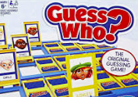 | Supermovers PSHE – fit and well  https://www.bbc.co.uk/teach/supermovers/pshe-super-mood-movers-fit-and-well/zqr67yc  Log onto:  www.gonoodle.com and complete your favourite NTV dance videos.  Don’t forget Joe Wicks is running his live PE session on his youtube channel at 9am today.
Spelling Green and Blue group only.
www.readingeggs.co.uk each child has been set a spelling task to complete. Follow the guidance attached to the blog to access the assignments.

A new assignment has been allocated, they will be updated daily.

Writing:
Orange group
Learning challenge: I can move in different ways, describing my movements.
We will be using this poem by Tony Mitton as a starting point for our work. You can find more poems by Tony in his books Plum and Come into this Poem
Find out more about Tony on his website: http://www.tonymitton.co.uk/ You will find clips of him reading his poems there too.
The focus for this learning is mainly speaking, listening and extending the children’s vocabulary. Share the poem every day and you might like to encourage them to undertake some drawing and writing tasks with adult help if appropriate. Resources attached below.
Day 3: Put on real or imaginary boots and move in different ways – walk, march, stamp, hop, leap, run. Play Follow my Leader games – take it in turns to be the leader.
Take some photographs of your movements and send them to me.
Green and blue groups.
We will be using this poem by Tony Mitton as a starting point for our work. You can find more poems by Tony in his books Plum and Come into this Poem.Find out more about Tony on his website:
http://www.tonymitton.co.uk/ You will find clips of him reading his poems there too.
About this poem: This poem tells the story of a much-loved pair of shoes which, after long and faithful service and an eventful ‘life’ are finally put in the recycling bin.
Day 3:
Learning challenge: I can draw pictures and label them using a poem as inspiration.
Draw a picture map showing all the things the shoes in the poem have done in their life and label e.g. trudging through snow and rain – trampled to school – danced with glee – clambered up a tree.

Poem is attached below.

Everyone:
When logging onto the www.readingeggs.co.uk app follow the link on the home screen to ‘fast phonics’.
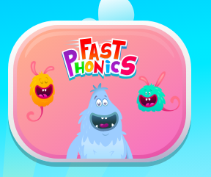

There are a variety of games to play which have been set at your child’s level.

Follow this link to our tricky words song and sing along.

https://www.youtube.com/watch?v=TvMyssfAUx0

Scroll down below grid for resources

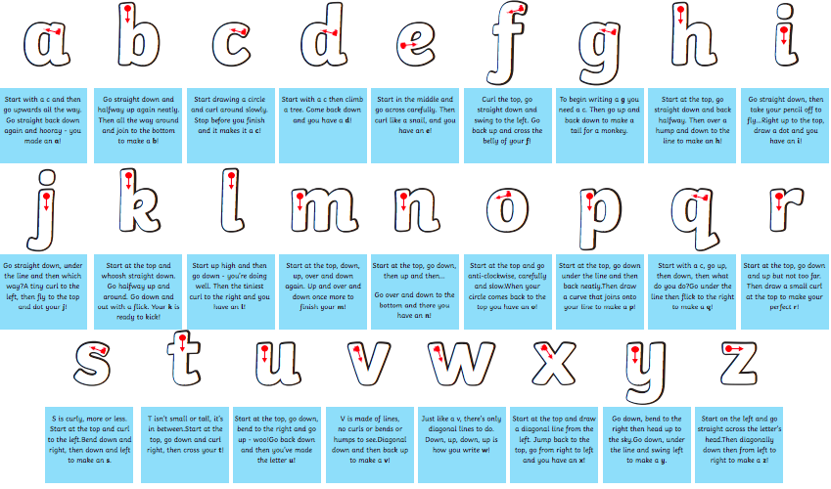
Phonics.
Pink group: letter formation rhymes

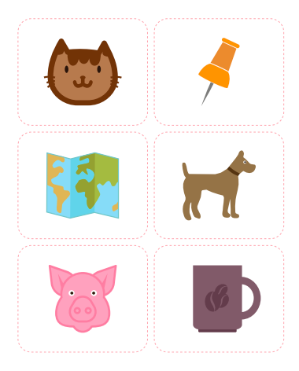
map
cat

pin

dog

cup

pig

Phonics.
Orange group – sentences.
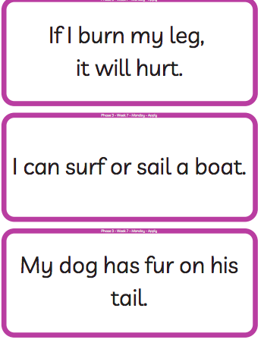

Phonics
Green group - sentences
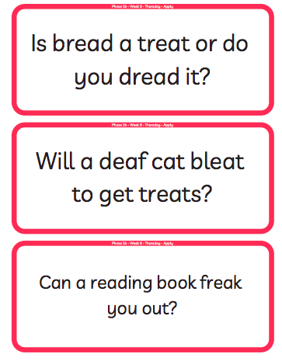

Phonics
Blue group example ‘best fit’ poster.

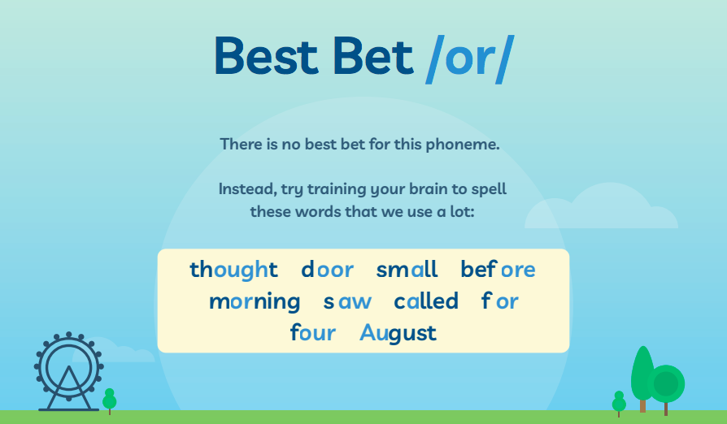

Orange group – writing.
About this poem:
This is a joyous, punchy, rhythmic poem. Children will love speaking it and moving to it. It is a poem to take outdoors and use as a marching rhyme and one we recommend to parents as a way of keeping little ones on the move!
Technical aspects:
The punchy feel to this poem is achieved by:
- the alliterative ‘b’ sounds in boots, big, busy which they can enjoy on their lips
- the use of mostly single syllable words
- the chorus repetition
- the 4-beat rhythm
- the use of rhyme
- the poem also uses onomatopoeia e.g. toot, squeak, splosh, squelch You do not need to use these terms with the children at this age.
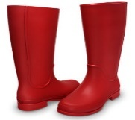
- Big Red Boots
This Photo by Unknown Author is licensed under CC BY

- Big red boots, big red boots.
One of them squeaks and the other one toots.
One of them hops and the other one stamps.
Big wet boots take long, wet tramps.

Boots, boots, big red boots.
One of them squeaks and the other one toots.

Big red boots on busy little feet
start out shiny, clean and neat.
Big red boots oh yes, yes, yes,
end up muddy in a terrible mess.

Boots, boots, big red boots.
One of them squeaks and the other one toots.

Boots, boots, big red boots,
squelch through mud and trample roots.
Big red boots say, “Look! Oh gosh!
What a great puddle there... Yay! SPLOSH!”

- Reproduced by kind permission of Tony Mitton

Green and blue group writing resources.
Technical aspects: The poem has a strong, marching rhythm of two beats to a line. The shoes in the poem are personified – given a life and a personality. The rhyme pattern is ABCB. Tony uses powerful verbs - trudged, tramped, clambered, pushed, stamped etc. reflect the hard, action- packed life of the shoes. The adjectives reflect what happens in the ageing process of humans – wrinkled, lined, thinning. The expression ‘down at heel’ is literal here but is an idiom sometimes used of people.

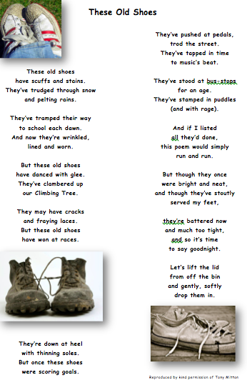

Green group maths questions – Adding using bonds.
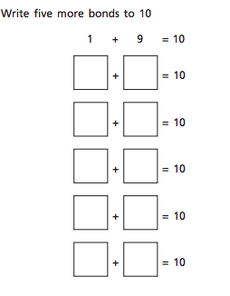
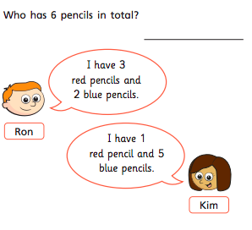
Questions should be answered in the following order: Green, orange, red, silver and gold.
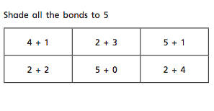

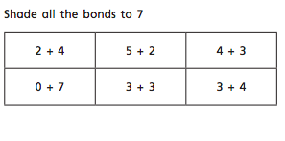

Blue group maths questions – Add by making 10
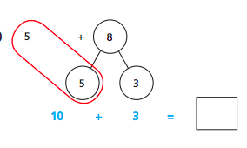
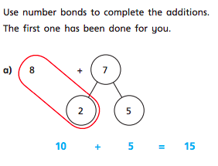
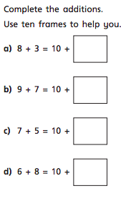
Questions should be answered in the following order: Green, orange, red, silver and gold.
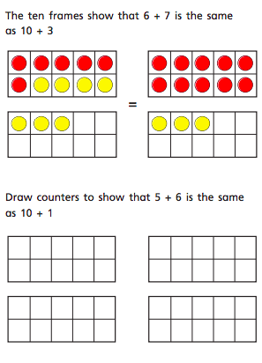

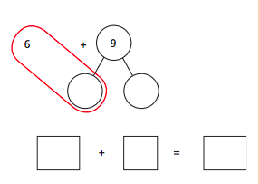

Orange group maths questions.
Discuss yesterdays questions and representations with the children. Today the children will be representing 9 using movement. Ask the children to show you 9 hops, skips, jumps, steps, claps and any other movements that you or they can think of! Take photographs to send in. Next, go for a numeral hunt in your environment or when you go for your daily exercise. You will be surprised at where you can find the number 9. Below are some examples. Take pictures of the most unusual place you find the number 9.
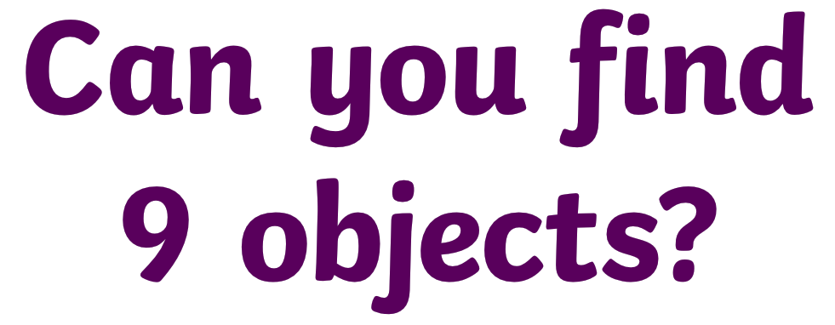

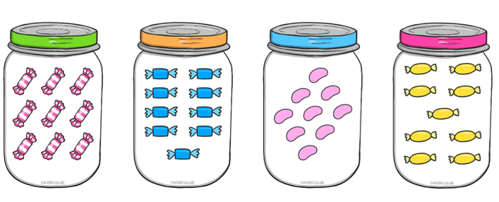
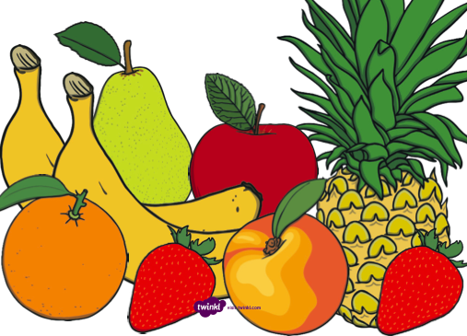
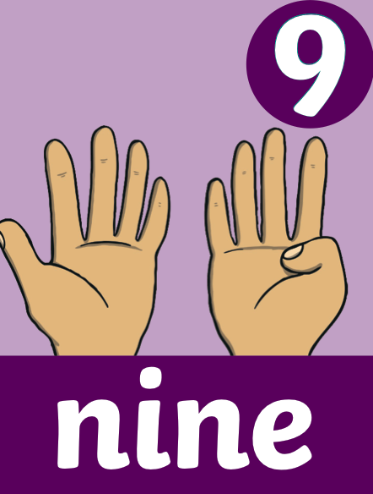
How many ways can you show 9 on your fingers?
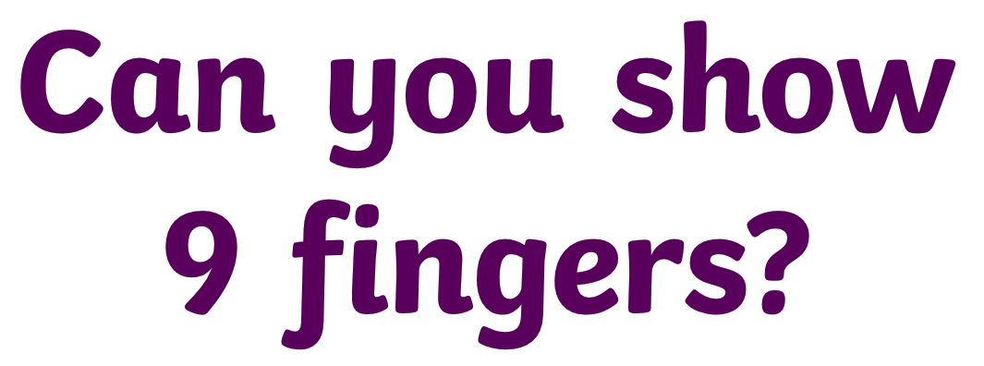
What time is this clock showing?

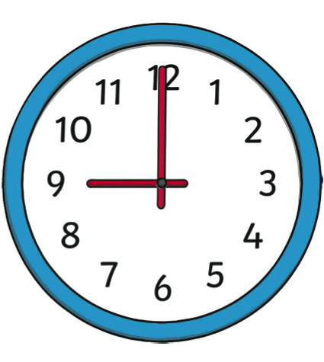
Can you identify the numeral 9 on the number line below?

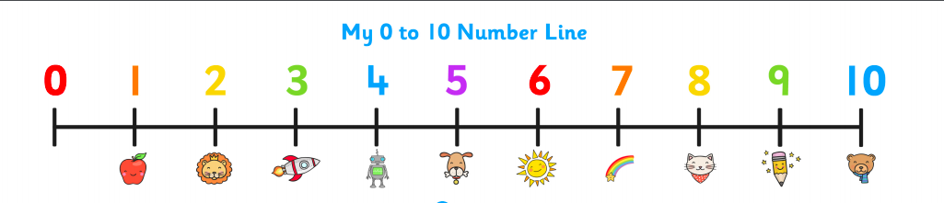

What is one more than 9?
What is one less than 9?

What number does this numicon shape represent?
How many spots are on this dice?

How many counters haver been placed in this 10 frame?

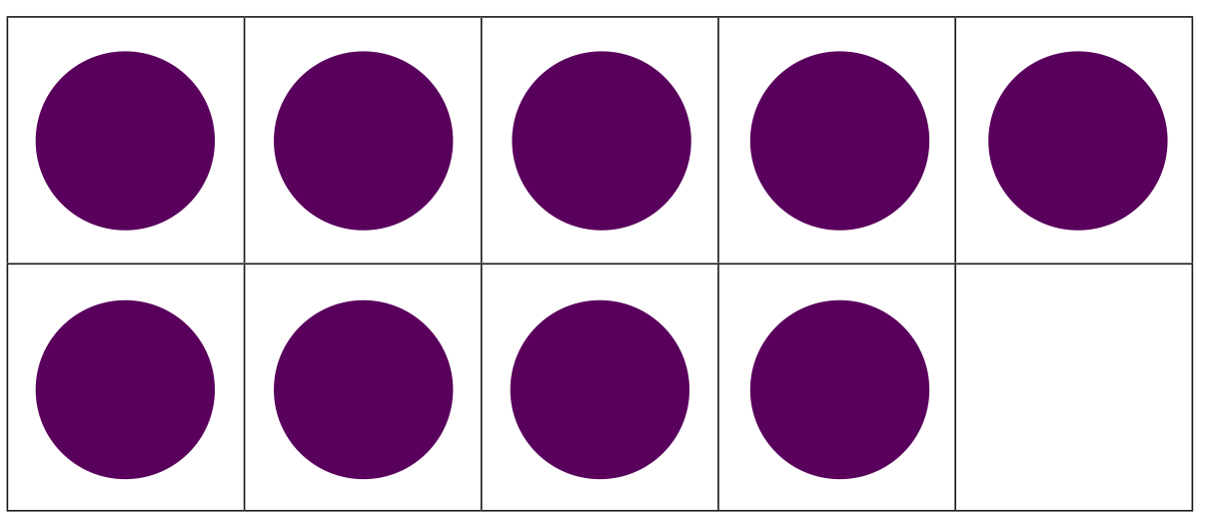

What is different about these representations?
How many ways have we represented 9?
What is the same about these representations?

Can you represent 9 in any other way? Take a picture and send it to me.

