Monday | ENGLISH  LC: I can use apostrophes for contraction and possession.  This is an online lesson delivered at 10am via TEAMS. Please login 5 minutes before with your microphone muted.  You will need:  - Pencil and paper  - Apostrophes -flowchart  - Apostrophe activity  There’s no need to print the resources.  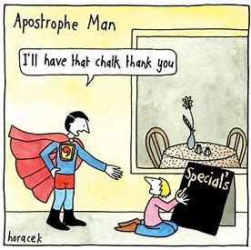  Apostrophes for possessions  How to use possessive apostrophes - BBC Bitesize  Apostrophes for contractions  How to use apostrophes in contractions - BBC Bitesize | MATHS  Today you are going to use a White Rose video and worksheet.  RED GROUP  Learning Challenge: I can divide by 5 and 10.  This is revisiting learning from Year 2 so please watch both videos and complete the 2 work sheets.  Aut3.10.4 - Divide by 5 on Vimeo  Aut3.10.5 - Divide by 10 on Vimeo  YELLOW, GREEN and BLUE GROUP  Learning Challenge: I can divide by 100.  Aut4.10.4 - Divide by 100 on Vimeo  PURPLE GROUP  Learning Challenge: I can divide using factors.  Aut6.5.4 - Division using factors on Vimeo  You will need:  - Pen and paper  - Worksheet on the blog (no need to print) | ENQUIRY  For our enquiry, this half term we are looking at inventions and inventors. Our questions to investigate and answer is:  WHAT HASN’T BEEN INVENTED YET?  To start thinking about this, we are focussing on “What is an inventor?”  I would like you to draw a picture of what you think an inventor looks like.  Is an inventor a mad professor in a lab coat?  Is an inventor Doctor Who or Wallace and Gromit?  Watch this video on BBC to find out what an inventor is like.  Design and Technology KS2: What is an inventor like? - BBC Teach  Label your drawing with the key words for what inventors are like. | ACTIVE  To make sure you are active for at least 60 minutes a day, try these activities:  *Have a scooter race/complete Active Mile  *Time yourself to see how many Star jumps you can do in one minute. What is your best score?  *Online PE with Joe Wicks is back. The 20-minutes sessions called PE with Joe are streamed live on Wicks’ YouTube channel at 9am Mondays, Wednesday and Fridays. Join him first thing for a positive start to the day or later on to suit you.

