08/1 | PHONICS | ENGLISH | MATHS | ENQUIRY | ACTIVE
WednesdayWWEDMONDAY | Pink group –  Learning challenge;  I can recognise, say and write the ‘p’ phoneme.  watch:  https://www.youtube.com/watch?v=8_NmgZWvWG4  Practice writing the letter ‘p’ - please see letter formation rhymes below as a guide.  Play silly soup- find things around your home that begin with the initial letter sound ‘t’. Add them into a container or saucepan to make a ‘t’ silly soup.  Practise oral blending. Look at the picture and word cards attached below. Sound out the words and match them to the right picture.  Orange group –  Learning challenge: I can spell two syllable words.  Watch: https://www.youtube.com/watch?v=epk-hnVC10k  Adults say the following words, children should put their fingers under their chin to work out how many syllables the words contain, then sound out the write the word.  Chicken, jacket, velvet, wicked, zigzag, tonight, farmyard, market.  Look at a pictures below of a boat, car, rocket, cart, jeep. Ask each child to write a caption for a picture e.g. This is my jeep. This rocket can go to the moon. This boat can zoom. This cart can go to the park. The car is on the road. The boat has got a sail.  Green group –  Learning challenge: I can pronounce the ‘er’ grapheme in a variety of ways.  Watch: https://www.youtube.com/watch?v=R2obnoQZMVA  then follow this link to play Acorn adventures https://www.phonicsplay.co.uk/resources/phase/5/acorn-adventures  Log in details are – Username: jan21 Password: home  Click on resources, phase 5, scroll down to phase 5b and select Acorn adventures, select the ‘er’ grapheme.  Finally, sound out to read the sentences below. They contain different pronunciations of the ‘ea’ grapheme.  Blue group:  Learning challenge: I identify the ‘air’ grapheme spelt in a variety of ways.  Read through the phoneme spotter attached below. How many ways can you spot the phoneme ‘air’ being spelt differently? Write down all the ways you find. | Reading.  www.readingeggs.co.uk each child has been set a reading comprehension task to complete. Follow the guidance attached to the blog to access the assignments.  Each child has also been allocated a library book which you can access through the library function on the homepage. | Orange group – this week we will be focusing on the number 9.  Learning challenge: I can identify and represent the number 9 in a variety of ways.  Today we will be partitioning 9 in a variety of ways and using part whole models to represent our findings.  Resources and questions/instructions are attached below.  Parents follow this link to learn about using part whole models: https://www.youtube.com/watch?v=t0VndEcSOJM  Green group – you will be continuing our work on addition and subtraction by adding more.  Learning challenge: I can find a part.  Watch this video by following the link: https://vimeo.com/467773676 then answer the questions attached below.  Once finished, check your understanding using the answers (attached to the blog).  Blue group: you will be continuing our work on addition and subtraction.  Learning challenge: I can add a two digit number and a one digit number, crossing 10.  Watch this video by clicking the link: https://vimeo.com/465863014 the answer the questions attached below.  Once finished, check your understanding using the answers (attached to the blog). | Our enquiry this half term is based around ‘inventors’ and we will work towards answering the question ‘Can anybody be an inventor?’  This week we will be focusing on the questions:  ‘What is an inventor?’  and  ‘What is an invention?’  Take a large piece of paper and record what you already know about this topic (as we would in school). Be prepared to feedback your responses to the above questions – there are no wrong answers! | 60 second challenge!  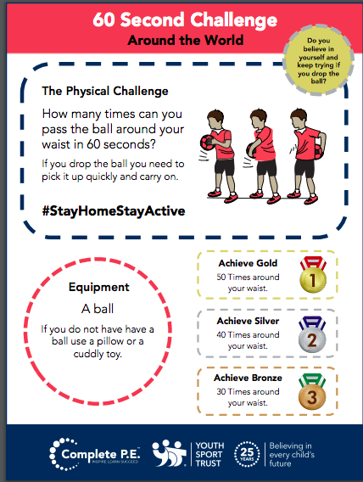  Don’t forget Joe Wicks is running his live PE session on his youtube channel at 9am today.
Spelling Green and Blue group only.
www.readingeggs.co.uk each child has been set a spelling task to complete. Follow the guidance attached to the blog to access the assignments.

A new assignment has been allocated, they will be updated daily.

Writing:
Orange group
Learning challenge: I can continue a rhyming string.
We will be using this poem by Tony Mitton as a starting point for our work. You can find more poems by Tony in his books Plum and Come into this Poem
Find out more about Tony on his website: http://www.tonymitton.co.uk/ You will find clips of him reading his poems there too.
The focus for this learning is mainly speaking, listening and extending the children’s vocabulary. Share the poem every day and you might like to encourage them to undertake some drawing and writing tasks with adult help if appropriate. Resources attached below.
Day 4: Read the poem again and leave out the rhyming words at the end of each second line – can your child fill in the gaps? Can you think of other rhyming words to go with them?
Attached below are some rhyming boots to help – you could sound out to write your rhyming string if you would like a challenge!
boots – toots – roots - ? stamps – tramps - ?
feet – neat - ?
yes – mess - ?
gosh – splosh -?

Green and blue groups.
We will be using this poem by Tony Mitton as a starting point for our work. You can find more poems by Tony in his books Plum and Come into this Poem.Find out more about Tony on his website:
http://www.tonymitton.co.uk/ You will find clips of him reading his poems there too.
About this poem: This poem tells the story of a much-loved pair of shoes which, after long and faithful service and an eventful ‘life’ are finally put in the recycling bin.
Day 4:
Learning challenge: I can identify verbs (movement words) and think of synonyms.
Draw round your foot and write the movement words from the poem inside the foot: trudge, tramp, danced… Check that you know what each word means.
Can you add more related words?
Poem is attached below.

Everyone:
When logging onto the www.readingeggs.co.uk app follow the link on the home screen to ‘fast phonics’.
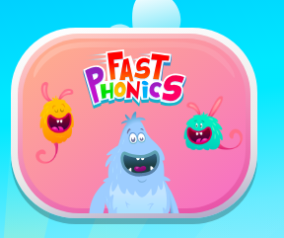

There are a variety of games to play which have been set at your child’s level.

Follow this link to sing our alphabet song:
https://www.youtube.com/watch?v=XC6wQQHo8uU

Scroll down below grid for resources

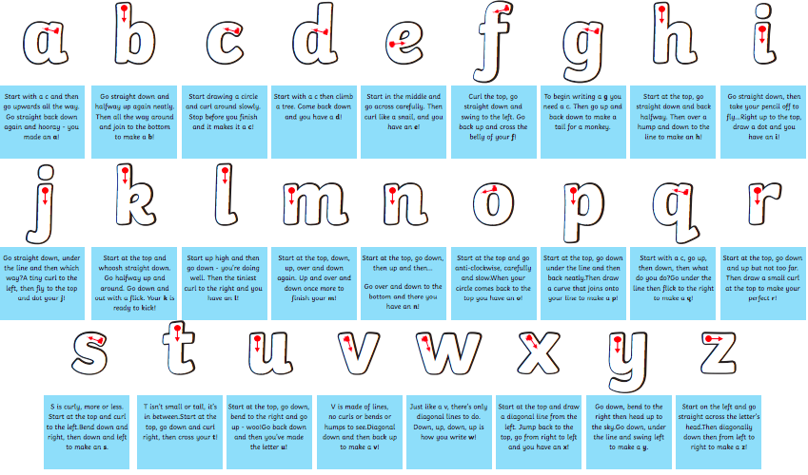
Phonics.
Pink group: letter formation rhymes

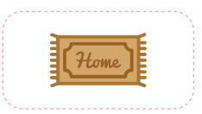
pan
map

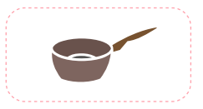

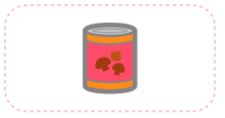
tin

mat

Phonics.
Orange group –
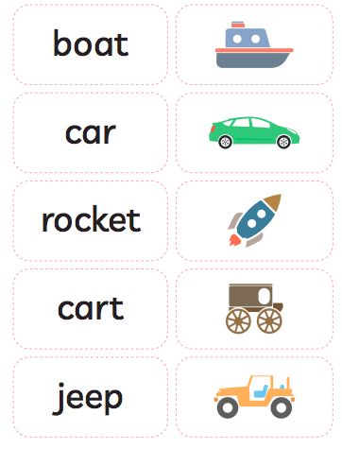

Phonics
Green group - sentences
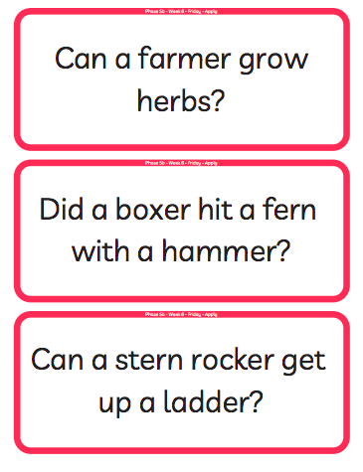

Phonics
Blue group ‘air’ phoneme spotter

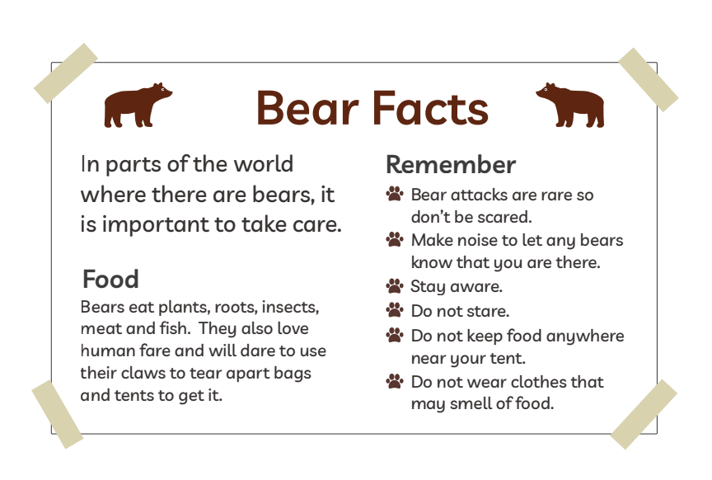

Orange group – writing.
About this poem:
This is a joyous, punchy, rhythmic poem. Children will love speaking it and moving to it. It is a poem to take outdoors and use as a marching rhyme and one we recommend to parents as a way of keeping little ones on the move!
Technical aspects:
The punchy feel to this poem is achieved by:
- the alliterative ‘b’ sounds in boots, big, busy which they can enjoy on their lips
- the use of mostly single syllable words
- the chorus repetition
- the 4-beat rhythm
- the use of rhyme
- the poem also uses onomatopoeia e.g. toot, squeak, splosh, squelch You do not need to use these terms with the children at this age.
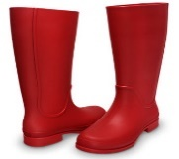
- Big Red Boots
This Photo by Unknown Author is licensed under CC BY

- Big red boots, big red boots.
One of them squeaks and the other one toots.
One of them hops and the other one stamps.
Big wet boots take long, wet tramps.

Boots, boots, big red boots.
One of them squeaks and the other one toots.

Big red boots on busy little feet
start out shiny, clean and neat.
Big red boots oh yes, yes, yes,
end up muddy in a terrible mess.

Boots, boots, big red boots.
One of them squeaks and the other one toots.

Boots, boots, big red boots,
squelch through mud and trample roots.
Big red boots say, “Look! Oh gosh!
What a great puddle there... Yay! SPLOSH!”

- Reproduced by kind permission of Tony Mitton
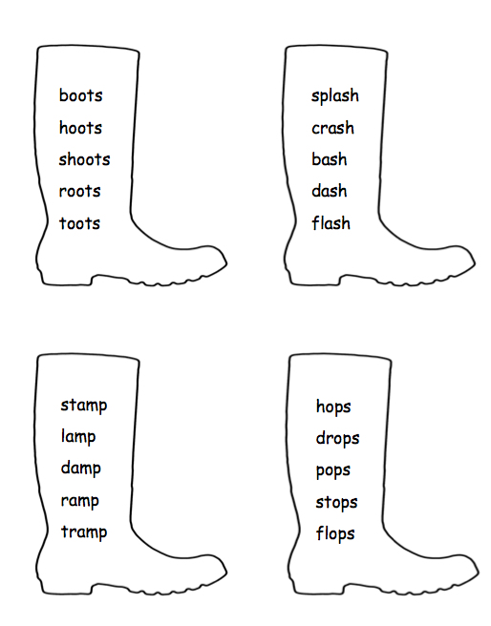

Green and blue group writing resources.
Technical aspects: The poem has a strong, marching rhythm of two beats to a line. The shoes in the poem are personified – given a life and a personality. The rhyme pattern is ABCB. Tony uses powerful verbs - trudged, tramped, clambered, pushed, stamped etc. reflect the hard, action- packed life of the shoes. The adjectives reflect what happens in the ageing process of humans – wrinkled, lined, thinning. The expression ‘down at heel’ is literal here but is an idiom sometimes used of people.

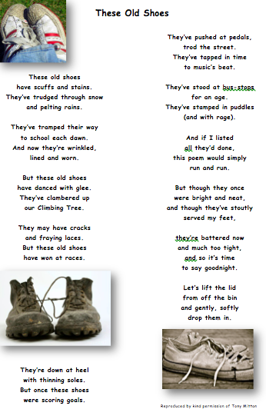

Green group maths questions – Find a part
Questions should be answered in the following order: Green, orange, red, silver and gold.
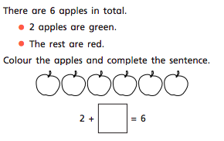
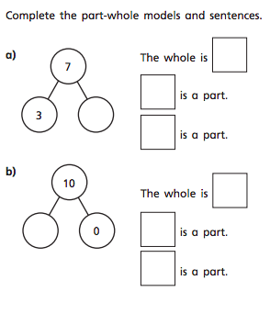
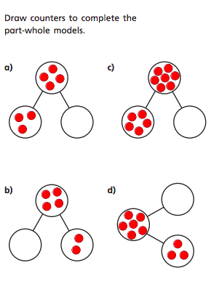

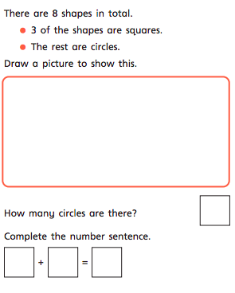

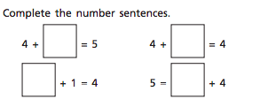

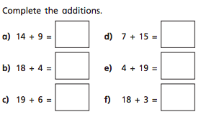
Blue group maths questions – Add a two-digit number and a one-digit number – crossing 10
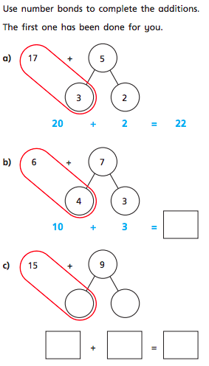
Questions should be answered in the following order: Green, orange, red, silver and gold.
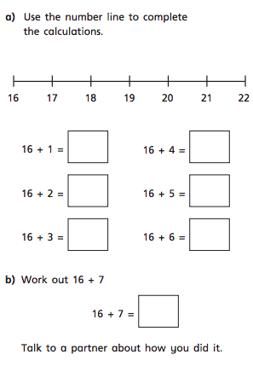

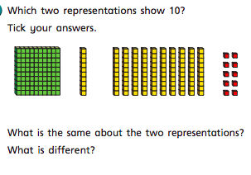

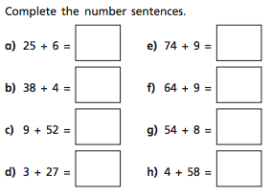
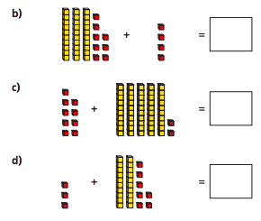
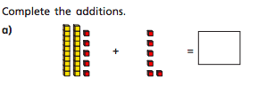

Orange group maths questions.
Recap all the work completed on the number 9 so far. Can you represent/identify nine in a variety of ways? Use the part whole model below to show how many ways 9 can be partitioned. Take photographs and send them to me. Can you find all the ways?
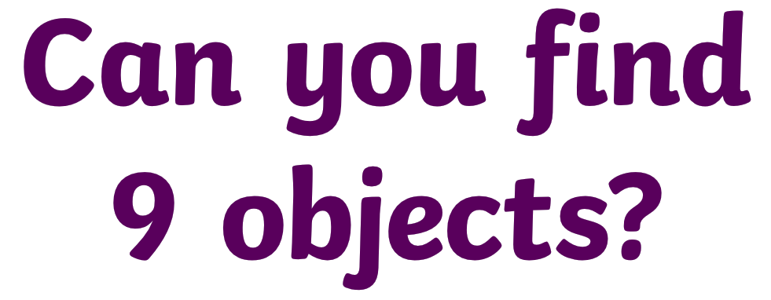

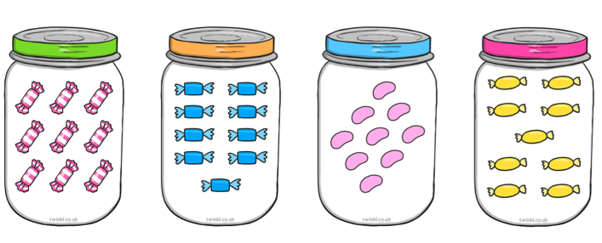
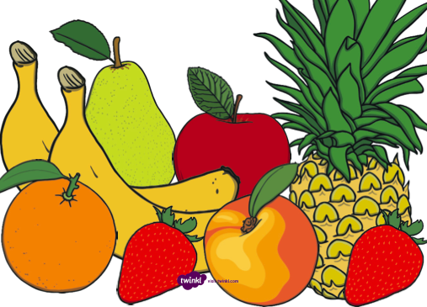
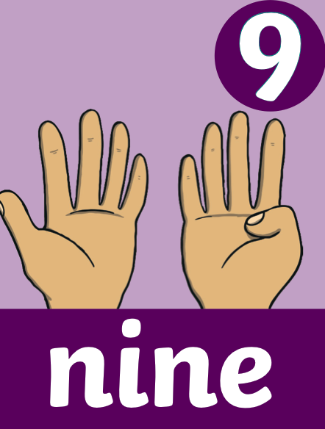
How many ways can you show 9 on your fingers?
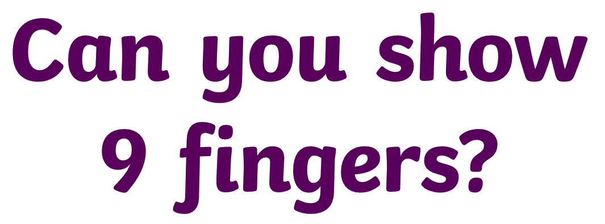
What time is this clock showing?

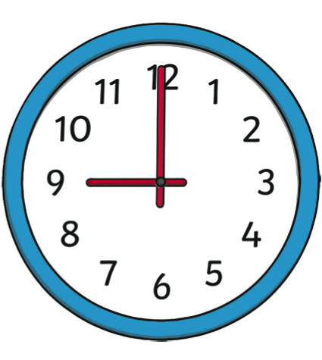
Can you identify the numeral 9 on the number line below?

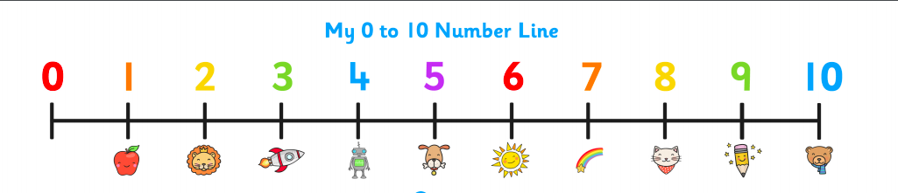

What is one more than 9?
What is one less than 9?

What number does this numicon shape represent?
How many spots are on this dice?

How many counters haver been placed in this 10 frame?

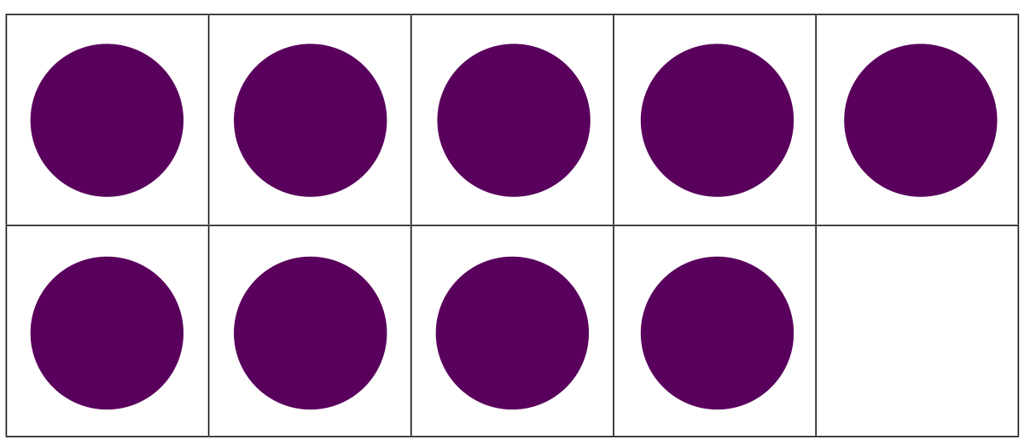

What is different about these representations?
How many ways have we represented 9?
What is the same about these representations?

Can you represent 9 in any other way? Take a picture and send it to me.

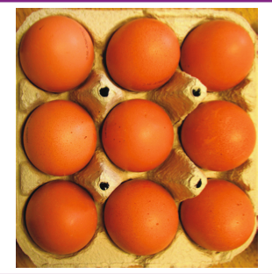
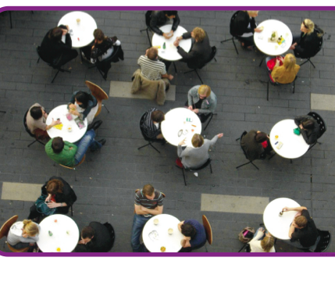
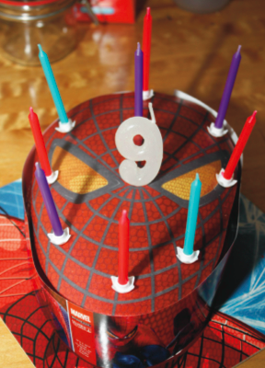
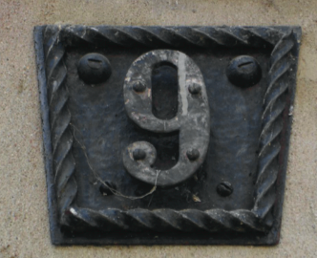

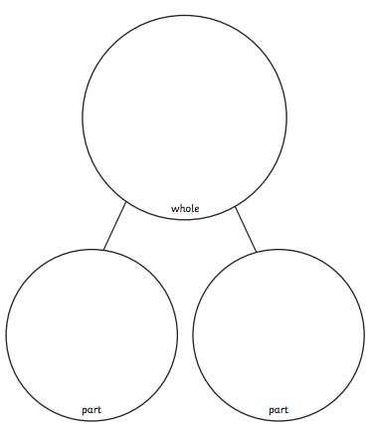

Active challenge:

