This is the home screen once you have logged in. To find the assignments that your teacher has set for you, click on the purple Reading Eggspress icon.
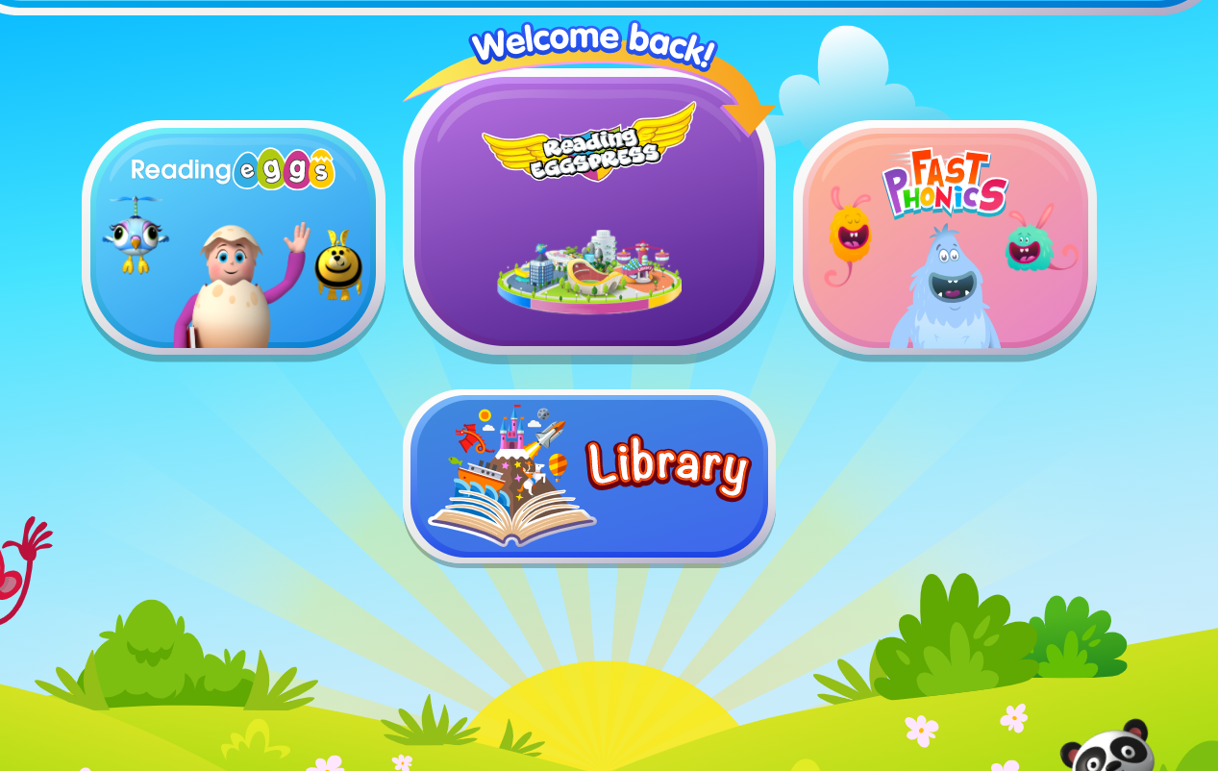
This screen shows you your assignments to complete and tells you when they should be completed by. There may be more than one assignment as we are using this platform for both spelling and reading comprehension. Click START NOW to complete your work.
