Tuesday | ENGLISH  Year 3/4 Learning Challenge: I can find and record key facts.  Continue with the Plum Poetry unit.  Use a computer or the fact sheet attached to the blog (Year 3-4 Trees Information) to research the importance of trees: try https://trees.org or https://www.woodlandtrust.org.uk  Make notes about why trees are important. Re-write the facts in your own words, be careful with spellings.  You will need:  - Pen and paper  - Trees Information sheet attached to Blog (no need to print)  Year 5/6 LEARNING CHALLENGE: I can find key facts and use these as information.  Continue with the Elephant Poetry unit.  Produce either: A list of important facts under the title: Did you know this about Elephants?’  or: A poster entitled: Elephants In Danger alerting people to the man-made threats to elephant survival.  Success Criteria:  *Use the information you have collected so far.  *Think back to our posters for information about Polruan. Use the learning about lay out to make sure your fact file/poster is easily accessible (the information is easy to read).  *Make sure all key words are spelt correctly.  You will need:  - Pencil and paper.  - Information about elephants. | MATHS  These are live TEAMS lessons. Check your group colour and login 5 minutes before your session with your microphone muted.  RED 9:00 – 9:30  Learning Challenge: I can multiply and divide by 3.  YELLOW & BLUE 9:40-10:10  Learning Challenge: I can multiply by 1 and 0  GREEN 10:20 – 10:50  Learning Challenge: I can multiply by 1 and 0  PURPLE 11:00 – 11:30  Learning Challenge: I can use long division.  You will need:  - Pen and paper  - Worksheet attached to Blog (no need to print)  - A smile | ENQUIRY  For our enquiry, this half term we are looking at inventions and inventors. Our questions to investigate and answer is:  WHAT HASN’T BEEN INVENTED YET?  To start thinking about this, we will focus on What is an inventor?  HISTORY  Learning challenge: I can use research to collect facts.  Today we are looking at famous inventors.  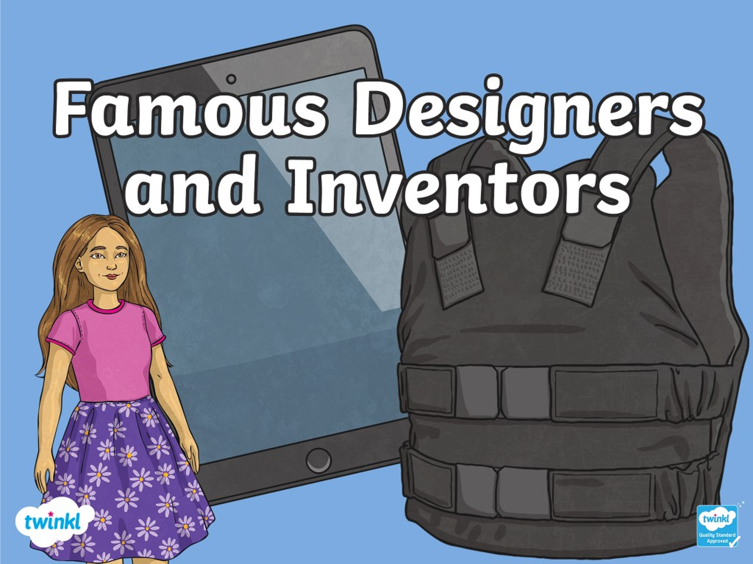  Watch the PowerPoints to learn about some of the most famous inventors. Complete the tasks on slide 3, 12, 13 and 14. | ACTIVE  To make sure you are active for at least 60 minutes a day, try these activities:  *Time yourself to see how many squats you can do in one minute. What is your best score?  *Choose a “Let’s Dance!” video from this link:  https://www.youtube.com/playlist?list=PLJnn5H8Y_tYE3LdXoJIG_azMC2l5TjCON  *Go for a walk in the village.

