12/1 | PHONICS | ENGLISH | MATHS | ENQUIRY | ACTIVE
WednesdayWWEDMONDAY | Pink group –  Learning challenge;  I can recognise, say and write the ‘s,a,t, p’ phonemes.  This will be an online lesson delivered via TEAMS at 10:30am. Please log in 5 minutes before the session is due to start.  You will need:  - Phonics flashcards for letters: s a t p (these can just be written on paper if you cannot find your flashcards).  - Paper and something to write with.  After the lesson please see how many words you can make using the phonemes s a t p. Take a photograph and if possible video your child segmenting and blending these words – send me the pictures/video it would be lovely to hear you blending!  Orange group –  Learning challenge: I can recognise, read and write the ‘ow’ phoneme.  This will be an online lesson delivered via TEAMS at 9:30am. Please log in 5 minutes before the session is due to start.  You will need:  - Paper and something to write with.  After the lesson please watch this video by following this link: https://www.youtube.com/watch?v=EznhbviF_2w  Green group –  Learning challenge: I can pronounce the ‘a’ grapheme in a variety of ways.  This will be an online lesson delivered via TEAMS at 11:00. Please log in 5 minutes before the session is due to start.  You will need:  - Paper and something to write with.  After the lesson please follow this link to play tricky word trucks: https://www.phonicsplay.co.uk/resources/phase/5/tricky-word-trucks  Click on ‘start’, then ‘phase 5b’ record your score!  Username: jan21  Password: home  Blue group:  Learning challenge: I identify the ‘air’ grapheme spelt in a variety of ways.  This will be an online lesson delivered via TEAMS at 9:00am. Please log in 5 minutes before the session is due to start.  You will need:  - Your phoneme spotter from yesterday  - Paper and something to write with. | Reading.  www.readingeggs.co.uk each child has been set a reading comprehension task to complete. Follow the guidance attached to the blog to access the assignments.  Each child has also been allocated a library book which you can access through the library function on the homepage. | Orange group – this week we will be focusing on the number 9.  Learning challenge: I can identify and represent the number 9 in a variety of ways.  Investigate how many ways you can make 9p using coins. 5p, 2p and 1p.  Resources and questions/instructions are attached below. Please take photographs of this activity and send them to me.  Once you have completed these questions please log onto www.mathseeds.co.uk and complete your set assignment.  Green group – you will be continuing our work on addition and subtraction by crossing out.  Learning challenge: I can subtract using the crossing out method.  Watch this video by following the link: https://vimeo.com/468246766 then answer the questions attached below.  Please submit a photograph of this work to me by the end of the day for marking and feedback.  Once you have completed these questions please log onto www.mathseeds.co.uk and complete your set assignment.  Blue group: you will be continuing our work on addition and subtraction.  Learning challenge: I can subtract crossing 10.  Watch this video by clicking the link: https://vimeo.com/465728628 then answer the questions attached below.  Please submit a copy of this work to me (photograph) by the end of the day for marking and feedback.  Once you have completed these questions please log onto www.mathseeds.co.uk and complete your set assignment. | Our enquiry this half term is based around ‘inventors’ and we will work towards answering the question ‘Can anybody be an inventor?’  Yesterday you thought about the questions “what is an inventor?” and “what is an invention?”  Discuss: Today we will be thinking about whether an invention always needs to be something brand new or whether you could adapt an existing product.  Watch the following clip.  https://www.bbc.co.uk/teach/class-clips-video/design-and-technology-ks2-what-is-an-invention/zrf92sg  Choose a small product in your house that you think you may be able to improve.  Draw the product with your improvements and label it. Send a picture to me so that I can see your inventions! | 60 second challenge!  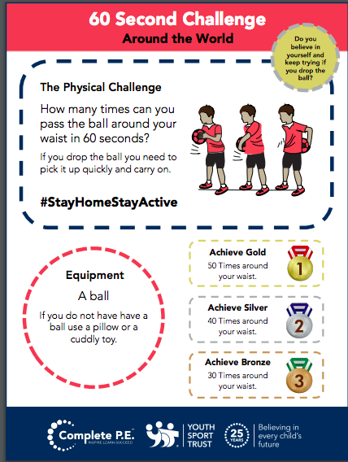  PSHE – taking care of our world.  https://www.bbc.co.uk/teach/supermovers/pshe-super-mood-movers-taking-care-of-the-world/zyxc3j6
Spelling Green and Blue group only.
www.readingeggs.co.uk each child has been set a spelling task to complete. Follow the guidance attached to the blog to access the assignments.

A new assignment has been allocated, they will be updated daily.

Writing:
Orange group
Learning challenge: I can identify and suggest onomatopoeic words.
We will be using this poem by Tony Mitton as a starting point for our work. You can find more poems by Tony in his books Plum and Come into this Poem
Find out more about Tony on his website: http://www.tonymitton.co.uk/ You will find clips of him reading his poems there too.
The focus for this learning is mainly speaking, listening and extending the children’s vocabulary. Share the poem every day and you might like to encourage them to undertake some drawing and writing tasks with adult help if appropriate. Resources attached below.
Day 5:
Watch the following video clip to learn about onomatopoeia: YOU ONLY NEED TO WATCH TO 4 MINUTES - https://www.youtube.com/watch?v=_qW6677kmVo
Talk about the onomatopoeic words such as squeak, toot, squelch, splosh. Can you think of anymore? For example: splash, ooze, crash, bang. Make sure that they know what these words mean.

Green and blue groups.
We will be using this poem by Tony Mitton as a starting point for our work. You can find more poems by Tony in his books Plum and Come into this Poem.Find out more about Tony on his website:
http://www.tonymitton.co.uk/ You will find clips of him reading his poems there too.
About this poem: This poem tells the story of a much-loved pair of shoes which, after long and faithful service and an eventful ‘life’ are finally put in the recycling bin.
Day 5:
Learning challenge: I can add the suffix ‘ed’ to write in the past tense.
Follow this link to learn about adding suffixes ‘ed’ and ‘ing’ to words: https://www.bbc.co.uk/bitesize/articles/zp74vwx
Then complete the interactive activities.
Imagine you have been for a walk and then write a list poem about what you did, using the vocabulary from yesterday. For example:
We marched to the gate.
We trampled down the road.
We stamped in puddles.
Remember to use -ed in the past tense.
Poem is attached below.

Everyone:
When logging onto the www.readingeggs.co.uk app follow the link on the home screen to ‘fast phonics’.
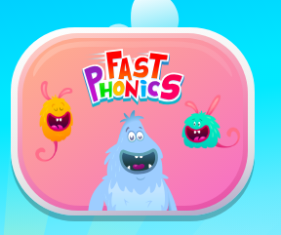

There are a variety of games to play which have been set at your child’s level.

Follow this link to sing our tricky words song:
https://www.youtube.com/watch?v=TvMyssfAUx0

Scroll down below grid for resources

Blue group ‘air’ phoneme spotter

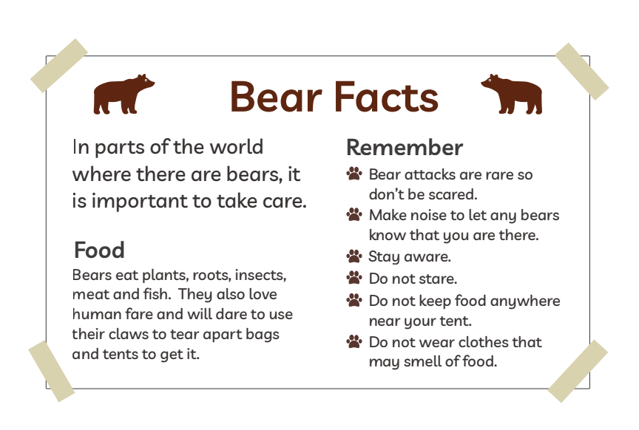

Orange group – writing.
About this poem:
This is a joyous, punchy, rhythmic poem. Children will love speaking it and moving to it. It is a poem to take outdoors and use as a marching rhyme and one we recommend to parents as a way of keeping little ones on the move!
Technical aspects:
The punchy feel to this poem is achieved by:
- the alliterative ‘b’ sounds in boots, big, busy which they can enjoy on their lips
- the use of mostly single syllable words
- the chorus repetition
- the 4-beat rhythm
- the use of rhyme
- the poem also uses onomatopoeia e.g. toot, squeak, splosh, squelch You do not need to use these terms with the children at this age.
- Big Red Boots
This Photo by Unknown Author is licensed under CC BY

- Big red boots, big red boots.
One of them squeaks and the other one toots.
One of them hops and the other one stamps.
Big wet boots take long, wet tramps.

Boots, boots, big red boots.
One of them squeaks and the other one toots.

Big red boots on busy little feet
start out shiny, clean and neat.
Big red boots oh yes, yes, yes,
end up muddy in a terrible mess.

Boots, boots, big red boots.
One of them squeaks and the other one toots.

Boots, boots, big red boots,
squelch through mud and trample roots.
Big red boots say, “Look! Oh gosh!
What a great puddle there... Yay! SPLOSH!”

- Reproduced by kind permission of Tony Mitton
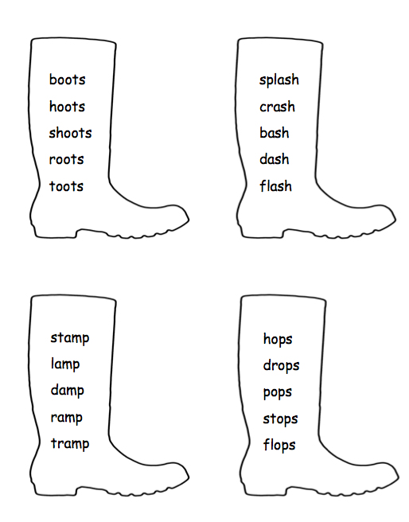

Green and blue group writing resources.
Technical aspects: The poem has a strong, marching rhythm of two beats to a line. The shoes in the poem are personified – given a life and a personality. The rhyme pattern is ABCB. Tony uses powerful verbs - trudged, tramped, clambered, pushed, stamped etc. reflect the hard, action- packed life of the shoes. The adjectives reflect what happens in the ageing process of humans – wrinkled, lined, thinning. The expression ‘down at heel’ is literal here but is an idiom sometimes used of people.

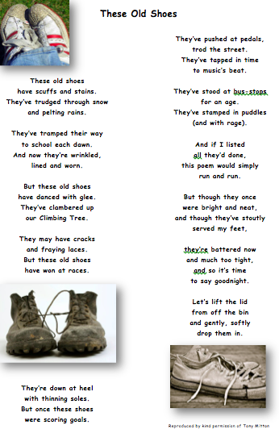
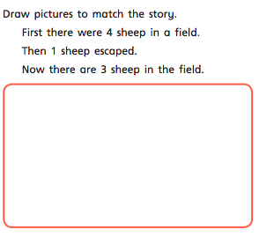
Green group maths questions – Subtract by crossing out
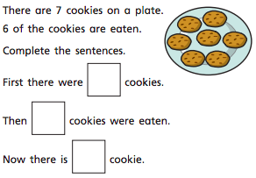
Questions should be answered in the following order: Green, orange, red, silver and gold.
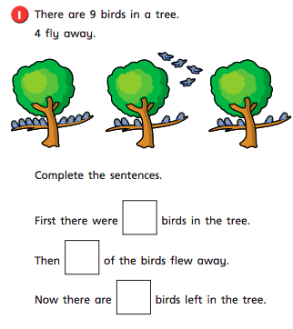

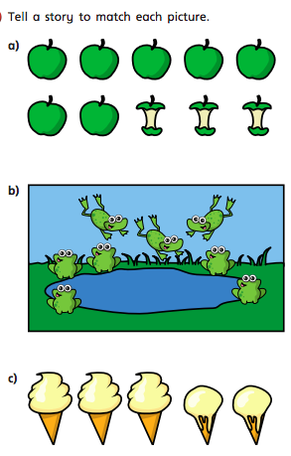

Blue group maths questions – Subtract – crossing 10
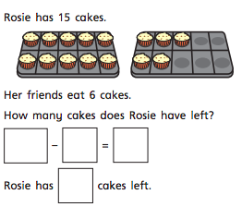
Questions should be answered in the following order: Green, orange, red, silver and gold.
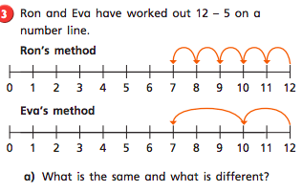
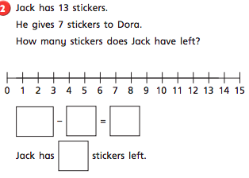

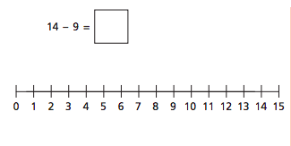
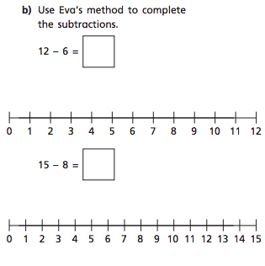
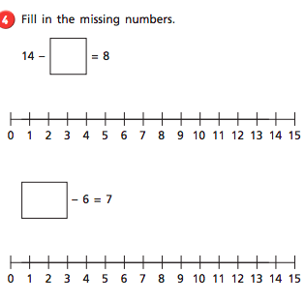

Orange group maths questions.
Recap all the work completed on the number 9 so far. Can you represent/identify nine in a variety of ways? Use the part whole model below to show how many ways 9 can be partitioned. Use the coins to find how many ways you can make 9p.
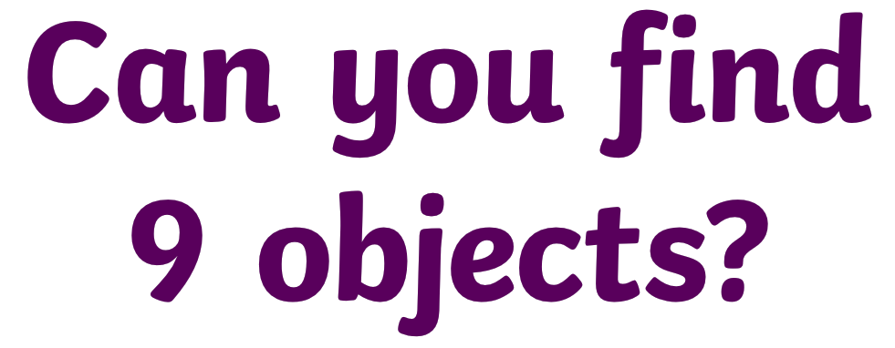

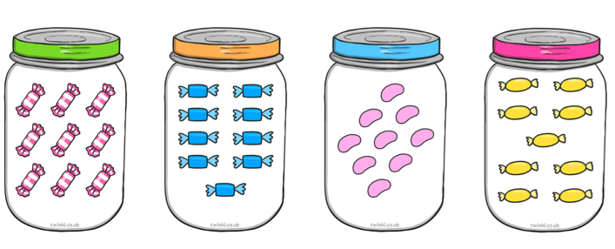
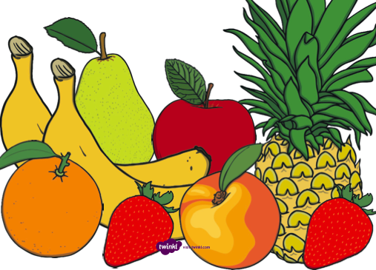
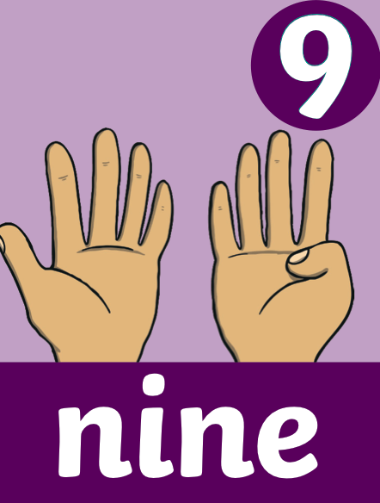
How many ways can you show 9 on your fingers?
What time is this clock showing?

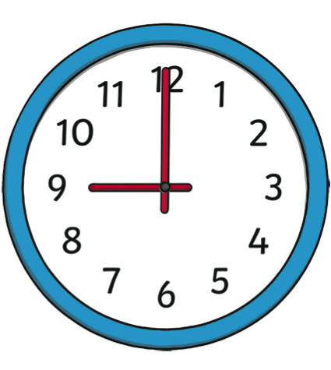
Can you identify the numeral 9 on the number line below?

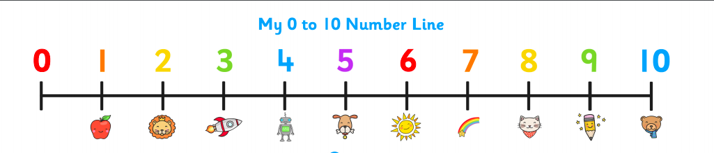

What is one more than 9?
What is one less than 9?

What number does this numicon shape represent?

How many counters haver been placed in this 10 frame?
How many spots are on this dice?

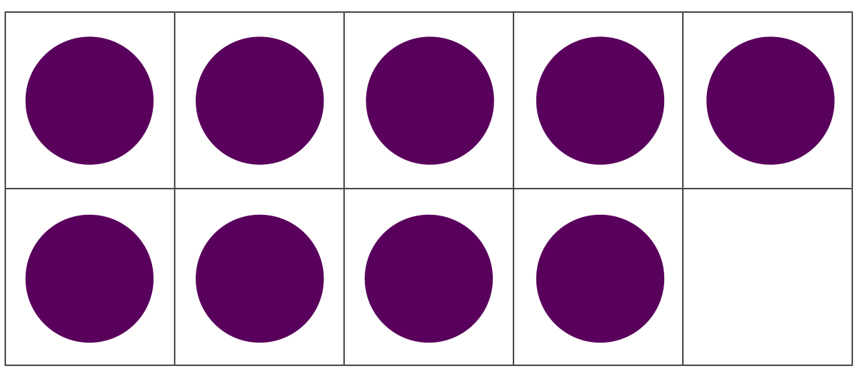

What is different about these representations?

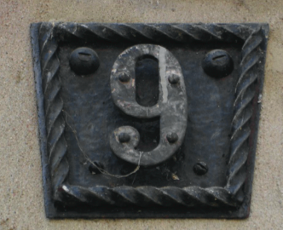
Can you represent 9 in any other way? Take a picture and send it to me.

How many ways have we represented 9?
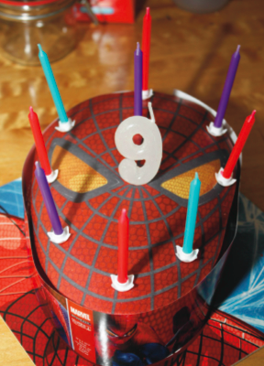
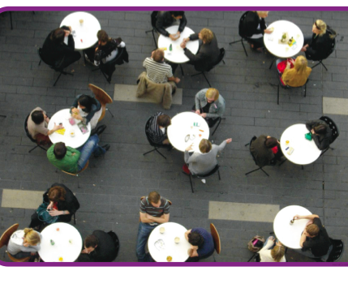
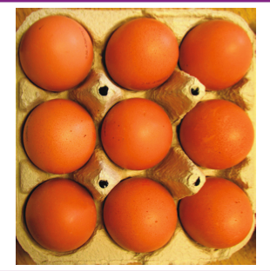
What is the same about these representations?

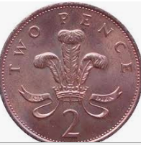
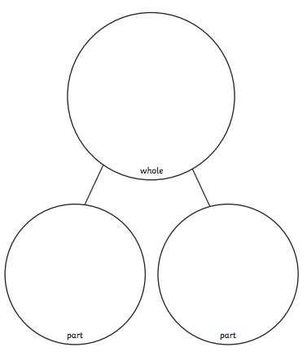

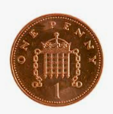

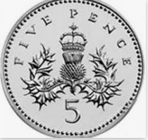

Active challenge:

