13/1 | PHONICS | ENGLISH | MATHS | ENQUIRY | ACTIVE
WednesdayWWEDMONDAY | Pink group –  Learning challenge;  I can recognise, say and write the ‘i’ phoneme.  Follow this link to watch this video: https://www.youtube.com/results?search_query=mr+thorne+does+phonics+i  Then, practise writing the letters learned so far using a range of writing implements (and lots of different colours!). You should fill your page with the phonemes s, a, t, p, i Take a photograph of your full, colourful page and send it to me.  Orange group –  Learning challenge: I can recognise, read and write the ‘oi’ phoneme.  Follow this link to watch this video: https://www.youtube.com/watch?v=IRTITdRL_cU  Then, play Quickwrite: Adults say the following words children should sound out to write the words (remember to use phoneme fingers) and add soundbuttons underneath.  oil, boil, coin, coil, join, soil, poison, foil, turnip, burn, down, town.  Send me a photograph of your completed words.  Finally, sound out to read the questions below and give a thumbs up if the answer is yes and a thumbs down if the answer is no.  Green group –  Learning challenge: I can pronounce the ‘y’ grapheme in a variety of ways.  Follow this link to play tricky word trucks: https://www.phonicsplay.co.uk/resources/phase/5/tricky-word-trucks  Click on ‘start’, then ‘phase 5b’ record your score!  Username: jan21  Password: home  Then follow this link to watch this video:  Divide your page into four columns and label as below:  Y Y – ‘igh’ Y – ‘i’ Y – ‘ee’  yes by gym very  Sort the following words into the correct columns based on how they are pronounced (said) in the word. yes, yell, yawn, yellow, yet, by, why, dry, reply, sky, gym, crystal, pyramid, myth, happy, funny, hairy, smelly, crunchy  Finally, read the sentences attached below – the all contain the ‘y’ grapheme pronounced in a variety of ways.  Blue group:  Learning challenge: I identify the ‘air’ grapheme spelt in a variety of ways.  Read through our phoneme spotter from Monday – how many ways can you spot to spell the grapheme ‘air’.  Using the grid below sort the words into the correct columns. When you have finished count the number of words in each column. Which is the most common spelling? Which is the least common spelling?  Resources attached below. | Reading.  www.readingeggs.co.uk each child has been set a reading comprehension task to complete. Follow the guidance attached to the blog to access the assignments.  Each child has also been allocated a library book which you can access through the library function on the homepage. | Orange group – this week we will be focusing on the number 9.  Learning challenge: I can identify and represent the number 9 in a variety of ways.  Today we will be finishing our work on the number 9. Work through the powerpoint ‘All about 9’ which is attached to the class blog. There is also an ‘I spy 9’ and a ‘9 formation’ activity below.  Once you have completed these questions please log onto www.mathseeds.co.uk and complete your set assignment.  Green group – you will be continuing our work on addition and subtraction by crossing out.  Learning challenge: I can subtract by finding a part.  This will be an online lesson delivered via TEAMS at 10:30am.Please log onto your teams platform 5 minutes before the lesson is due to start.  You will need:  - A pencil  - Questions (attached below).  Once you have completed these questions please log onto www.mathseeds.co.uk and complete your set assignment.  Blue group: you will be continuing our work on addition and subtraction.  Learning challenge: I can subtract a 1 digit number from a 2 digit number.  Watch this video by clicking the link: https://vimeo.com/466497248 then answer the questions attached below.  Once you have completed these questions please log onto www.mathseeds.co.uk and complete your set assignment. | Our enquiry this half term is based around ‘inventors’ and we will work towards answering the question ‘Can anybody be an inventor?’  Yesterday you chose a small product in your house that you improved.  Today you will present your invention to the world!  What is your inventions name?  What does your invention do?  How did you make the improvements?  What’s the best thing about your invention?  Is there anything special you would like to tell us about your invention?  Adults, please video your child presenting their invention and send it to me or they can answer these questions by writing. | Don’t forget Joe Wicks is running his live PE session today from his youtube channel.  Log into www.gonoodle.com and choose your favourite Pump it up workout video. Can you challenge yourself to complete the whole 20 minutes?
Spelling Green and Blue group only.
www.readingeggs.co.uk each child has been set a spelling task to complete. Follow the guidance attached to the blog to access the assignments.

A new assignment has been allocated, they will be updated daily.

Writing:
Orange group
Learning challenge: I can identify and describe places I have been.
The focus for this learning is mainly speaking, listening and extending the children’s vocabulary. Share the poem every day and you might like to encourage them to undertake some drawing and writing tasks with adult help if appropriate. Resources attached below.
Day 6: This will be an online lesson delivered via TEAMS at 10:00am. Please log into teams 5 minutes before the lesson is due to start.

Resources you will need:
- A pencil
- Paper to write on.

Green and blue groups.
About this poem: This poem tells the story of a much-loved pair of shoes which, after long and faithful service and an eventful ‘life’ are finally put in the recycling bin.
Day 6:
Learning challenge: I can write 2A (2 adjective) descriptive sentences.
This will be an online lesson delivered via TEAMS at 11:30am. Please log into teams 5 minutes before the lesson is due to start.

Resources you will need:
- A pencil
- Paper to write on.

Poem is attached below.

Everyone:
When logging onto the www.readingeggs.co.uk app follow the link on the home screen to ‘fast phonics’.
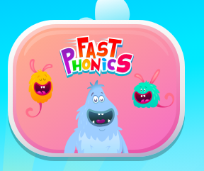

There are a variety of games to play which have been set at your child’s level.

Follow this link to sing our phase 3 tricky words song:
https://www.youtube.com/watch?v=R087lYrRpgY

Scroll down below grid for resources

Phonics
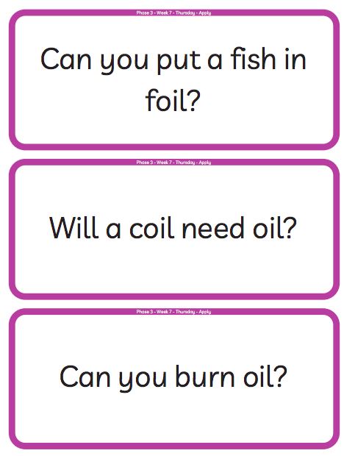
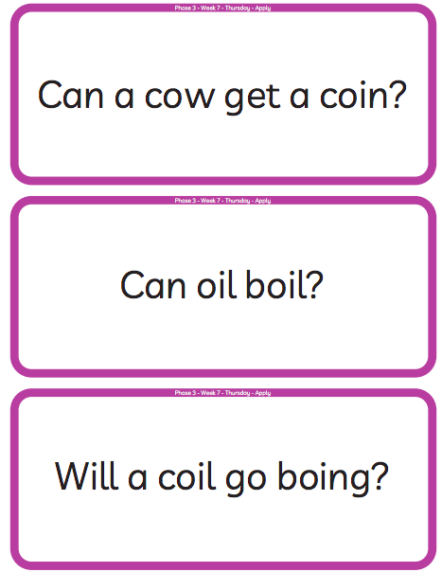
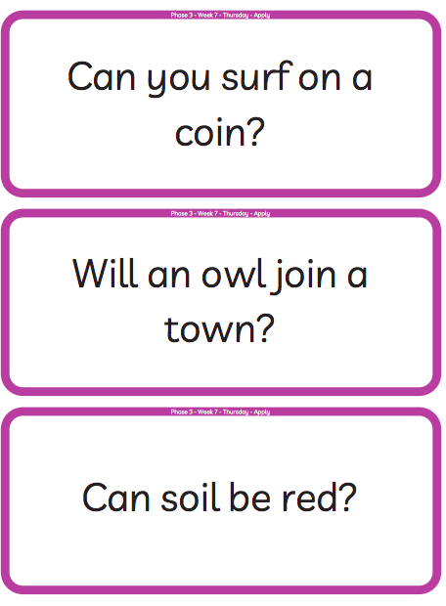
Orange group.

Phonics
Green group
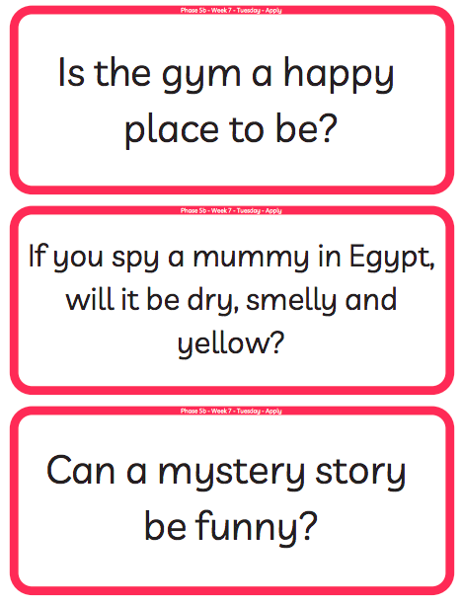

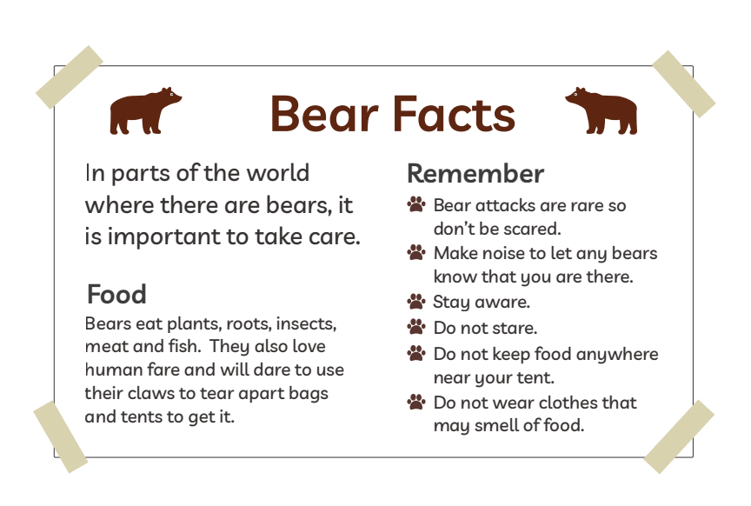
Blue group ‘air’ phoneme spotter, grid and words to sort.

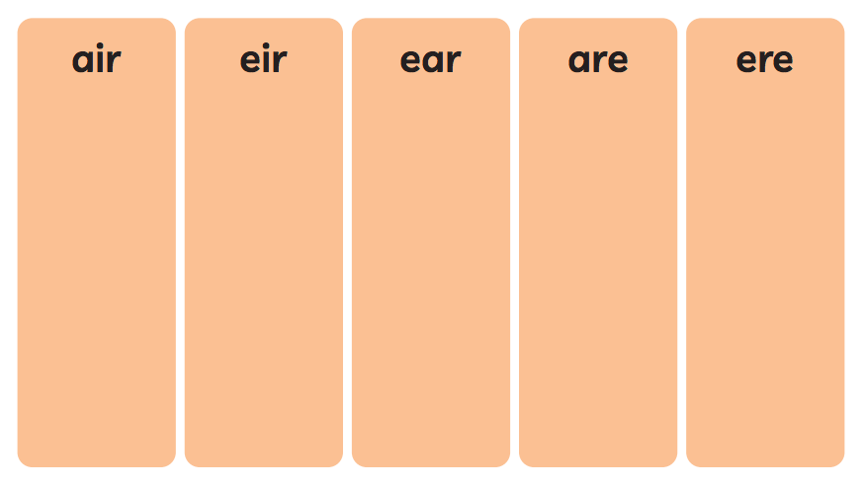

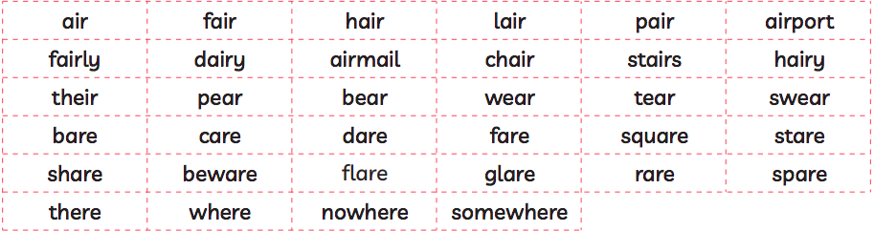

Orange group – writing.
About this poem:
This is a joyous, punchy, rhythmic poem. Children will love speaking it and moving to it. It is a poem to take outdoors and use as a marching rhyme and one we recommend to parents as a way of keeping little ones on the move!
Technical aspects:
The punchy feel to this poem is achieved by:
- the alliterative ‘b’ sounds in boots, big, busy which they can enjoy on their lips
- the use of mostly single syllable words
- the chorus repetition
- the 4-beat rhythm
- the use of rhyme
- the poem also uses onomatopoeia e.g. toot, squeak, splosh, squelch You do not need to use these terms with the children at this age.
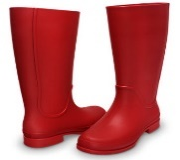
- Big Red Boots
This Photo by Unknown Author is licensed under CC BY

- Big red boots, big red boots.
One of them squeaks and the other one toots.
One of them hops and the other one stamps.
Big wet boots take long, wet tramps.

Boots, boots, big red boots.
One of them squeaks and the other one toots.

Big red boots on busy little feet
start out shiny, clean and neat.
Big red boots oh yes, yes, yes,
end up muddy in a terrible mess.

Boots, boots, big red boots.
One of them squeaks and the other one toots.

Boots, boots, big red boots,
squelch through mud and trample roots.
Big red boots say, “Look! Oh gosh!
What a great puddle there... Yay! SPLOSH!”

- Reproduced by kind permission of Tony Mitton
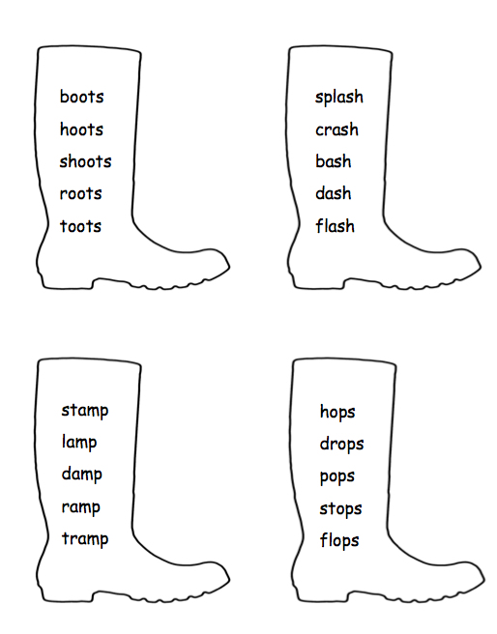

Green and blue group writing resources.
Technical aspects: The poem has a strong, marching rhythm of two beats to a line. The shoes in the poem are personified – given a life and a personality. The rhyme pattern is ABCB. Tony uses powerful verbs - trudged, tramped, clambered, pushed, stamped etc. reflect the hard, action- packed life of the shoes. The adjectives reflect what happens in the ageing process of humans – wrinkled, lined, thinning. The expression ‘down at heel’ is literal here but is an idiom sometimes used of people.

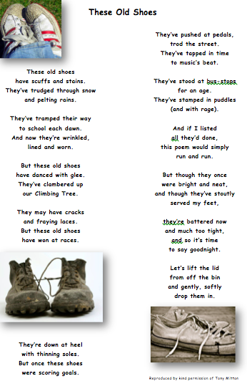

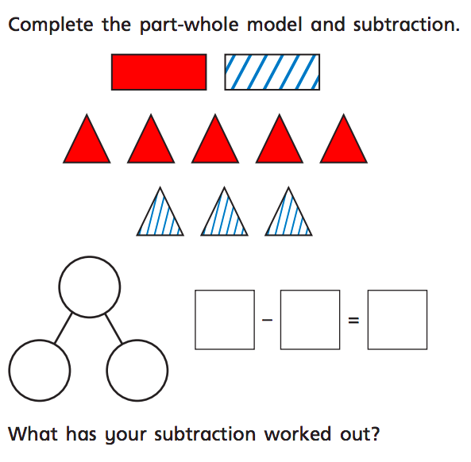
Green group maths questions – Subtract by finding a part
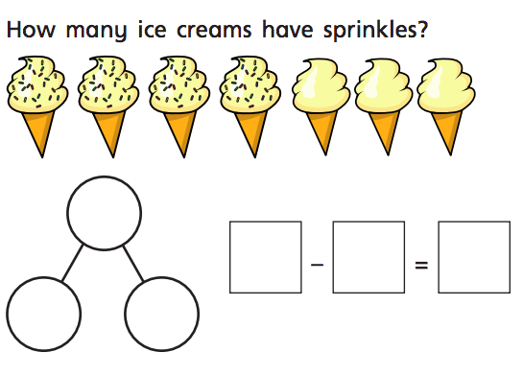
Questions should be answered in the following order: Green, orange, red, silver and gold.
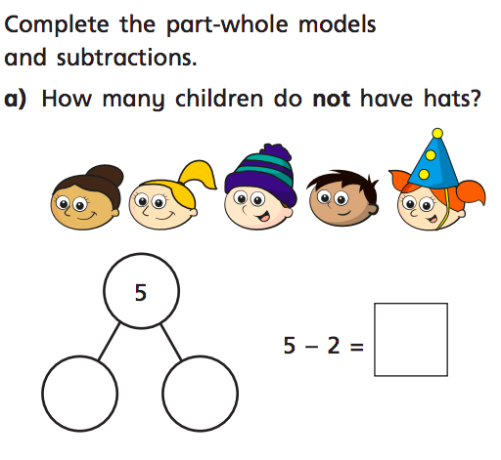

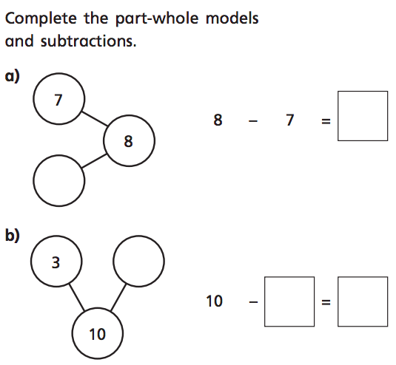

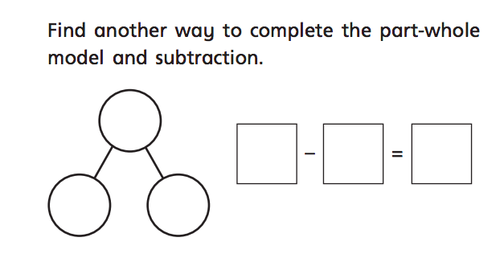
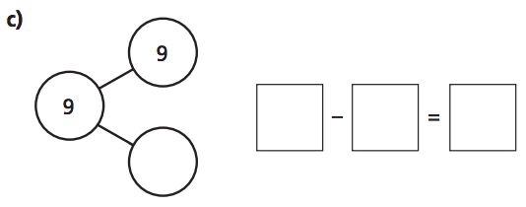

Blue group maths questions – Subtract a one digit number from a 2 digit number.
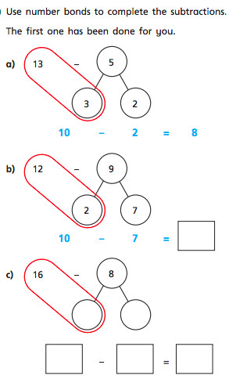
Questions should be answered in the following order: Green, orange, red, silver and gold.
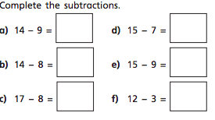
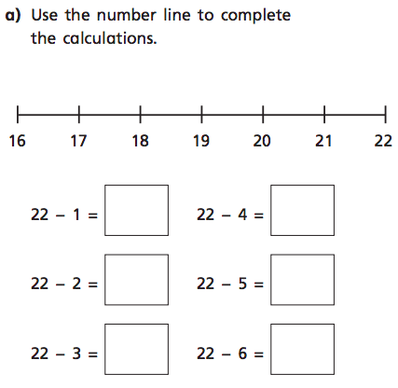

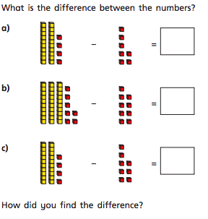
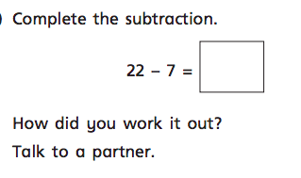

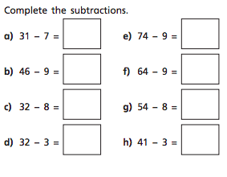
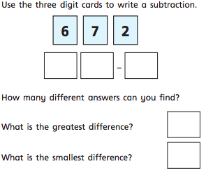

Orange group maths questions.
Recap all the work completed on the number 9 so far. Can you represent/identify nine in a variety of ways? Use the part whole model below to show how many ways 9 can be partitioned. Use the coins to find how many ways you can make 9p.
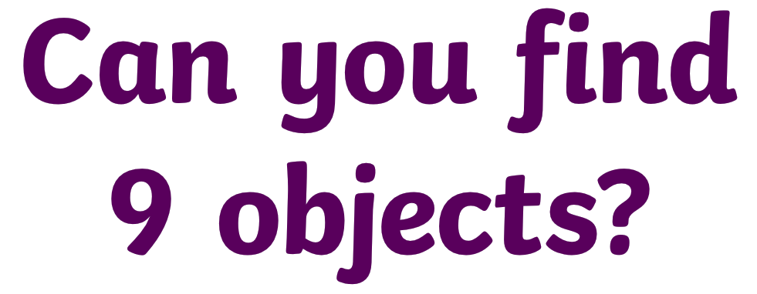

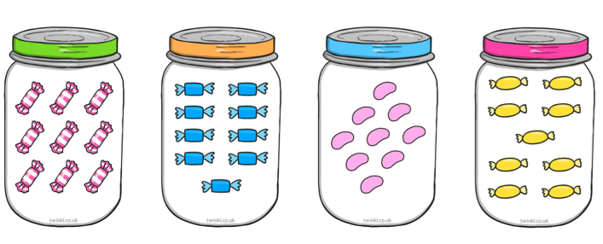
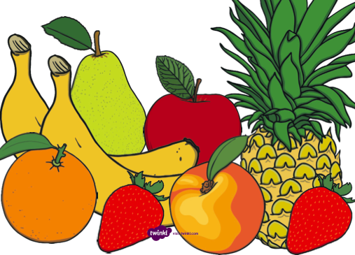
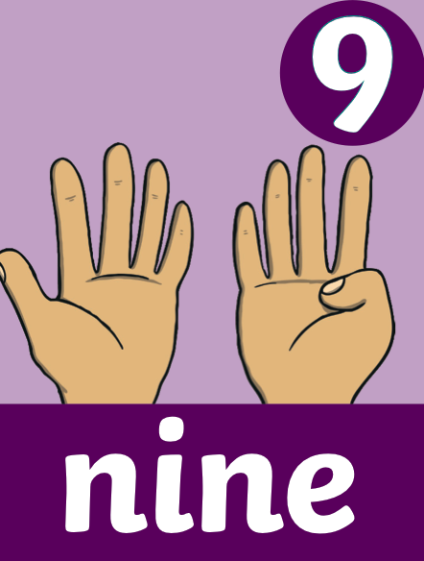
How many ways can you show 9 on your fingers?
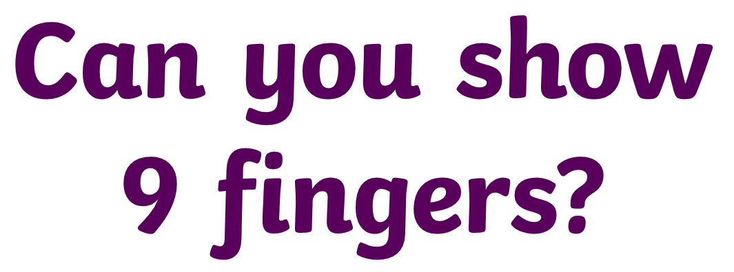
What time is this clock showing?

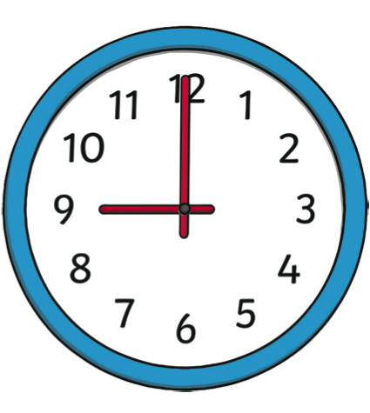
Can you identify the numeral 9 on the number line below?

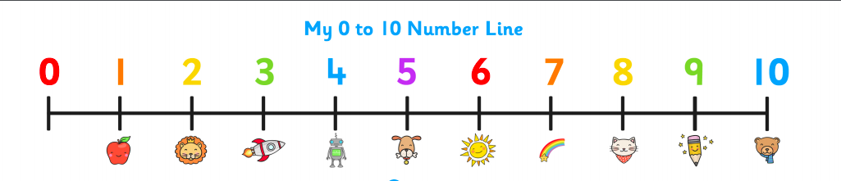

What is one more than 9?
What is one less than 9?

What number does this numicon shape represent?

How many counters haver been placed in this 10 frame?
How many spots are on this dice?

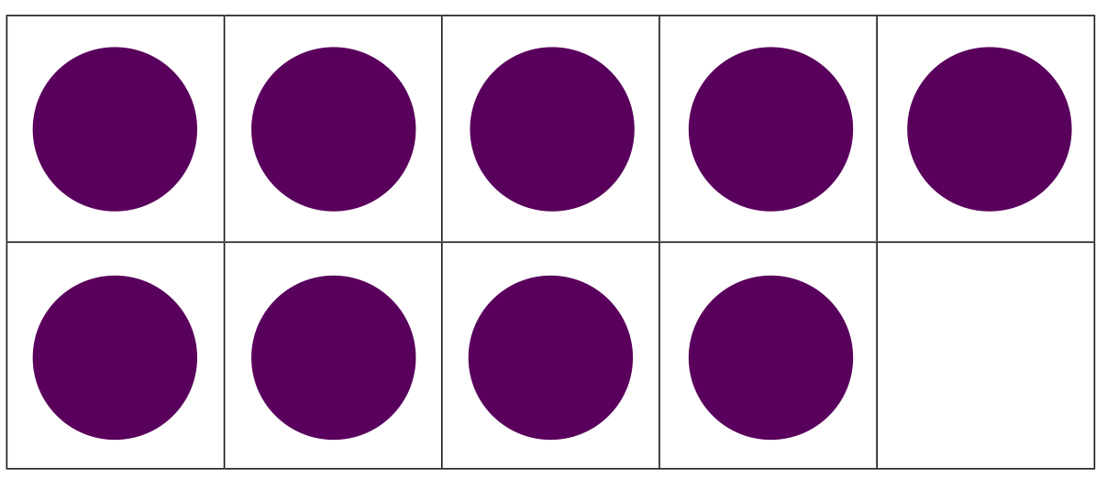

What is different about these representations?

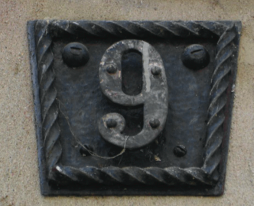
Can you represent 9 in any other way? Take a picture and send it to me.

How many ways have we represented 9?
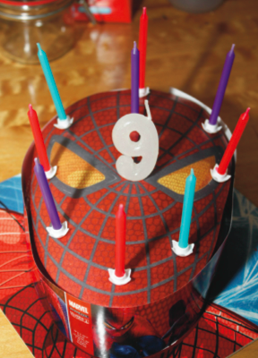
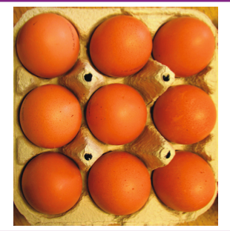
What is the same about these representations?

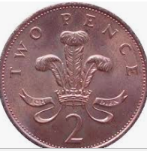
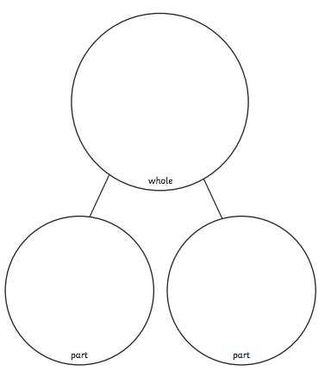

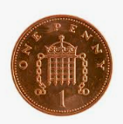

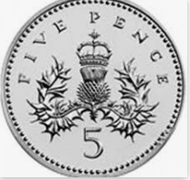

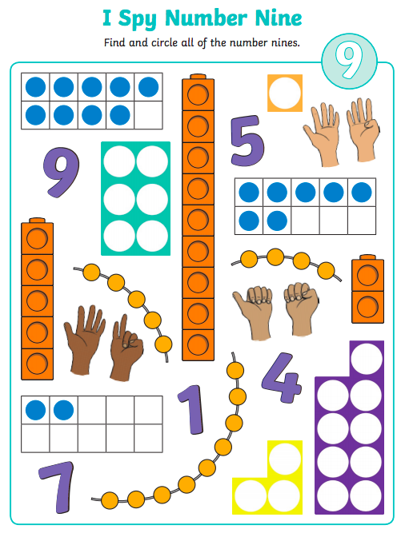
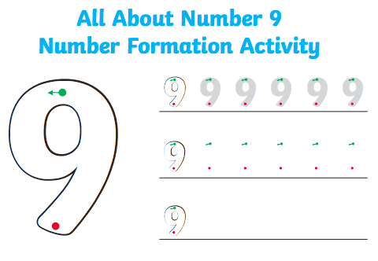

Active challenge:
