14/1 | PHONICS | ENGLISH | MATHS | ENQUIRY | ACTIVE
Wedne | Pink group –  Learning challenge;  I can blend words for reading.  Follow this link to watch this video: https://www.youtube.com/watch?v=3ovJIxTQpsU  Then, Play Sound Buttons to teach blending for reading. Write a word and draw a sound button underneath each sound in the word. Pretend to press each button as you make the sound, then blend all the sounds together to say the word. Ask children to repeat. Use any of these words: at, it, is, sat, pat, tap, sit, tip, pip, sip  Next: Play Buried Treasure using the words: sat, pat, tas, si, is, ti, it, pip. Show children a real or made up word written on a coin. Ask a child to soundtalk the word then blend it together. Ask all children to repeat the soundtalking and the blending. Ask children to decide whether the word is real (put it in the treasure chest) or fake (put it in the bin).  Resources attached below.  Hold up word cards that give instructions in turn. Children sound-talk the word and then act out following the instruction.  Resources attached below.  Orange group –  Learning challenge: I can read captions.  Follow this link to play flashcards speed trial – record your score to see if you can beat it next time.  https://www.phonicsplay.co.uk/resources/phase/2/flashcards-speed-trials  click on ‘start’ then ‘phase 2 & 3’  Username: jan21  Pass word: home  Then, children read captions (attached below) and draw pictures to represent what is happening in the caption.  Green group –  Learning challenge: I can pronounce the ‘ch’ grapheme in a variety of ways.  Follow this link to play tricky word trucks: https://www.phonicsplay.co.uk/resources/phase/5/tricky-word-trucks  Click on ‘start’, then ‘phase 5b’ record your score!  Username: jan21  Password: home  Then follow this link to watch this video: https://www.youtube.com/watch?v=VVc3vDqemig  Divide your page into three columns and label as below:  ch ch - c ch - sh  chin school chef  Sort the following words into the correct columns based on how they are pronounced (said) in the word. church, chick, crunch, pinch, chirping, school, chemist, chord, chorus, technical, chef, chalet, brochure, machine  Finally, read the sentences attached below – the all contain the ‘ch’ grapheme pronounced in a variety of ways.  Blue group:  Learning challenge: I identify the ‘air’ grapheme spelt in a variety of ways.  Read through our phoneme spotter from Monday – how many ways can you spot to spell the grapheme ‘air’.  Which was the most common spelling of the ‘air’ grapheme? Which was the least common?  Make a ‘best fit’ poster to show which would be the best fit for spelling with the ‘air’ grapheme. Make sure your poster is bright, colourful and eye catching.  An example is attached below to help you. | Reading.  www.readingeggs.co.uk each child has been set a reading comprehension task to complete. Follow the guidance attached to the blog to access the assignments.  Each child has also been allocated a library book which you can access through the library function on the homepage.  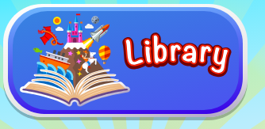 | Orange group – this week we will be focusing on the number 10.  Learning challenge: I can identify and represent the number 10 in a variety of ways.  Today we will be beginning our work on the number 10. We will start our work with objects.  Resources and questions are attached below.  Once you have completed these questions please log onto www.mathseeds.co.uk and complete your set assignment.  Green group – you will be continuing our work on addition and subtraction by crossing out.  Learning challenge: I can subtract by counting back  This will be an online lesson delivered via TEAMS at 10:30am.Please log onto your teams platform 5 minutes before the lesson is due to start.  You will need:  - A pencil  - Questions (attached below).  Once you have completed these questions please log onto www.mathseeds.co.uk and complete your set assignment.  Blue group: you will be continuing our work on addition and subtraction.  Learning challenge: I can add two 2digit numbers.  Watch this video by clicking the link: https://vimeo.com/467781234 then answer the questions attached below.  Use the answer sheet attached to the blog to check your understanding.  Once you have completed these questions please log onto www.mathseeds.co.uk and complete your set assignment. | Our enquiry this half term is based around ‘inventors’ and we will work towards answering the question ‘Can anybody be an inventor?’  You have all shared with me your marvellous new inventions and they are brilliant!  Today, please draw a picture of you the inventor in your workshop/laboratory.  What will you be wearing? Why?  What tools will you have in your workshop? Things to help you measure? Weigh? Draw?  What resources will you have? Glue? Scissors? Tape?  Label you picture and colour it in.  Discuss with someone in your house what personal qualities you will need to have as an inventor. Will you be hard working? Will you give up easily? Or will you enjoy solving problems?  Why will you need these qualities? | 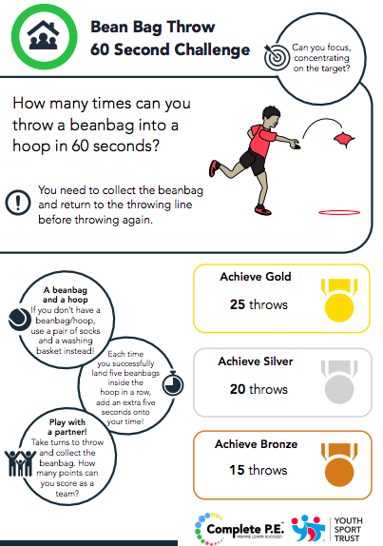  Log into www.gonoodle.com and choose your favourite Pump it up workout video. Can you challenge yourself to complete the whole 20 minutes?
Spelling Green and Blue group only.
www.readingeggs.co.uk each child has been set a spelling task to complete. Follow the guidance attached to the blog to access the assignments.

A new assignment has been allocated, they will be updated daily.

Writing:
Orange group
Learning challenge: I can design and label a pair of boots.
The focus for this learning is mainly speaking, listening and extending the children’s vocabulary. Share the poem every day and you might like to encourage them to undertake some drawing and writing tasks with adult help if appropriate. Resources attached below.
Day 7: This will be an online lesson delivered via TEAMS at 10:00am. Please log into teams 5 minutes before the lesson is due to start.

Resources you will need:
- A pencil
- Paper to write on.
- Orange group boots picture (below)

Green and blue groups.
About this poem: This poem tells the story of a much-loved pair of shoes which, after long and faithful service and an eventful ‘life’ are finally put in the recycling bin.
Day 7:
Learning challenge: I can plan a list poem.
This will be an online lesson delivered via TEAMS at 11:30am. Please log into teams 5 minutes before the lesson is due to start.

Resources you will need:
- A pencil
- Paper to write on.
- Think of an item of clothing that you loved before it became too old and worn, bring it to the lesson if you have it!

Poem is attached below.

Everyone:
When logging onto the www.readingeggs.co.uk app follow the link on the home screen to ‘fast phonics’.
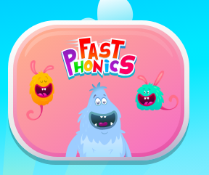

There are a variety of games to play which have been set at your child’s level.

Follow this link to sing our phase 4 tricky words song:
https://www.youtube.com/watch?v=3NOzgR1ANc4

Scroll down below grid for resources

Phonics
Pink group.
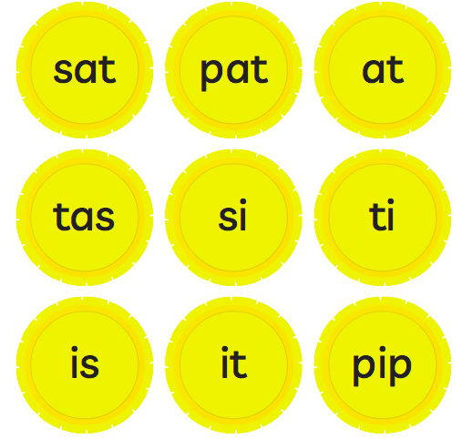
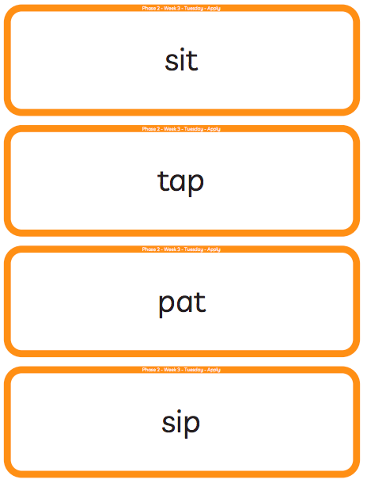

Phonics
Orange group.
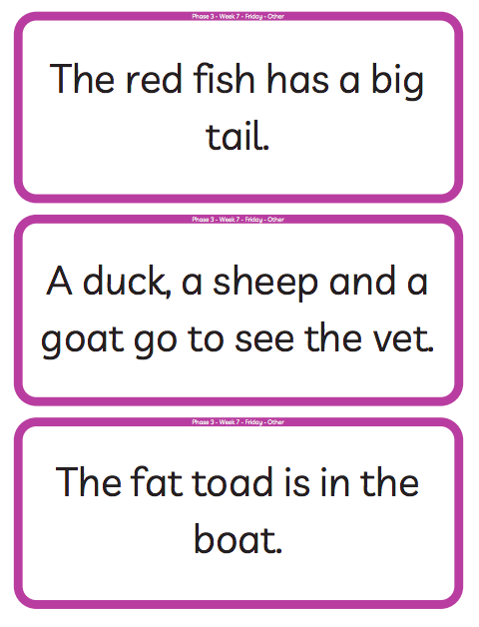
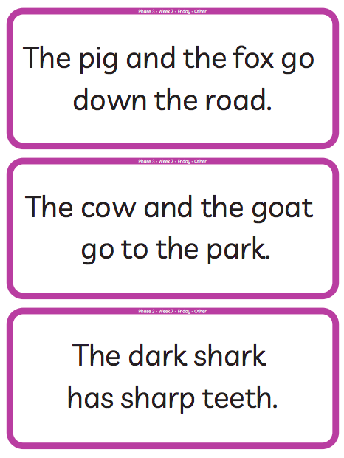

Phonics
Green group – alternative pronunciations of ‘ch’
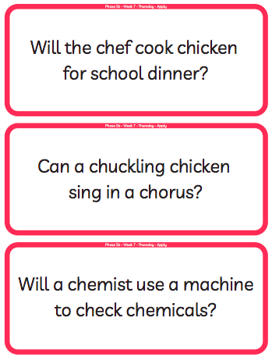

Blue group ‘best fit’ poster.
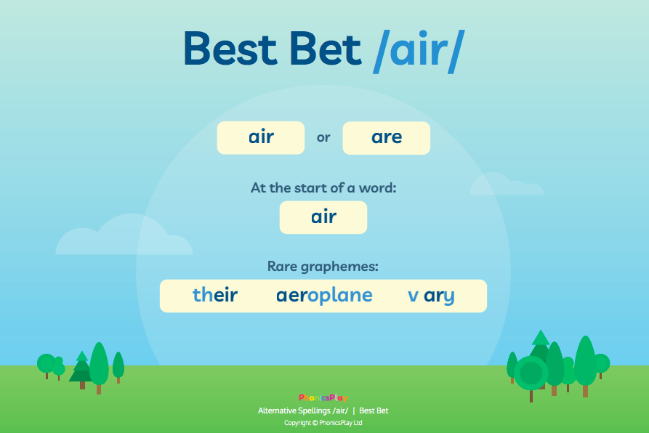

Orange group – writing.
About this poem:
This is a joyous, punchy, rhythmic poem. Children will love speaking it and moving to it. It is a poem to take outdoors and use as a marching rhyme and one we recommend to parents as a way of keeping little ones on the move!
Technical aspects:
The punchy feel to this poem is achieved by:
- the alliterative ‘b’ sounds in boots, big, busy which they can enjoy on their lips
- the use of mostly single syllable words
- the chorus repetition
- the 4-beat rhythm
- the use of rhyme
- the poem also uses onomatopoeia e.g. toot, squeak, splosh, squelch You do not need to use these terms with the children at this age.
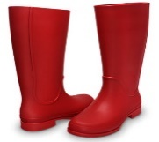
- Big Red Boots
This Photo by Unknown Author is licensed under CC BY

- Big red boots, big red boots.
One of them squeaks and the other one toots.
One of them hops and the other one stamps.
Big wet boots take long, wet tramps.

Boots, boots, big red boots.
One of them squeaks and the other one toots.

Big red boots on busy little feet
start out shiny, clean and neat.
Big red boots oh yes, yes, yes,
end up muddy in a terrible mess.

Boots, boots, big red boots.
One of them squeaks and the other one toots.

Boots, boots, big red boots,
squelch through mud and trample roots.
Big red boots say, “Look! Oh gosh!
What a great puddle there... Yay! SPLOSH!”

- Reproduced by kind permission of Tony Mitton

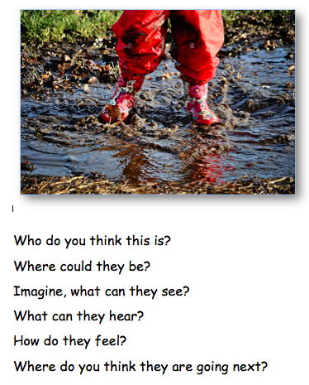

Green and blue group writing resources.
Technical aspects: The poem has a strong, marching rhythm of two beats to a line. The shoes in the poem are personified – given a life and a personality. The rhyme pattern is ABCB. Tony uses powerful verbs - trudged, tramped, clambered, pushed, stamped etc. reflect the hard, action- packed life of the shoes. The adjectives reflect what happens in the ageing process of humans – wrinkled, lined, thinning. The expression ‘down at heel’ is literal here but is an idiom sometimes used of people.

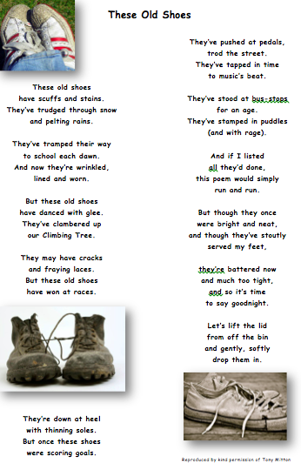

Green group maths questions – Subtract by counting back.
Questions should be answered in the following order: Green, orange, red, silver and gold.
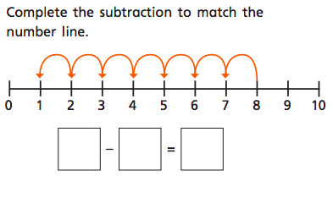
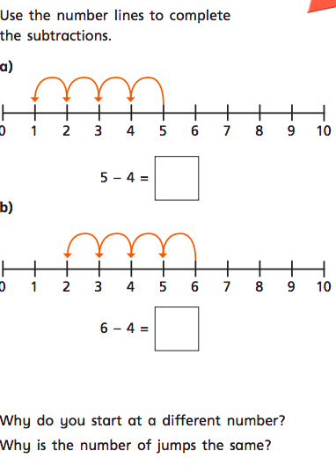

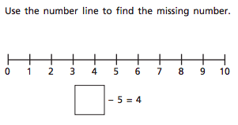
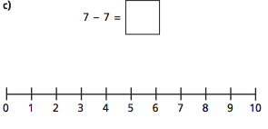

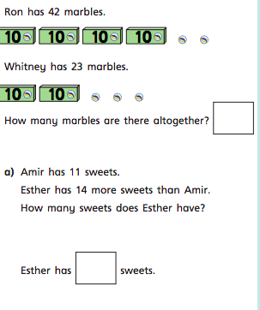
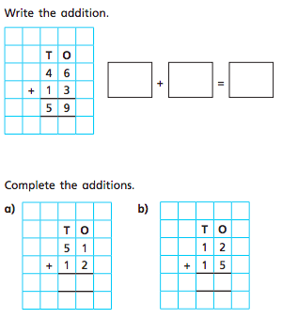
Blue group maths questions – Add two 2-digit numbers.
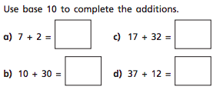
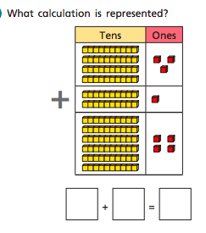
Questions should be answered in the following order: Green, orange, red, silver and gold.

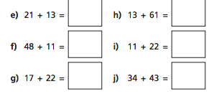

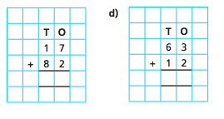

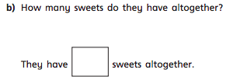

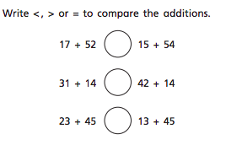
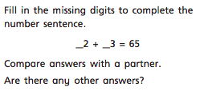

Orange group maths questions.
Use the questions below to discuss the children’s understanding of the number 10. Can they show 10 fingers? How many pieces of fruit are there? How many sweets in each jar? What is the same abou the jars? What is different about the jars?

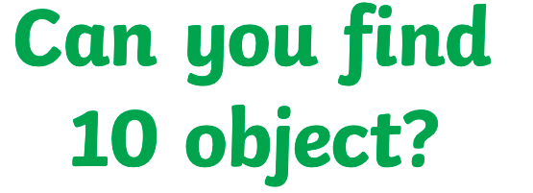

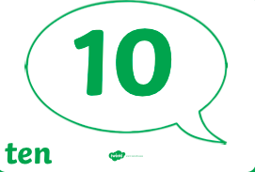
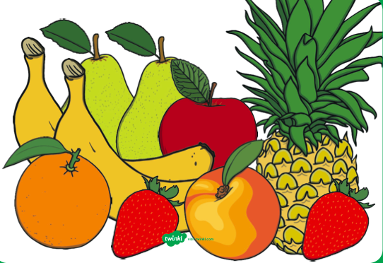
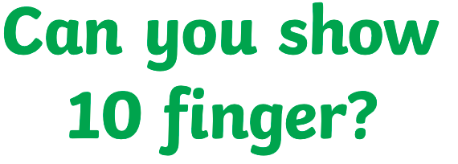
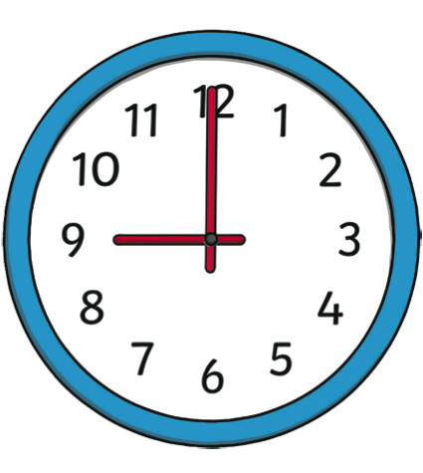

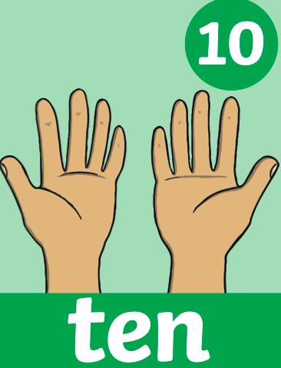
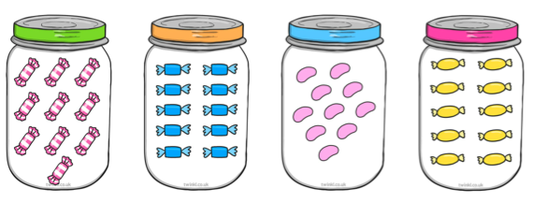

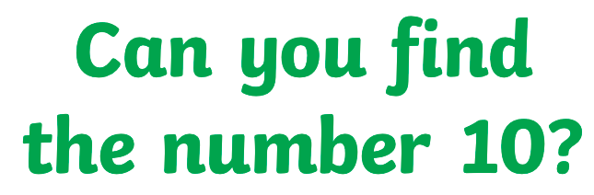

Active

Active challenge:
