15/1 | PHONICS | ENGLISH | MATHS | ENQUIRY | ACTIVE
Wedne | Pink group –  Learning challenge;  I can recognise, read and write the ‘n’ phoneme  Follow this link to watch this video: https://www.youtube.com/watch?v=oJ-7M1B07uU  Chn practice writing the letter in the air, on the table and on paper using different colour pens/pencils.  Then, Play Sound Buttons to teach blending for reading. Write a word and draw a sound button underneath each sound in the word. Pretend to press each button as you make the sound, then blend all the sounds together to say the word. Ask children to repeat. Use these words: an, in, nip, pan, pin, tin, tan, nap, nit.  Next: Look at the word and picture cards below ‘pat, tap, pip, pin’. Model sound talking one of the words and blending it. Ask children to match the word to the picture. Repeat with the other word cards. Resources attached below.  Orange group – Learning challenge: I can recognise, read and write the phoneme ‘ear’.  This new phoneme is a trigraph – three letters making one sound. Follow this link to watch the following video: https://www.youtube.com/watch?v=EneZ1UubxSA  Then, Play Sound Buttons to teach blending for reading. Write a word and draw a sound button underneath each sound in the word. Pretend to press each button as you make the sound, then blend all the sounds together to say the word. Ask children to repeat. Use these words: ear, dear, fear, hear, gear, near, tear, year, rear, beard.  Children then sound out to read the sentences attached below.  Green group – Learning challenge: I can pronounce the ‘ou’ grapheme in a variety of ways.  Follow this link to play tricky word trucks: https://www.phonicsplay.co.uk/resources/phase/5/tricky-word-trucks  Click on ‘start’, then ‘phase 5b’ record your score! Username: jan21 Password: home  Then follow this link to watch this video: https://www.youtube.com/watch?v=LJTvPS0IrDM  Divide your page into four columns and label as below:  ou ou - oo ou - oo ou- oa  out you could mould  Sort the following words into the correct columns based on how they are pronounced (said) in the word. loud, proud, sound, round, mountain, you, soup, group, could, would, should, mould, shoulder, boulder  Finally, read the sentences attached below – the all contain the ‘ou’ grapheme pronounced in a variety of ways.  Blue group:  Learning challenge: I identify the ‘ure’ grapheme spelt in a variety of ways.  Read through the phoneme spotter attached below – how many ways can you spot to spell the grapheme ‘ure’.  Underline, record or highlight all the different ways you can spell the ‘ure’ grapheme in different colours. | Reading.  www.readingeggs.co.uk each child has been set a reading comprehension task to complete. Follow the guidance attached to the blog to access the assignments.  Each child has also been allocated a library book which you can access through the library function on the homepage. | Orange group – this week we will be focusing on the number 10.  Learning challenge: I can identify and represent the number 10 in a variety of ways.  Today we will be continuing our work on the number 10. Using a number line and a variety of representations.  Resources and questions are attached below.  Once you have completed these questions please log onto www.mathseeds.co.uk and complete your set assignment.  Green group – you will be continuing our work on addition and subtraction  Learning challenge: I can subtract by finding the difference.  Watch this video by clicking the link: https://vimeo.com/470964093 then answer the questions attached below.  Once you have completed these questions check your understanding using the answer sheet attached to the blog then, please log onto www.mathseeds.co.uk and complete your set assignment.  Blue group: you will be continuing our work on addition and subtraction.  Learning challenge: I can add two 2digit numbers – crossing 10.  Watch this video by clicking the link: https://vimeo.com/468518962 then answer the questions attached below.  Use the answer sheet attached to the blog to check your understanding.  Once you have completed these questions please log onto www.mathseeds.co.uk and complete your set assignment. | The national Marine Aquaroum in Plymouth are holding ‘Deep Science’ at 1:00pm  Followed by ‘Mermaid Tales’ – stories read by a Mermaid at 1:30pm!  These activities are being broadcast live from the National Marine Aquariums Youtube channel.  Follow this link to take part, learn about creatures of the ocean and listen to a story read by a mermaid!  https://www.youtube.com/user/NMAPlymouth | Don’t forget Joe Wicks is running his PE session live from his youtube account at 9am today!  https://www.youtube.com/user/thebodycoach1  PSHE – friends and family.  https://www.bbc.co.uk/teach/supermovers/pshe-super-mood-movers-friends-and-family/z4yq8hv
Spelling Green and Blue group only.
www.readingeggs.co.uk each child has been set a spelling task to complete. Follow the guidance attached to the blog to access the assignments.

A new assignment has been allocated, they will be updated daily.

Writing:
Orange group
Learning challenge: I can sound out to write.
The focus for this learning is mainly speaking, listening and extending the children’s vocabulary. Share the poem every day and you might like to encourage them to undertake some drawing and writing tasks with adult help if appropriate. Resources attached below.
Day 7: Yesterday you designed, coloured and labeled your DREAM boots which were magic!

Talk to a grown up – where are your amazing boots going to take you? What happens on your adventure? Where do you go? What can you see? What can you hear? What can you smell? How do you feel?

Sound out to write some sentences to describe your first adventure in your amazing magic boots. You can scribe for the children if they are unable to write everything but try to have a go at writing one of your sentences independently.

Green and blue groups.
About this poem: This poem tells the story of a much-loved pair of shoes which, after long and faithful service and an eventful ‘life’ are finally put in the recycling bin.
Day 7:
Learning challenge: I can write a list poem.
Yesterday you thought about an old item of clothing that you used to love to wear. You thought about what this item of clothing looked like, how it made you feel and he experiences you had while wearing it.
Attached to the blog is a powepoint ‘List poem explanation and examples’. Read through the powerpoint and examples to find out more about list poems.
Then using the plan you created yesterday write your own. Remember your poem will be in the past tense.
Here is mine to help you, I have included 2A sentences and list sentences – see if you can do the same.
This old jumper.
This old jumper of green and blue is my most favourite of all.
It kept me warm and snug on cold winter mornings.
It has kept me dry and sheltered from icy rain that poured.
This old jumper was once soft and smooth but not anymore.
It has been caught on scratchy tree branches as I climbed.
It has charged through squelchy, muddy, brown fields.
This old jumper made me happy, relaxed and calm.
I love my old green blue jumper.

Everyone:
When logging onto the www.readingeggs.co.uk app follow the link on the home screen to ‘fast phonics’.
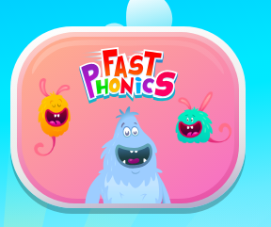

There are a variety of games to play which have been set at your child’s level.

Follow this link to sing the name and sound song:
https://www.youtube.com/watch?v=5PmB3SIjNdQ

Scroll down below grid for resources

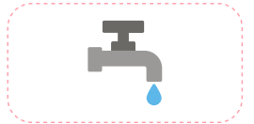
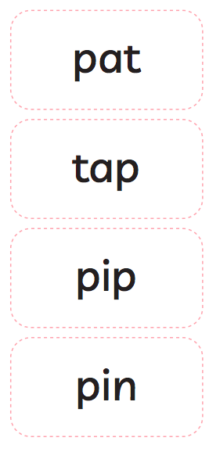
Phonics
Pink group.

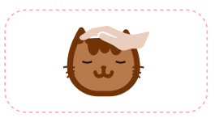

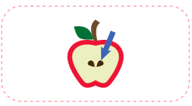

Phonics
Orange group.
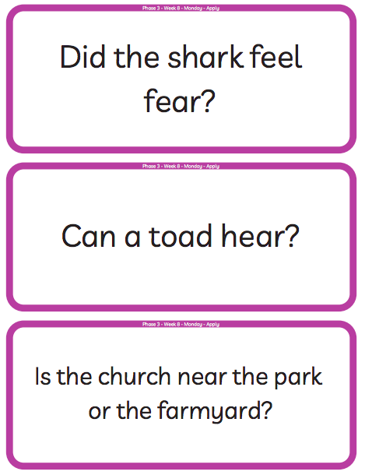

Phonics
Green group – alternative pronunciations of ‘ou’

Phonics
Green group
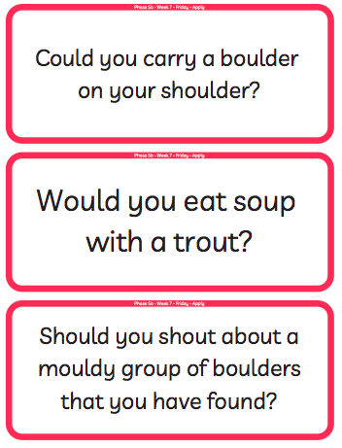

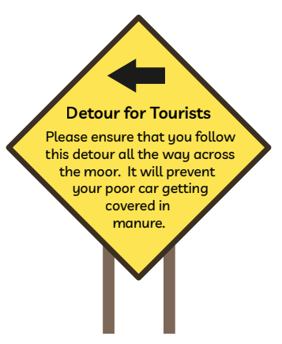
Blue group ‘ure’ phoneme spotter.

Orange group – writing.
About this poem:
This is a joyous, punchy, rhythmic poem. Children will love speaking it and moving to it. It is a poem to take outdoors and use as a marching rhyme and one we recommend to parents as a way of keeping little ones on the move!
Technical aspects:
The punchy feel to this poem is achieved by:
- the alliterative ‘b’ sounds in boots, big, busy which they can enjoy on their lips
- the use of mostly single syllable words
- the chorus repetition
- the 4-beat rhythm
- the use of rhyme
- the poem also uses onomatopoeia e.g. toot, squeak, splosh, squelch You do not need to use these terms with the children at this age.
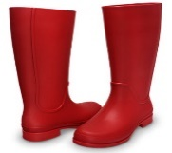
- Big Red Boots
This Photo by Unknown Author is licensed under CC BY

- Big red boots, big red boots.
One of them squeaks and the other one toots.
One of them hops and the other one stamps.
Big wet boots take long, wet tramps.

Boots, boots, big red boots.
One of them squeaks and the other one toots.

Big red boots on busy little feet
start out shiny, clean and neat.
Big red boots oh yes, yes, yes,
end up muddy in a terrible mess.

Boots, boots, big red boots.
One of them squeaks and the other one toots.

Boots, boots, big red boots,
squelch through mud and trample roots.
Big red boots say, “Look! Oh gosh!
What a great puddle there... Yay! SPLOSH!”

- Reproduced by kind permission of Tony Mitton

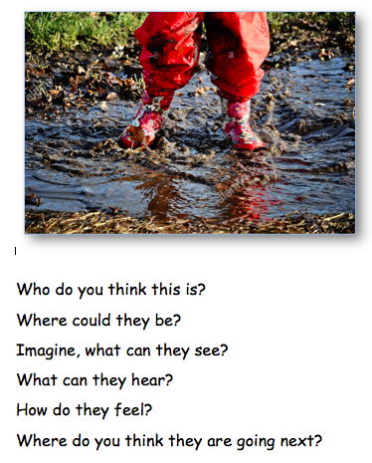

Green and blue group writing resources.
Technical aspects: The poem has a strong, marching rhythm of two beats to a line. The shoes in the poem are personified – given a life and a personality. The rhyme pattern is ABCB. Tony uses powerful verbs - trudged, tramped, clambered, pushed, stamped etc. reflect the hard, action- packed life of the shoes. The adjectives reflect what happens in the ageing process of humans – wrinkled, lined, thinning. The expression ‘down at heel’ is literal here but is an idiom sometimes used of people.

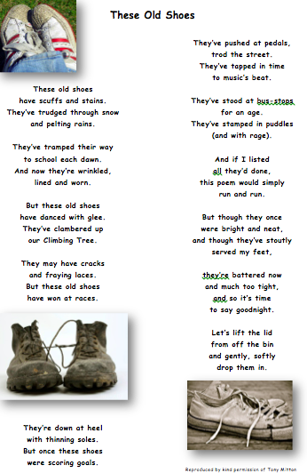

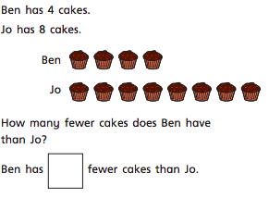
Green group maths questions – Subtract by finding the difference.
Questions should be answered in the following order: Green, orange, red, silver and gold.
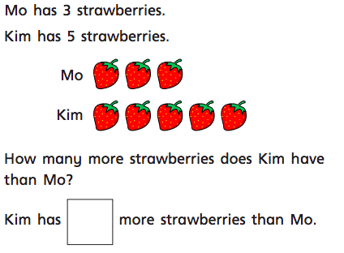
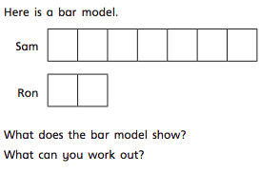
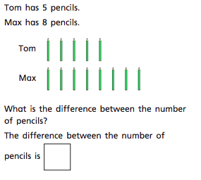
Blue group maths questions – Add two 2-digit numbers – crossing 10.
Questions should be answered in the following order: Green, orange, red, silver and gold.
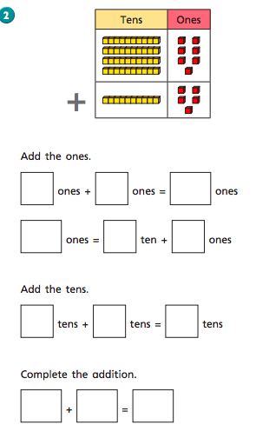
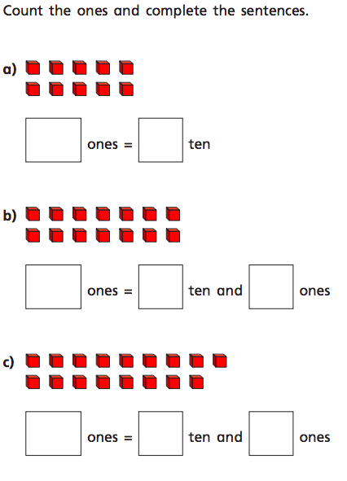

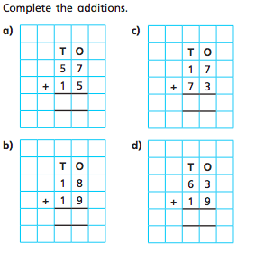

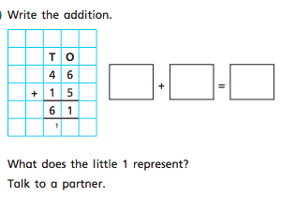

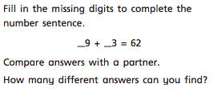

Orange group maths questions.
Recap the work children did on the number 10 yesterday. Can they show 10 fingers? How many pieces of fruit are there? How many sweets in each jar? What is the same about the jars? What is different about the jars? Look at the new questions and resources below, discuss the questions with the children. Are they able to identify all the different representations of 10?

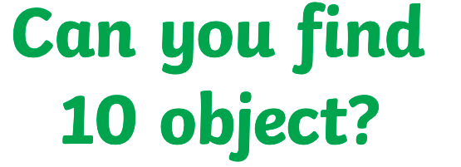

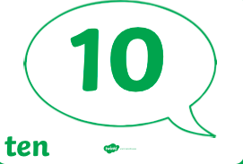
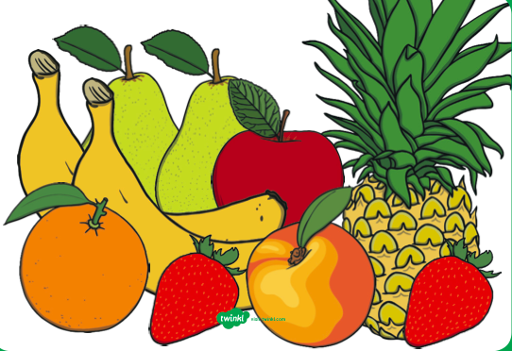
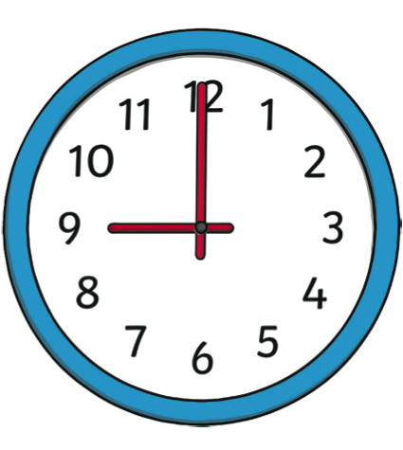

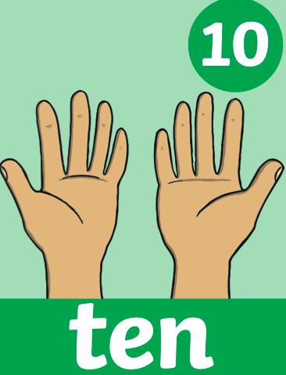
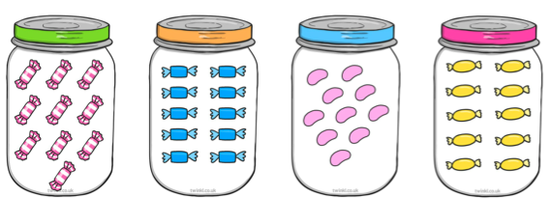

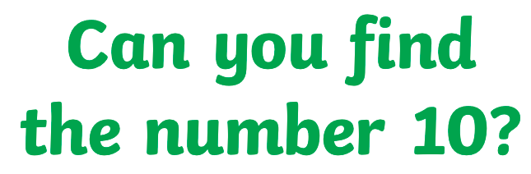

What number are these base 10
resources representing?
Which number is represented
on this die?
What time does the clock say?
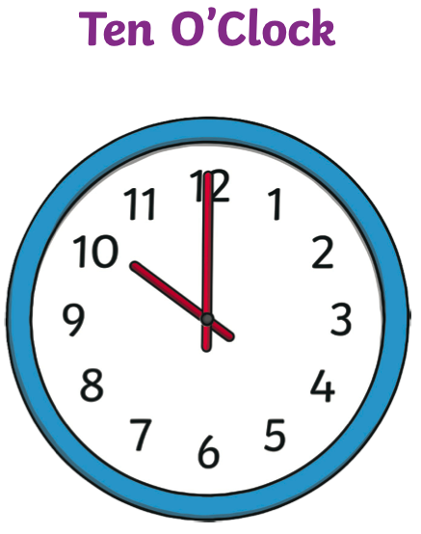

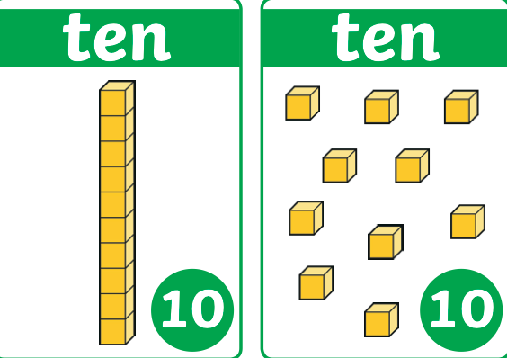

Which number is represented
with Numicon?
What is the same? What is different?
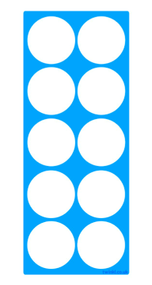
Which number is represented in this 10 frame? Do you need to count? Why? Why not?

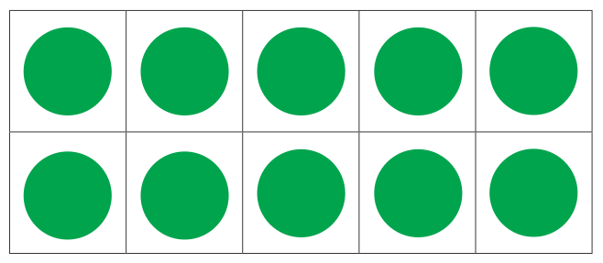

Can you find the number 10 on this number line? What is one less than 10? What is one more than 10?

