**The water cycle.**

The water cycle is also known as the hydrological cycle. There is the same amount of water on the Earth now as there was when the Earth began.  The water cycle is how the earth's water recycles itself.

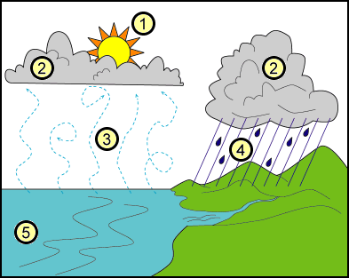

The cycle includes [precipitation](http://library.thinkquest.org/04apr/00222/words.htm), [evaporation](http://library.thinkquest.org/04apr/00222/words.htm), [condensation](http://library.thinkquest.org/04apr/00222/words.htm), and [transpiration](http://library.thinkquest.org/04apr/00222/words.htm).  Earth's water keeps changing from liquid water to vapour and then back again.  This cycle happens because of the sun's heat and gravity.

**How does the Water Cycle work?**

1. First of all, water [molecules](http://library.thinkquest.org/04apr/00222/words.htm) from lakes, rivers, streams, reservoirs, and the sea get heated up by the sun and then turn into vapour that rises into the air.

2. Next, these water molecules form into clouds, this is because a process called condensation occurs.

3. When the air and the water cool, they form drops of water which then fall to the earth as rain.  If they are frozen, they become snow or sleet.

4. Once the water reaches the ground, it can flow across the land until it reaches rivers, lakes, streams, or the sea.

It can also sink into the ground and flow because of gravity through gaps in rock, gravel and sand. Because of this, it reaches these bodies of water too.

5. Now the cycle begins again, when water is evaporated once more.

**Why is water important?**

Many of us think water will always be there for us when we want it.   Without water, living things would die.  You will die if you go without water for more than a week.  Plants will die without water and that would kill all of the animals that eat the plants.

