Thursday | ENGLISH  LEARNING CHALLENGE: I can use imperative verbs to write a set of instructions.  Imperative verbs are verbs in their shortest form, and you may know them as “bossy verbs”. These are examples of imperative/bossy verbs: pull, walk, push, run, pour, take, pass.  To warm up for today’s writing, set a one minute timer and write as many imperative verbs as you can think of.  You might want to watch the film again The Shirt Machine by Jon Davis - YouTube  Pay attention to the part with the ledger. This is a book which has drawings of the machine but is missing the page of how the machine works. You need to write the instructions for how to operate the machine to make a shirt of your choice. Read the explanation of how the machine works (attached below the blog) to help you. Remember to follow the success criteria for instruction writing.  Success Criteria:  *Start by explaining what the instructions are for.  *Next make a list of steps that you need to follow in order from starting the machine to the shirt is done.  *Don’t forget to use imperative verbs so your instructions are very clear.  *Add some adverbs to your imperative verb to say how you should carry out the instruction - Press the button lightly  You will need:  - Pencil and paper.  - Explanation about the machine | MATHS  These are live TEAMS lessons. Check your group colour and log in 5 minutes before your session with your microphone muted.  RED 9:00 – 9:30  Learning Challenge: I can divide 2-digits by 1-digit.  YELLOW 9:40-10:10  Learning Challenge: I can explore factor pairs.  GREEN 10:20 – 10:50  Learning Challenge: I can multiply 3 numbers.  PURPLE 11:00 – 11:30  Learning Challenge: I can explore square and cube numbers.  BLUE  Learning Challenge: I can explore prime numbers.  You will need:  - Pen and paper  - Worksheet attached to Blog (no need to print)  - A smile | ENQUIRY  WHAT HASN’T BEEN INVENTED YET?  To start thinking about this, this week we will focus on What is an inventor?  This is an online lesson lasting around 30 minutes delivered via TEAMS at 1:30pm. Please log in 5 minutes before with your microphone muted.  DESIGN AND TECHNOLOGY  Learning Challenge: I can think of ideas for a shirt.  Come to this lesson prepared to talk about which shirt you would make if you had the shirt machine. Share ideas, give each other feedback and support. We will also have time for:  Assembly  STAR of the WEEK  FRENCH  Watch the film on BBC bitesize on following directions.  French KS2: Following directions - BBC Teach  After the film, make some signs using the vocabulary à gauche(left), à droite(right), tout droit (straight ahead).  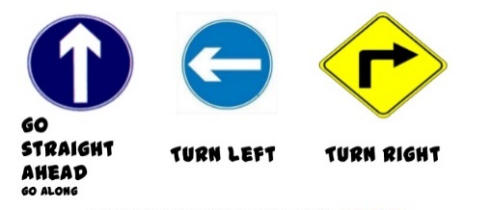 | ACTIVE  To make sure you are active for at least 60 minutes a day, try these activities:  *Choose a “Let’s Dance!” video from this link:  https://www.youtube.com/playlist?list=PLJnn5H8Y_tYE3LdXoJIG_azMC2l5TjCON  AND:  *Little Sports children’s fitness videos https://www.youtube.com/watch?v=L-8wW40jTzc

