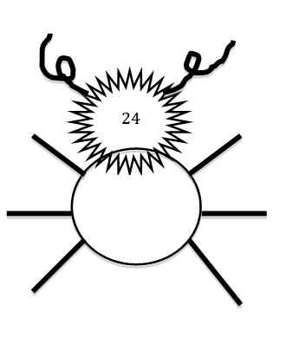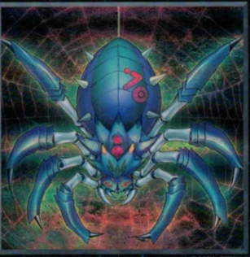
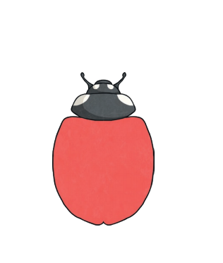

Think about all the numbers (multiples) of the 6 times table and write them all out. Now you need to make a bug for each of the numbers. You can use the ideas of the bugs on this page or you can choose to make your own from different materials, cardboard, clay, dough – anything you can think of.
By making these bugs, you will begin to remember all the numbers in the 6 times table because you will be making links to what each number looks like.
Hope you enjoy this activity.

