Friday | ENGLISH  Log in at 9:15am for this lesson.  LEARNING CHALLENGE:  I can identify features of jokes.  SUCCESS CRITERIA:  Read the jokes.  Decide which formula has been used.  Sort the jokes into the 3 types.  Choose your favourite jokes and explain why you chose these.  Have a go at writing your own joke using one of the formulas.  You will need:  Pen and paper  The Cheesy Joke Task sheet  Formula Jokes | MATHS  RED 10:00am  Learning Challenge: I can compare lengths.  YELLOW 10:30am  Learning Challenge: I can solve problems involving conversion.  GREEN  Learning Challenge: I can convert between m and km.  Aut4.8.3 - Kilometres on Vimeo  PURPLE  Learning Challenge: I can find the perimeter of rectilinear shapes.  Aut5.11.4 - Perimeter of rectilinear shapes on Vimeo  BLUE  Learning Challenge: I can find the perimeter of rectilinear shapes.  Aut5.11.4 - Perimeter of rectilinear shapes on Vimeo | ENQUIRY  SCREEN FREE FRIDAY AFTERNOON  This afternoon, I would like you to have a break from the internet and try out some of the activities below which need no screen time.  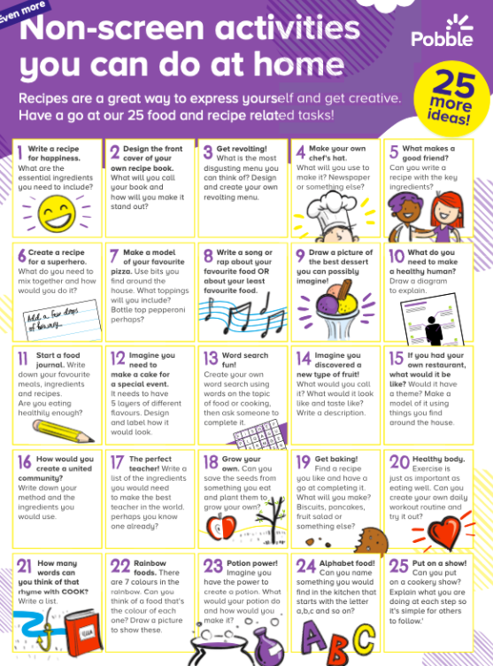 | ACTIVE  To make sure you are active for at least 60 minutes a day, try these activities:  Start your day with Joe Wicks streamed live on Wicks’ YouTube channel at 9am or later on to suit you.  No rain today, so time for some outside activities. Try out some of the challenges on the DailyMileAtHome sheet below.

