Tuesday | ENGLISH  LEARNING CHALLENGE: I can explore the use of rhyme in poetry.  Today your lesson is from BBC bitesize. Click on the link and follow the instructions  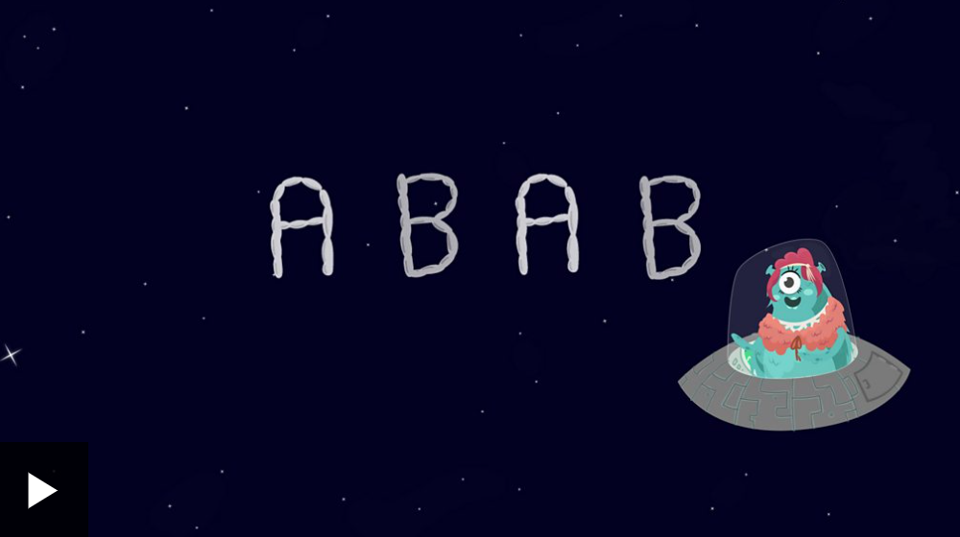  https://www.bbc.co.uk/bitesize/articles/z3tx8hv  When you have completed the lesson, try out some rhyming games on Wordwall:  KS2 Rhyming - Teaching resources (wordwall.net) | MATHS  RED 9:15am  Learning Challenge: I can subtract lengths.  YELLOW 10:15am  Learning Challenge: I can find perimeter on a grid.  GREEN 9:45am  Learning Challenge: I can measure perimeter.  Now complete the Mathletics homework on time and area.  PURPLE 11am  Learning Challenge: I can find the area of rectangles.  BLUE 11am  Learning Challenge: I can find the area of rectangles.  You need pen and paper.  Worksheet below the blog. | ENQUIRY  WHAT MAKES US LAUGH?  ART:  Learn how to draw a comic figure with a famous illustrator. Join Tony Ross, listen to how he is inspired to draw, where he gets his ideas from and learn how to draw Horrid Henry.  How to Draw Horrid Henry with Tony Ross - YouTube  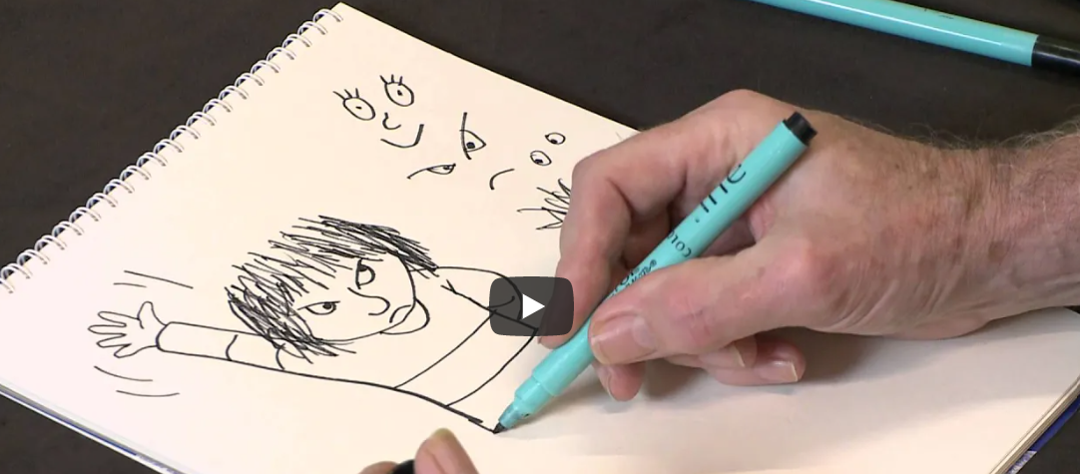  FRENCH  I am learning to say what clothes I have.  The verb AVOIR – to have.  Follow the learning in the video:  Saying clothes you have and using a conjunction (thenational.academy)  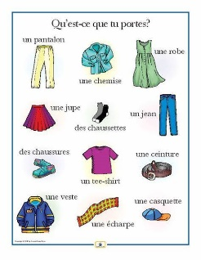 | ACTIVE  To make sure you are active for at least 60 minutes a day, try these activities:  PE at Home Fitness circuit 4  Year 5 and 6  HOME PE - KS2 Fitness Challenge Y5/6 | Primary PE Planning  PE at Home Fitness circuit 4  Year 3 and 4  HOME PE - KS2 Fitness Challenge Y3/4 | Primary PE Planning  Try the new SUPERMOVERS Look After Yourself  Super Mood Movers - Look after yourself - BBC Teach

