Friday | ENGLISH  Research  Find out about why today is called St Piran’s Day. Listen to the story here:  Listen to The Story of St Piran - Kowethas an yeth Kernewek (cornish-language.org)  Click on the link and download the audio book. Listen in English or Cornish and complete the quiz.  Game time  Try out your spelling, grammar and punctuation skills with the Crystal Explorers game:  Games - KS2 English - BBC Bitesize | MATHS  Live lesson for all at 9:30am  I can use my knowledge of area and perimeter to create a zoo.  Try your skills of creating shapes from the measurements on the Zoo tycoon guide by playing the games below.  Geoboard | Free Virtual Manipulatives | Toy Theater  Area Builder‬ 1.1.20‬ (colorado.edu)‬‬  Area Perimeter Explorer | Geometry for Kids | Toy Theater | ENQUIRY  SCREEN FREE FRIDAY AFTERNOON  This afternoon, I would like you to have a break from the internet and try out some of the activities below which need no screen time.  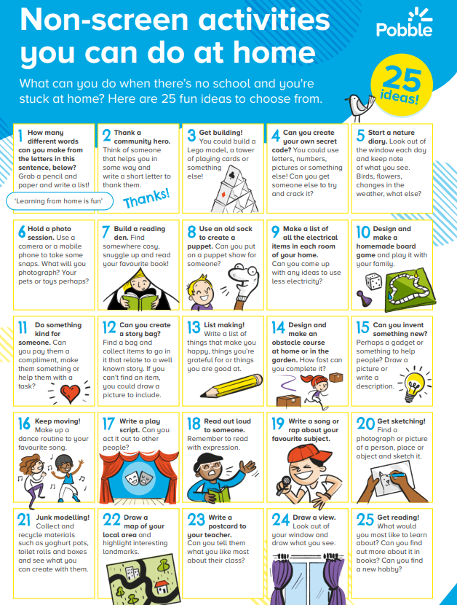 | ACTIVE  To make sure you are active for at least 60 minutes a day, try these activities:  Start your day with Joe Wicks streamed live on Wicks’ YouTube channel at 9am or later on to suit you.  No rain today, so time for some outside activities. Try out some of the challenges on the DailyMileAtHome Week 2 sheet below.

