Animal  Zoo Tycoon | Shape Required | EXACT area needed | 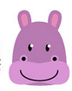  EXACT perimeter needed
Monkey | Square | 16m²
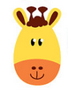  Elephant | Rectangle | 20m²
Penguin | Triangle |  | 45cm
Lion | Compound shape |  | 40m
Rhino | Rectangle | 28m² | 22m
Wolf | Triangle |  | 36cm
Gorilla | Compound shape | 18m²
Giraffe | Compound shape |  | 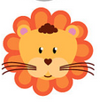  42m
Zebra | Square |  | 24m
Cheetah | Compound shape | 24m²
Tiger | Triangle |  | 30cm
Ostrich | Rectangle |  | 18m
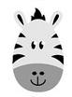  Hippo | Compound shape |  | 50m
Polar Bear | Rectangle | 36m²
Dolphin | Rectangle | 8m²
Meerkat | Square | 49m²
Kangaroo | Rectangle | 36m²
Spiders | Rectangle |  | 22m
Unicorn | Compound shape | 46m² | 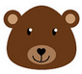

Guest Item | Shape Required | EXACT area needed | EXACT perimeter needed
Entrance Kiosk | Rectangle |  | 20m
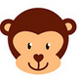  Gift Shop | Triangle | 12m²
Toilet | Square | 4m²
McDonalds | Rectangle | 12m² | 14m
Ice-cream store | Compound shape | 24m²

